**Promotion ->Registration**

1. State-code tidak accept 0..contoh 03

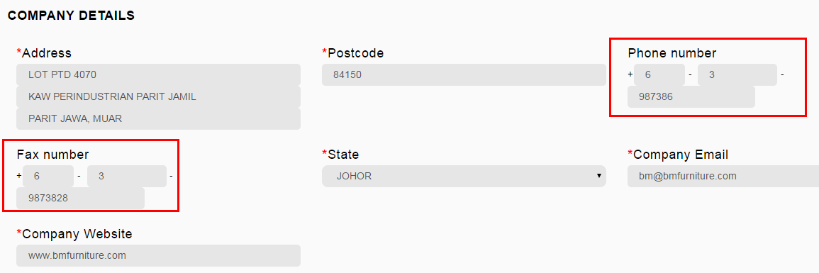

1. To hide if Programme Type Incoming Buying Mission or Individual Business Meeting MEEC/BGGP

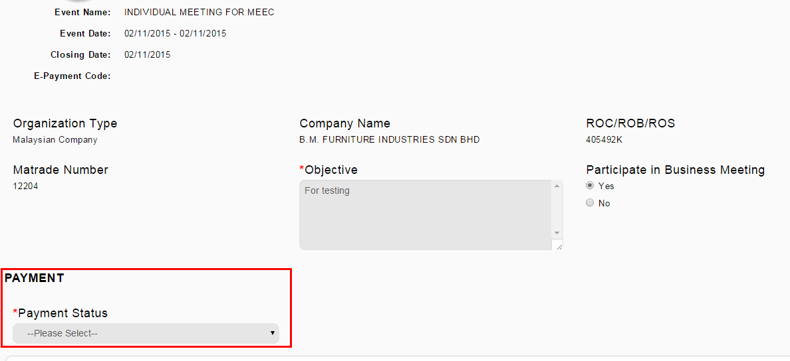

1. Sepatutnya bila nak new atau tambah Add Rep, page ADD REPRESENTATIVE empty

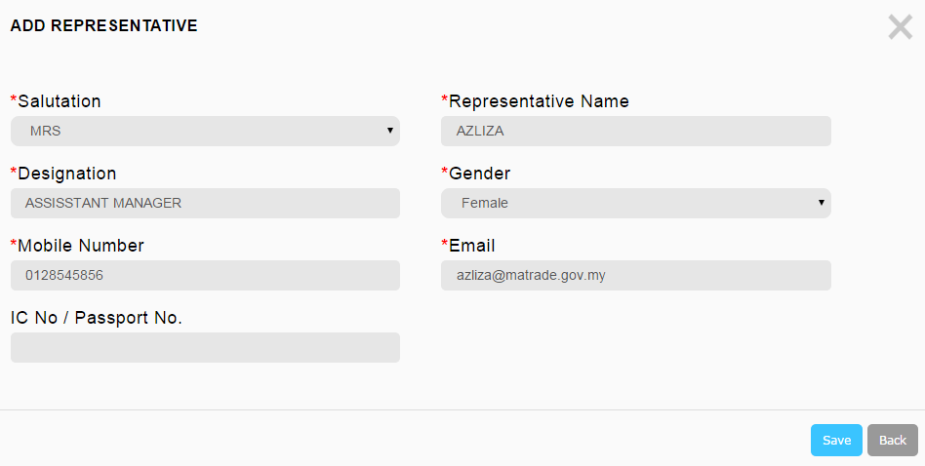

1. Registration Malaysian company

To make optional

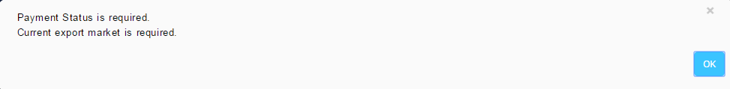

1. Registration Foreign Buyer

To make optional

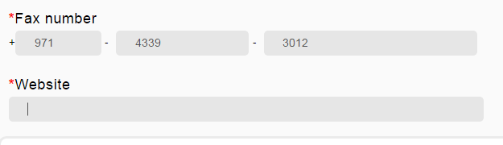

1. Business type for Foreign Buyer -> not same with old system

Remarks : already discussed with user, to follow new system list of business type

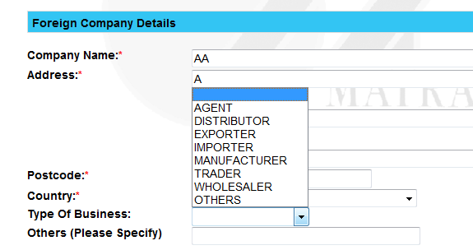

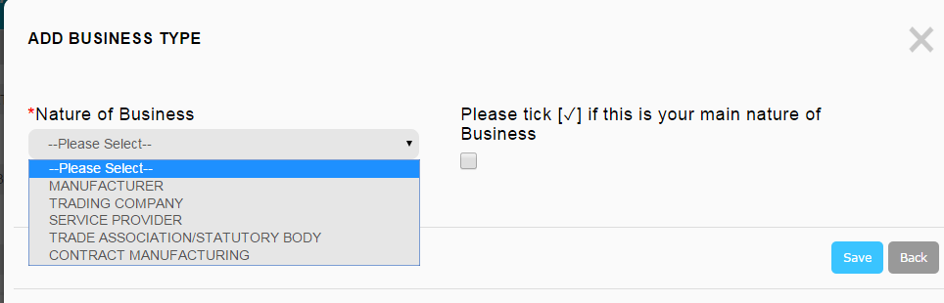

1. To sort TC Office

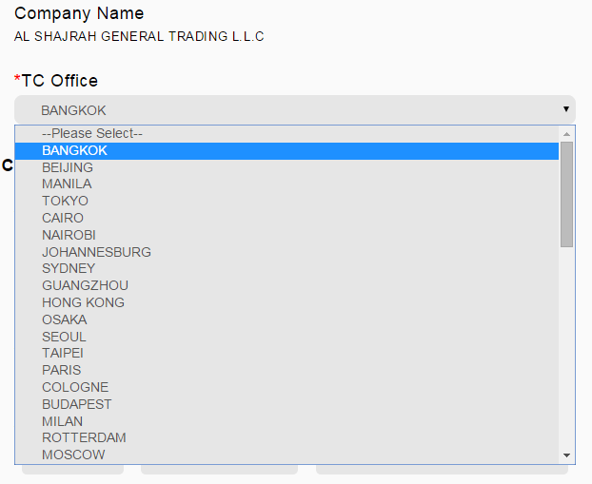

1. To add button Next or OK after select company name.

Remarks : already discussed with user, and found the real issue is that not all foreign company list can be clicked/selected.

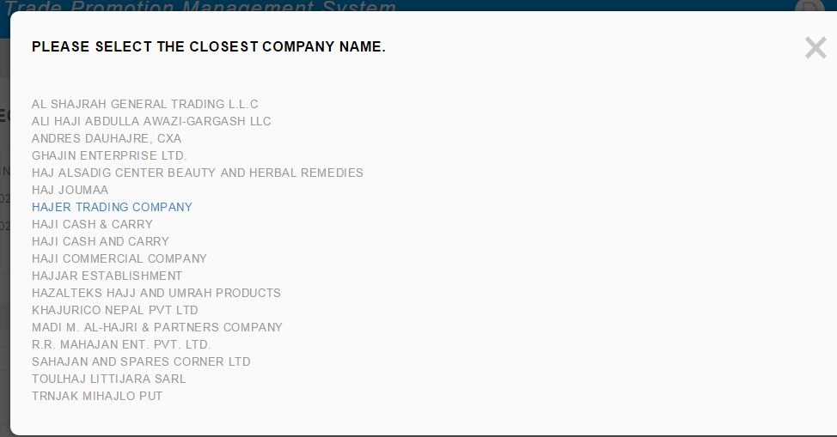

Only can choose first company, others cannot select

1. For product – to auto cap for product description

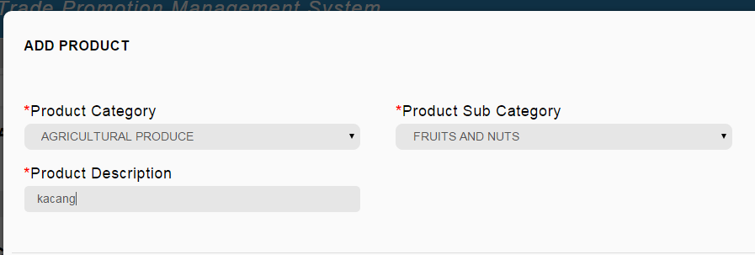

When to add another product, the page ADD PRODUCT must be empty. Must clear the previous data

1. Setup business meeting – manual matching

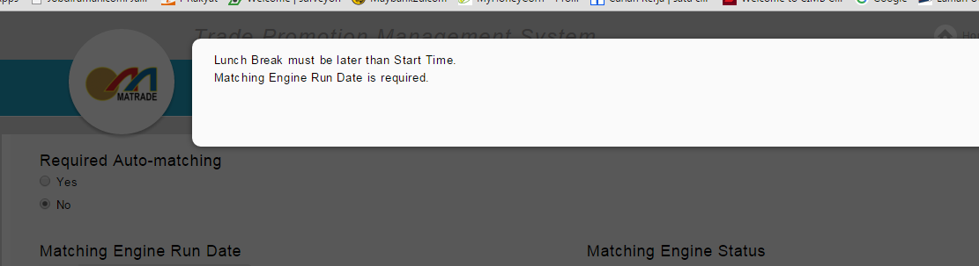

Select No for Required Auto-Matching, but system ask to set Engine Date