Check Digit

Computation of Check digit for SESCO Contract Account Number

- Multiply the basic contract account number with numbers 2, 3, 4, 5, 6, 7 from the right to left (from right means from the last digit before the check digit).
- Add the product together and divide it by 11.
- The remainder is the check digit.
- The check digit is ‘0’ if the remainder equals to ‘10’

Example:

Basic Contract Account Number | 2 | 0 | 1 | 0 | 1 | 2 | 9 | 3 | 3 | 1 | 1
Multiply | 6 | 5 | 4 | 3 | 2 | 7 | 6 | 5 | 4 | 3 | 2
Product | 12 | 0 | 4 | 0 | 2 | 14 | 54 | 15 | 12 | 3 | 2
Add the Product | 12 | +0 | +4 | +0 | +2 | +14 | +54 | +15 | +12 | +3 | +2 | =118

Divide sum by 11: 118/11 = 10 remainder 8
The check digit is 8.

Some example:
1) Contract Account Number: 20101294310 - the check digit is 0.
2) Contract Account Number: 20108626912 - the check digit is 5.

Current IBAM SETTING :

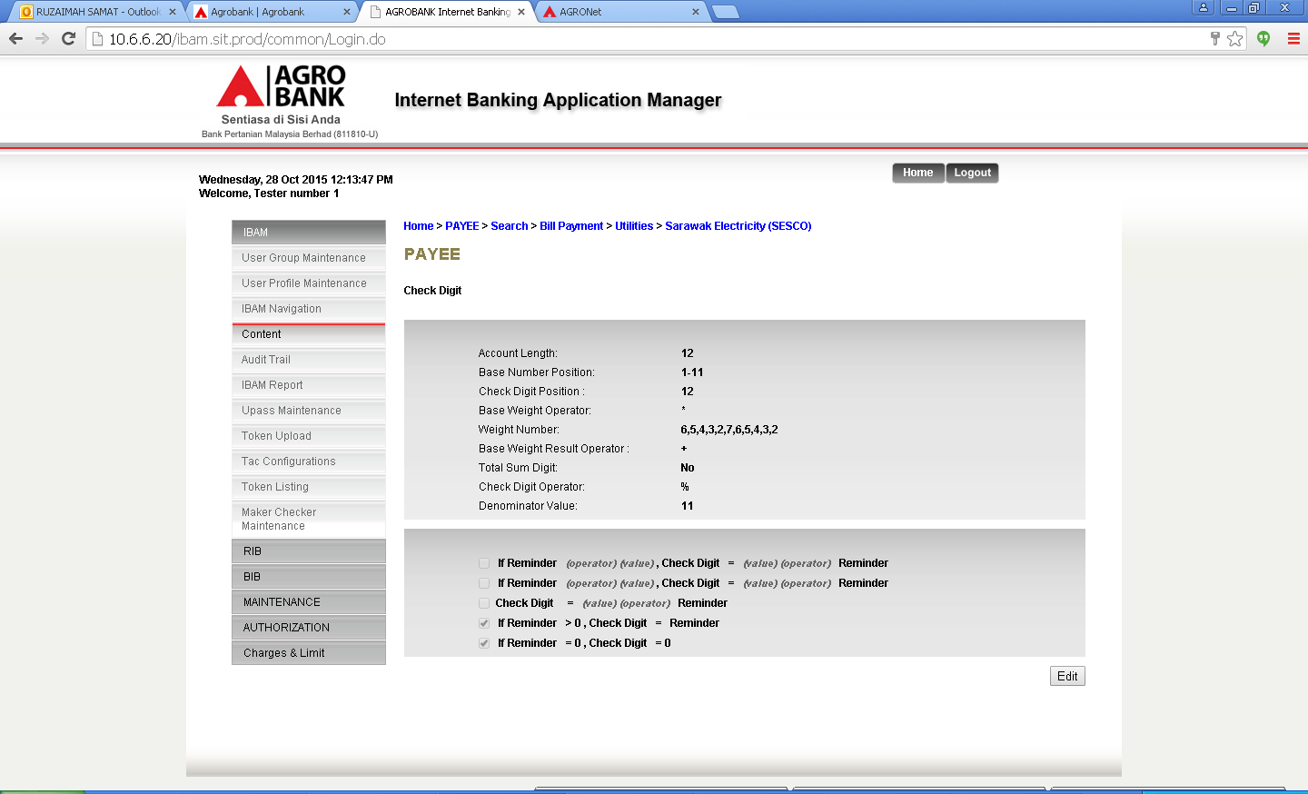
PERFORM AT RIB – Invalid Bill Account No

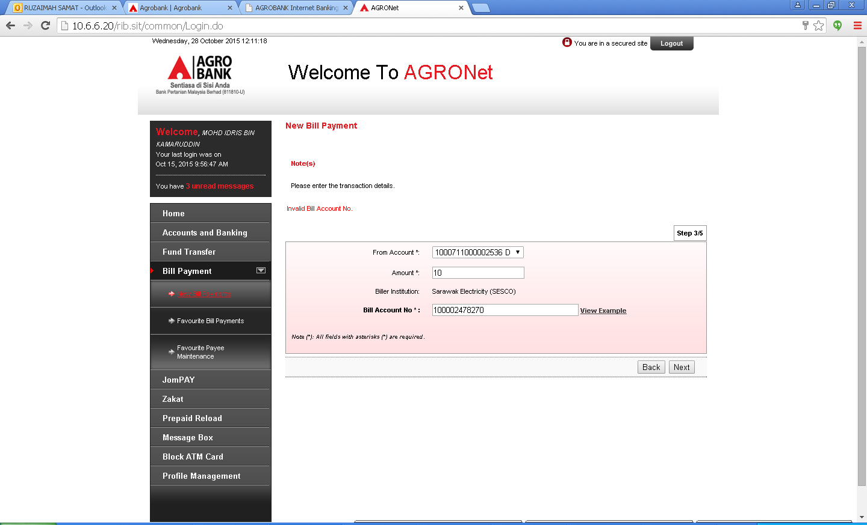

Calculation
Basic Contract Account Number | 1 | 0 | 0 | 0 | 0 | 2 | 4 | 7 | 8 | 2 | 7
Multiply | 6 | 5 | 4 | 3 | 2 | 7 | 6 | 5 | 4 | 3 | 2
Product | 6 | 0 | 0 | 0 | 0 | 14 | 24 | 35 | 32 | 6 | 14
Add the Product |  |  |  |  |  |  |  |  |  |  |  | 131
Divide sum by 11: |  | 131/11= | 10
The check digit is 0.

ROOTCAUSE :

Condition : The check digit is ‘0’ if the remainder equals to ‘10’

Incorrect value for below setting – should be Reminder = 10

SIT –

Change : If Reminder = 10, Check Digit = 0

