Bug 1.1 - Employer EPF No is not hide when click button clear button
1)Select service = EPF
2) click clear button
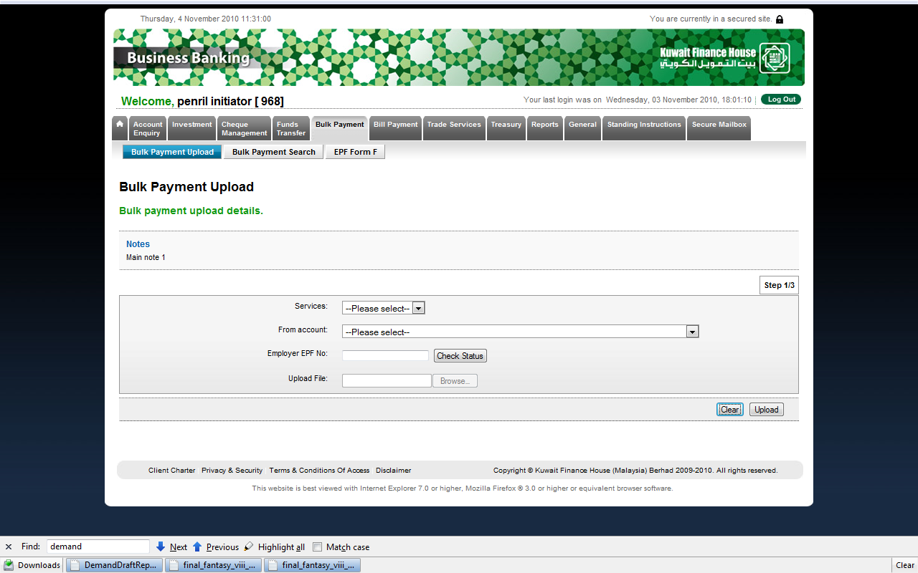

Bug 1.2 - Employer EPF No should numeric or alphanumeric.

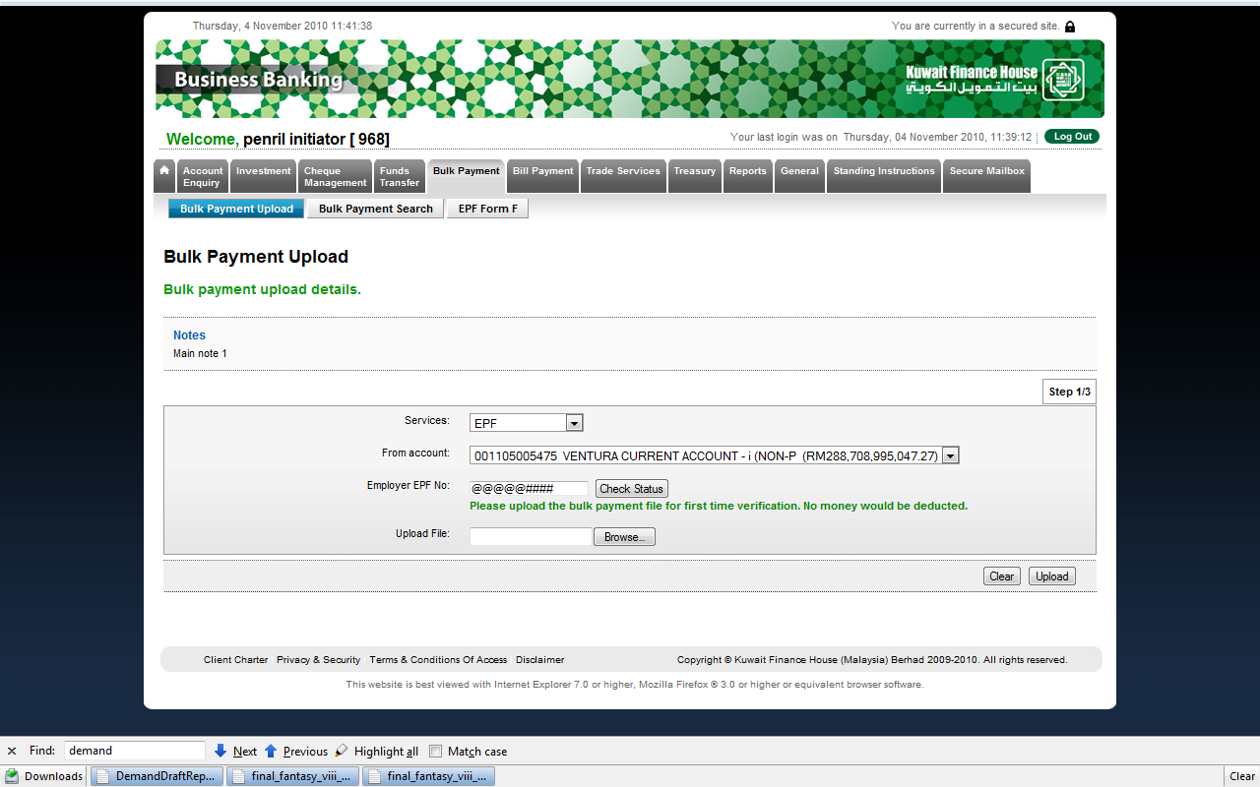

Bug 1.2 - Employer EPF No should required

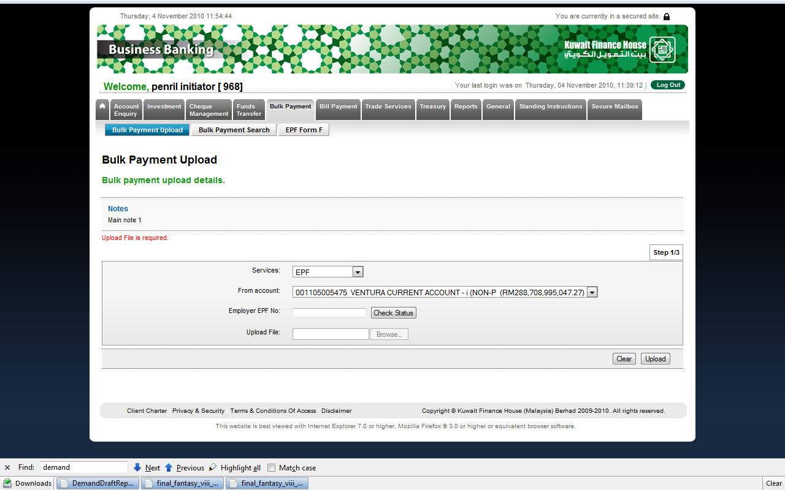

Bug 1.3 – Still throw error even transaction has rejected by verifier
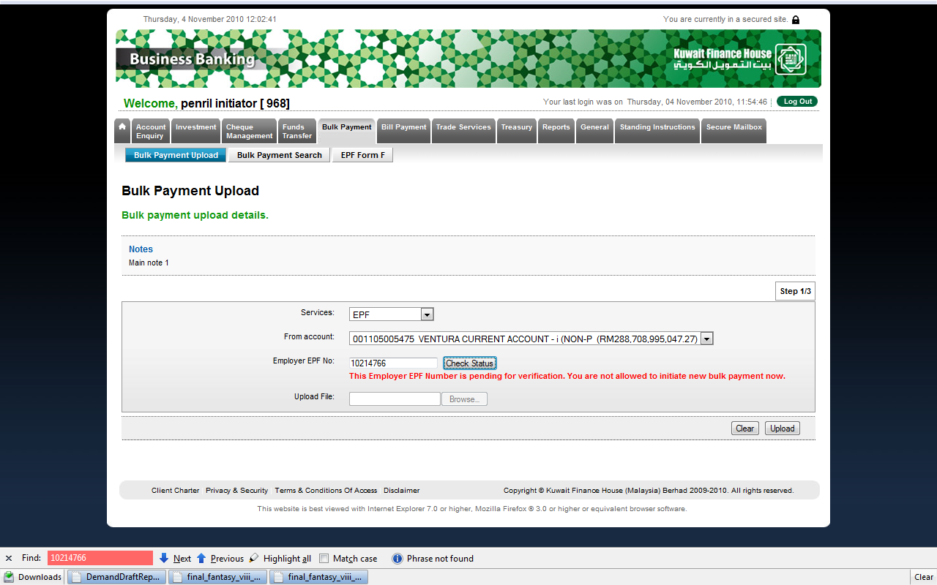

Upload file
Contribution Month : 000000
Contact Person Name : zxczxc ._32423423(BRS = Alphabet , System = alphanumeric, space, dot and underscore) which one is correct
Contact Phone No : werewrwer23432432 _.(BRS = Numeric , System = alphanumeric, space, dot and underscore) which one is correct
Payment Type : empty (required field)

Amount : 200000000000.00 (BRS = 12.2 , System = 10.2)

Bene IC / ID / Registration No : Empty (required field)

Bene IC / ID / Registration No : wer ._234 (BRS=alphanumeric space, dot and underscore , System = alphanumeric )

Beneficiary Name : wer ._234 (BRS=alphanumeric space, dot and underscore , System = alphanumeric )

Bug 1.4 – only have one record
P,,,,100.00,100.00,,,,,,,,,,,

