Default Function enable

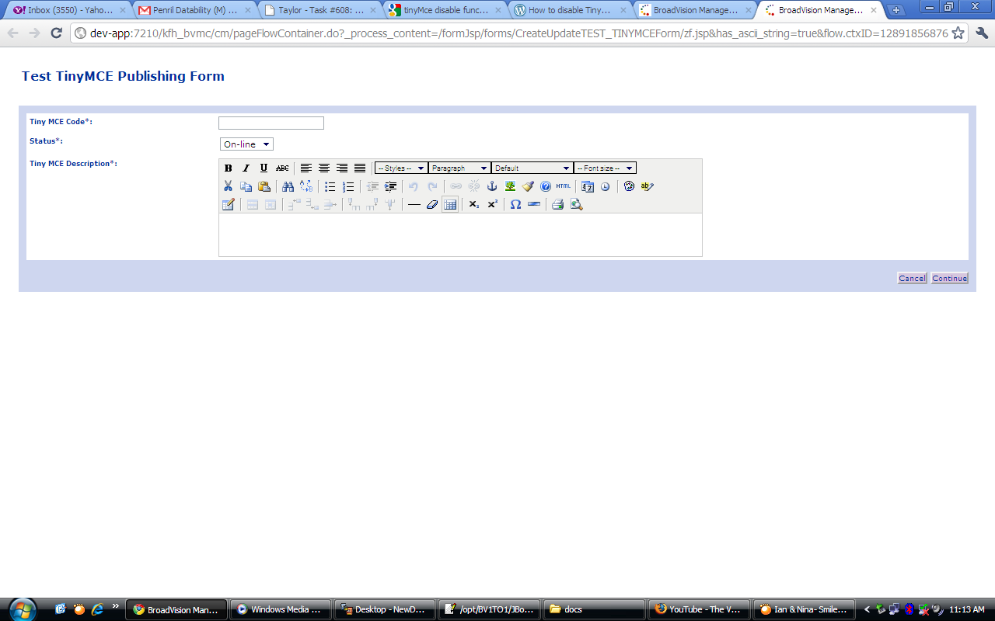

After disable certain function (Bold, italic, underline, Strikethrough & Insert/editimage)

