**Post Event – Programme Feedback**

**General (apply to all programme type)**

1. To include event date

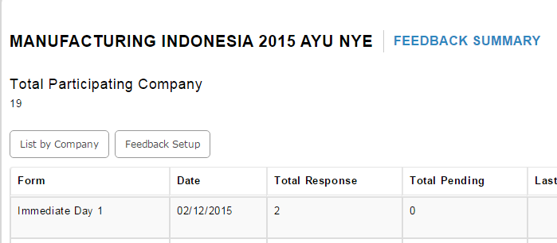

1. To modify printing format

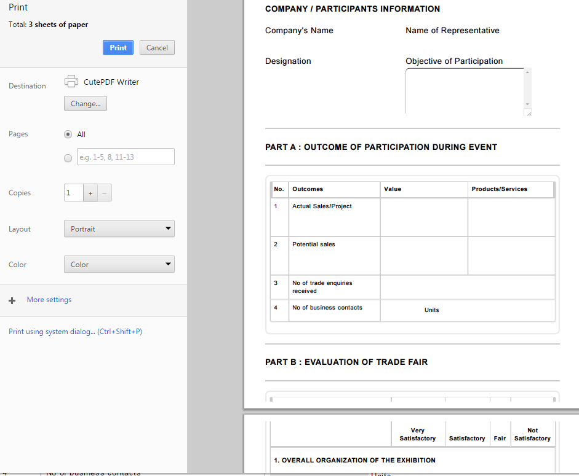

1. Follow up Feedback form 🡪 To add Yes, No and modify Note: If YES, please specify

* TPMS

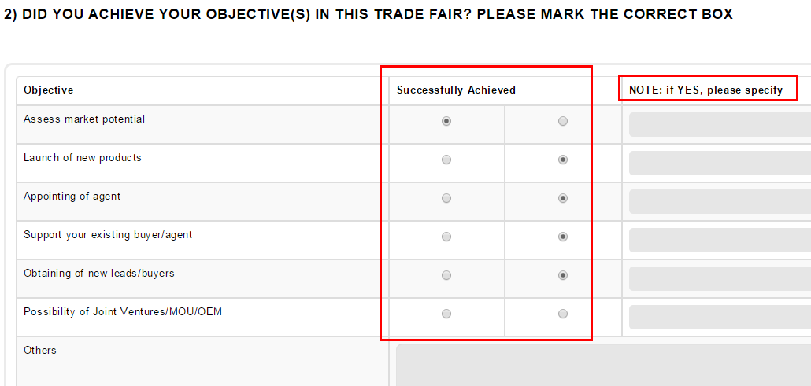

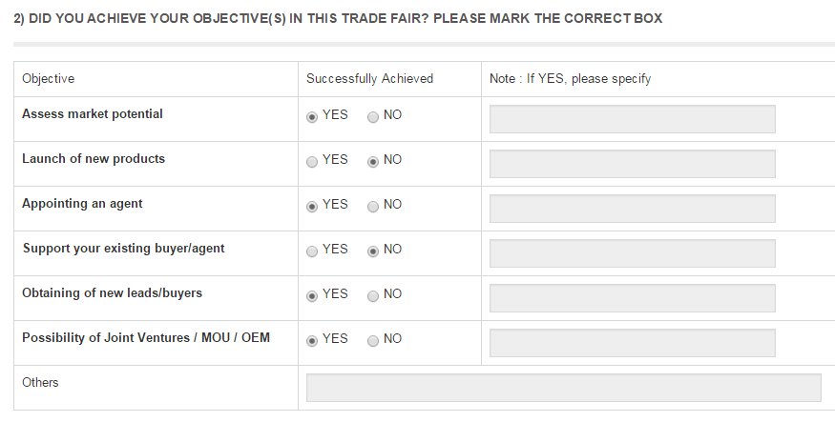

1. Follow up feedback form 🡪To modify

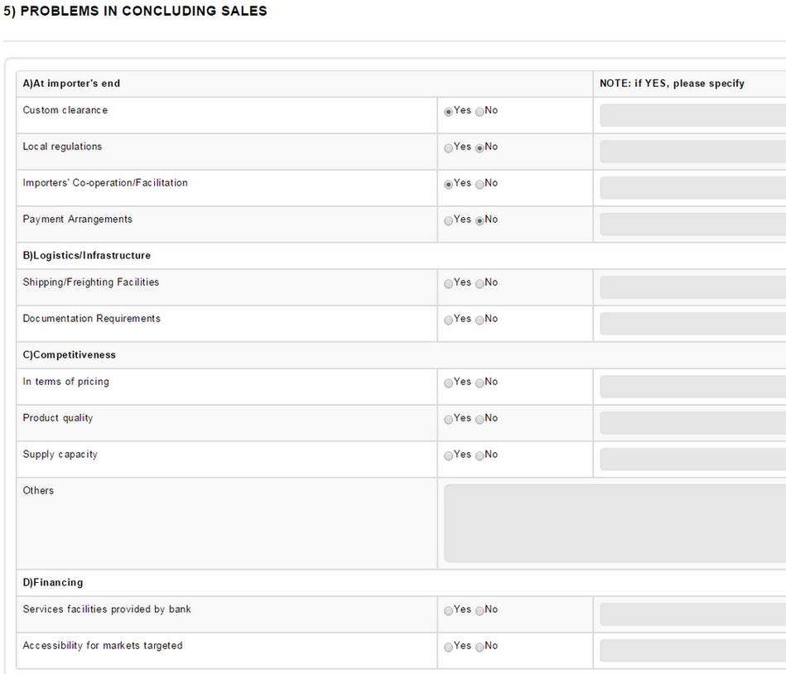

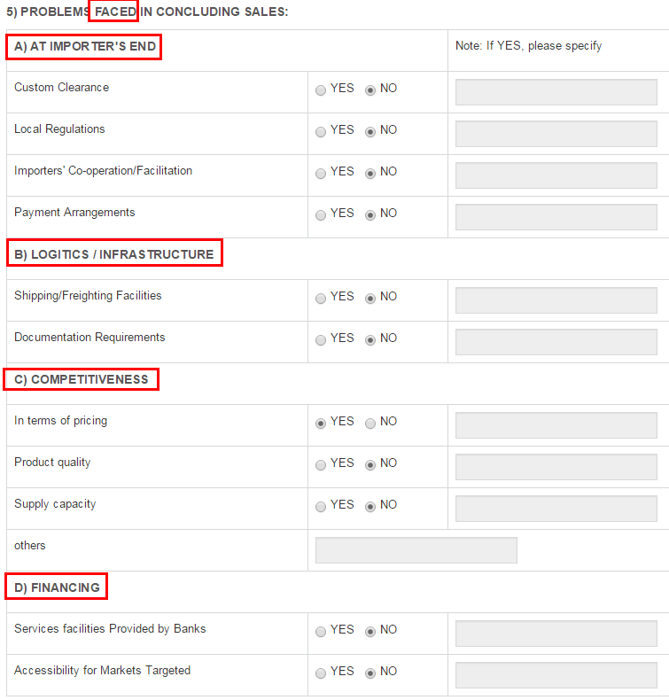

1. Follow up 🡪 To modify the wording

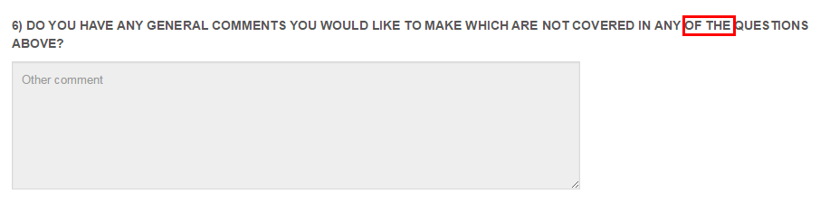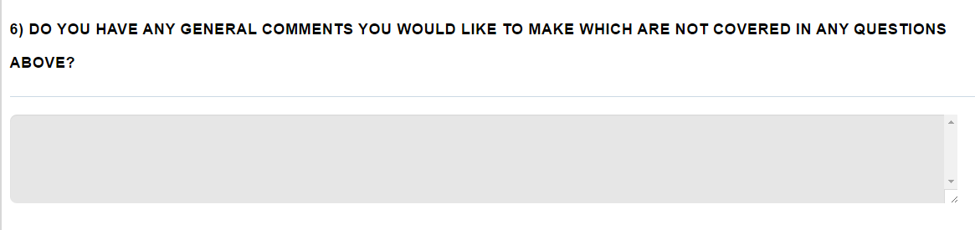

1. Kecil kan size font – follow size and change 2013 to 2015

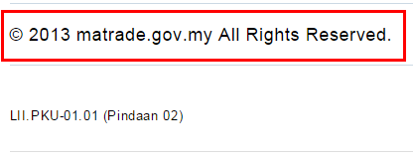

1. Cannot send manually – display error. The feedback must able to sent manually if did not set auto sent reminder or auto sent notification---apply to all follow up (refre URS MRP025)

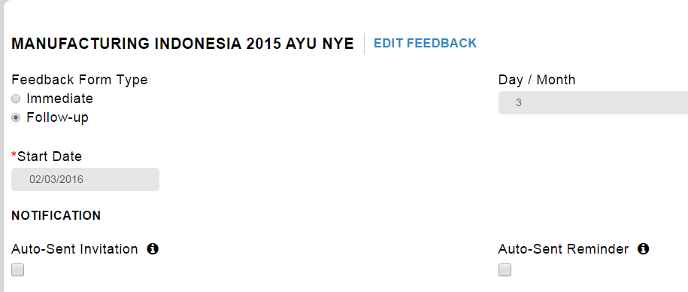

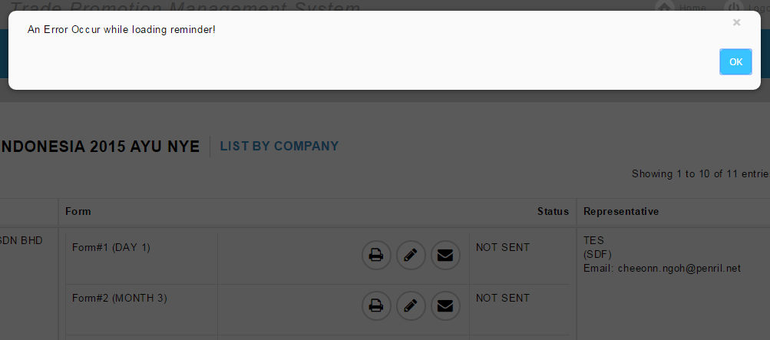

1. The system should allow PO to select representative’name and email when to sent follow up or immediate feedback form- refer URS MRP025

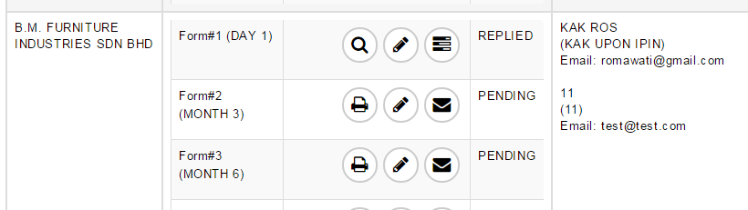

1. Link follow up feedback form not appeared and MATRADE logo not display – certain follow up feedback form

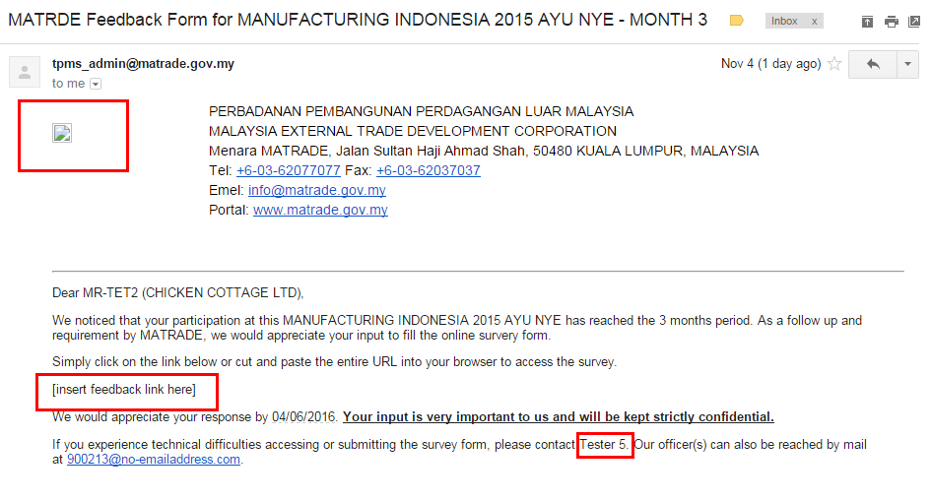

To amend word MATRDE to MATRADE

1. After copy and paste the link or direct click the link , the feedback form is not display nicely. But after refresh the link, the feedback form is ok.

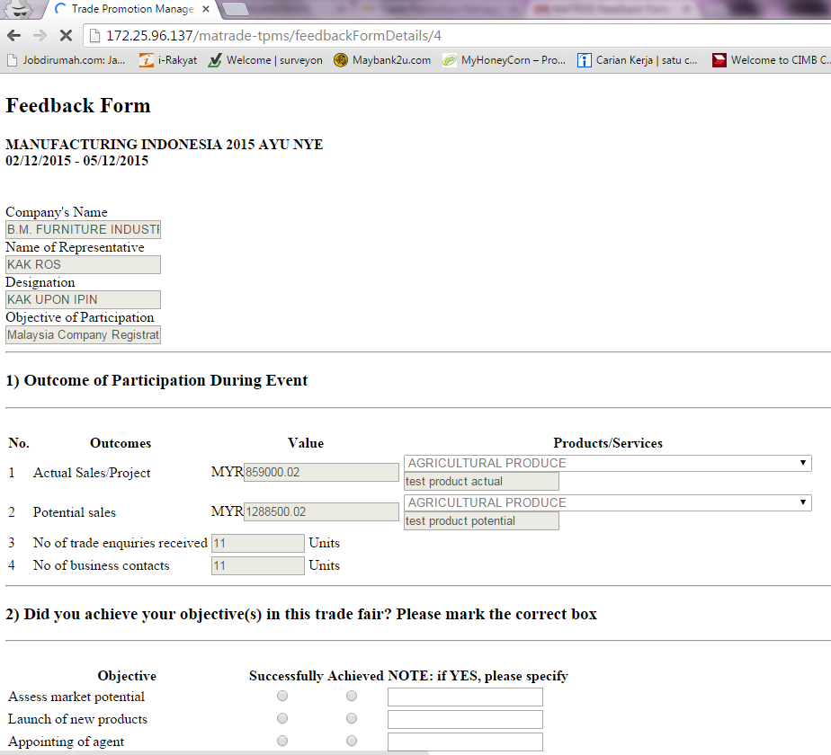

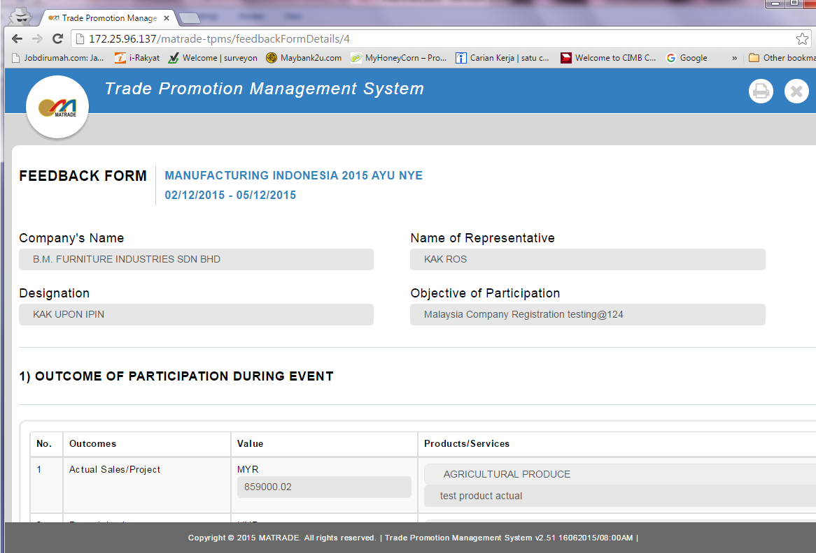

1. For Add Officer Remark , the currency rate not captured.

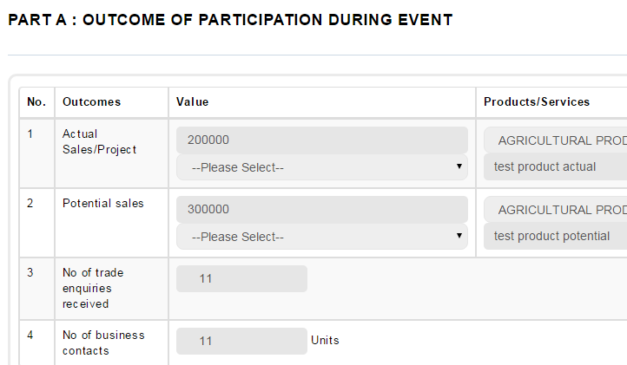

1. To amend – refer current Feedback System

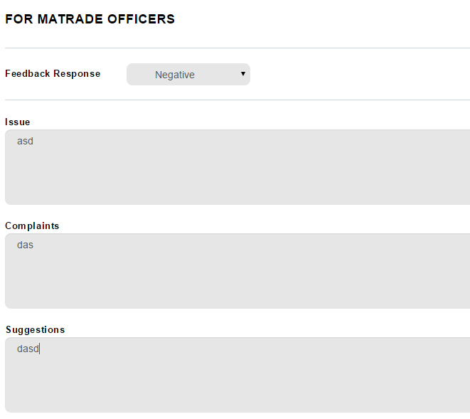

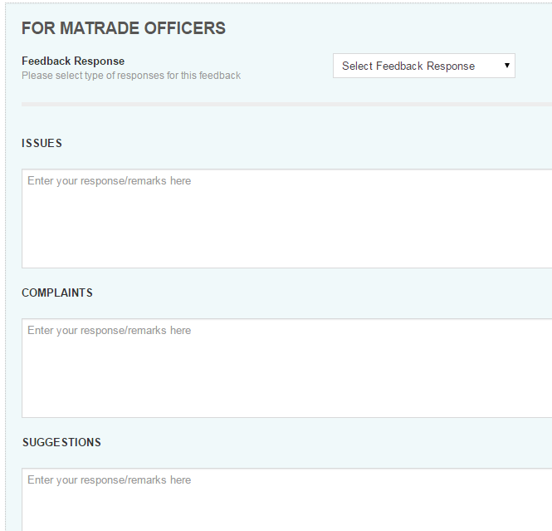

1. Currency rate – sale for immediate and follow up (for all) should be displayed same currency.

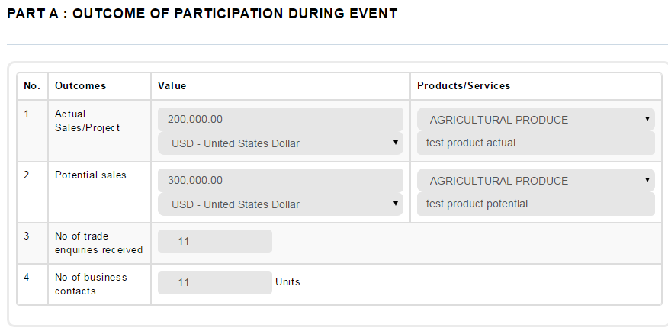

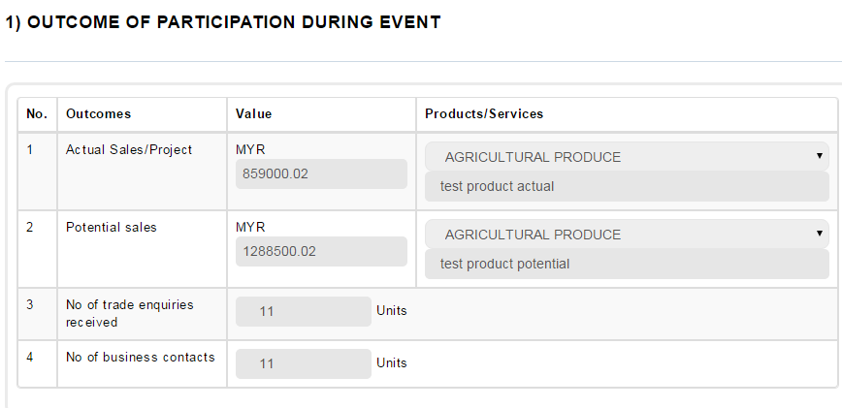

1. All questionnaires should be empty for all new follow up.

