**REPORT**

**Trade Fairs – Total Sales By Event – must be in RM, letak RM dalam header**

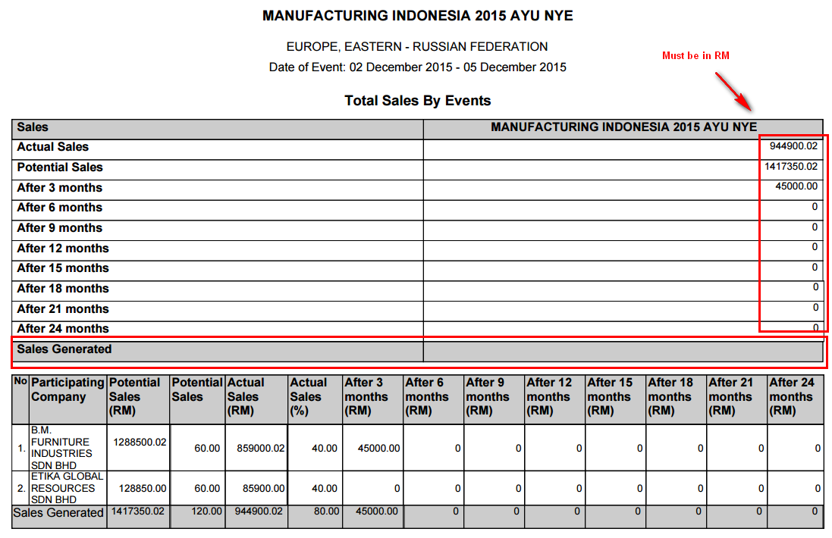

**Trade Fairs – Total Sales By Product/Service – bulan tak ikut susunan**

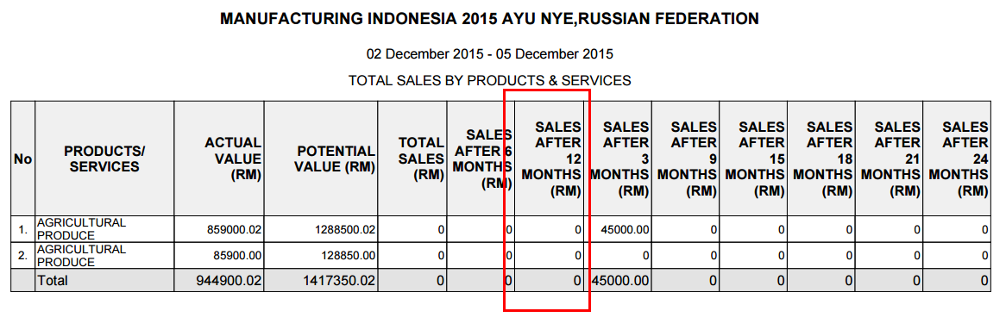

**Trade Fairs – Total Sales By Country – tak ada programme type dalam Choose Report**

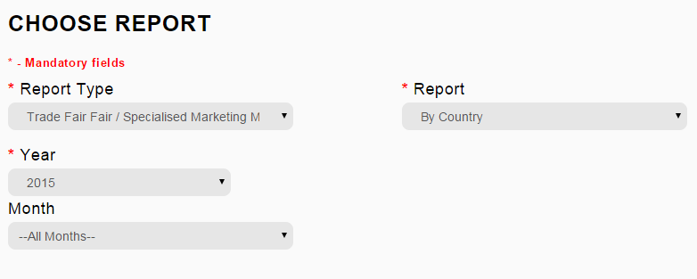

**After submit, baru boleh select Programme Type dan boleh select Year**

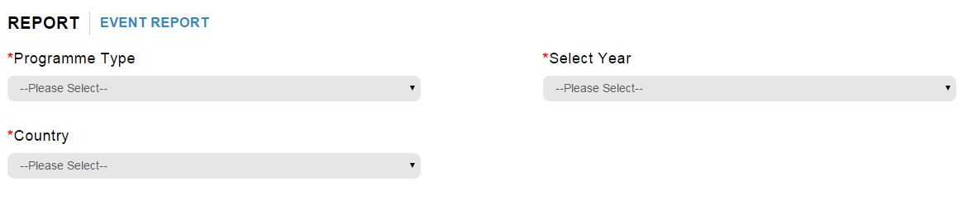

**List country kena sort by alphabetical order**

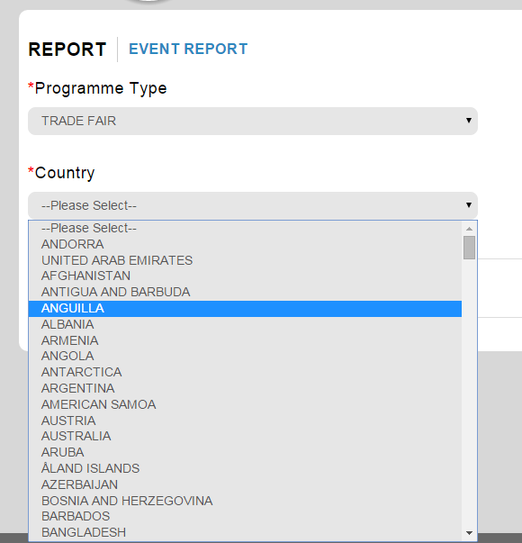

**Trade Fairs – Total Sales By Country – bulan tak ikut susunan**

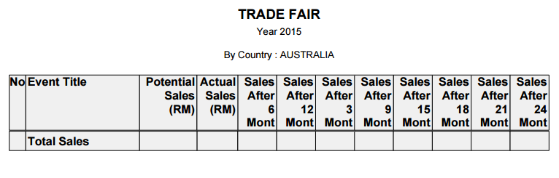

**Trade Fairs – Summary of Event – maklumat Representative tiada**

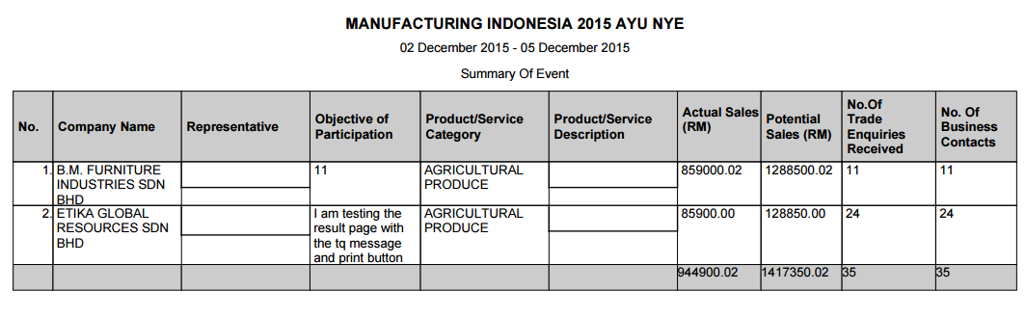

**Trade Fairs – Evaluation by event – must display description not number**

