**Register Buyer Details Page**

To change representative into table

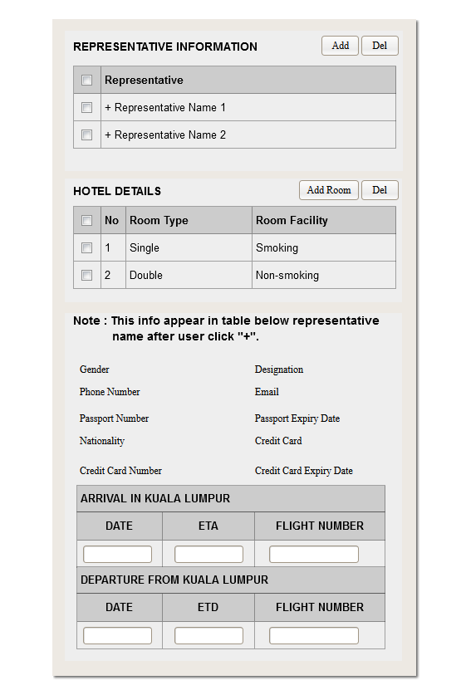

Click on Representative Add button, system will display Popup Representative Information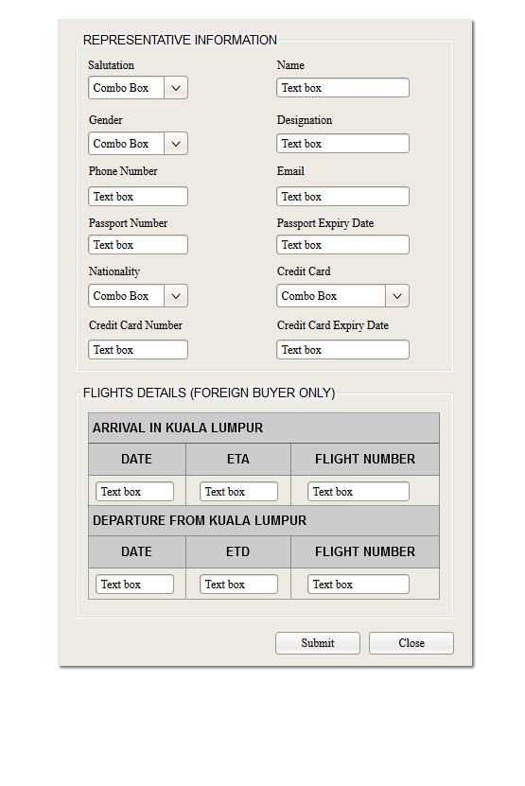

Click On Add Room Button, display Pop up Hotel Details

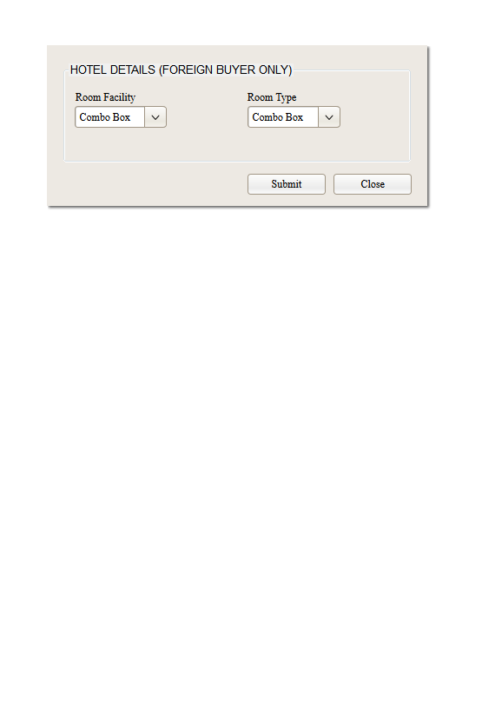

**Register Buyer View Page**

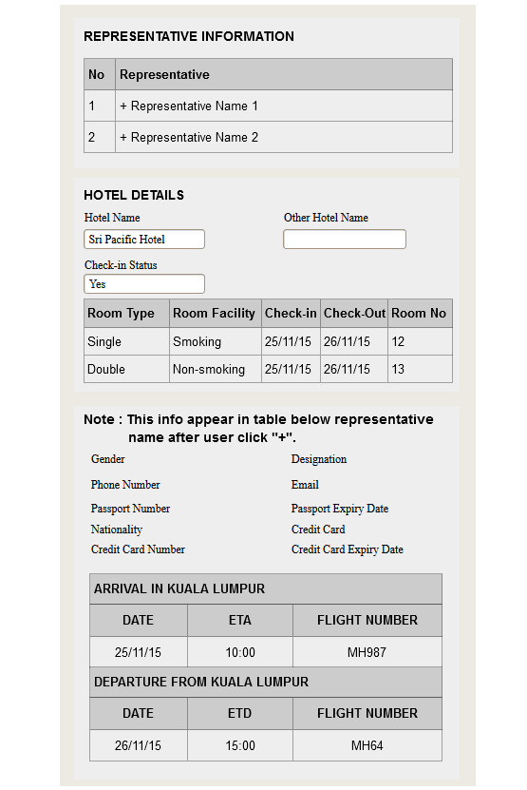

**Register Buyer Edit Page**

