Test Issue Log |  |  |  |  | TIL No.: URF-14-12-163
Project Name: | Conditional Sign-Off IBSCR068 & IBSCR072
Test Stage: | Unit Functionality Integration System Interface  Performance Regression Acceptance Pilot
Test Case Number: | IBG-049 |  |  | Test Started Date: |  | 25/06/2015
Test Title: | BIB EPF- Inaccurate Description
Test Description: | Issue #049 To ensure the Transaction Description for EPF Other Payment in BIB follow the user requirement.  Sender’s Account – To append Payment Code, EPF Number
Test Functionality: | BIB  - Bulk Payment  - EPF Other Payment (Form F, Late Charges Payment, Dividend Loss Payment, Other Charges  - Bulk Payment Upload File
Test Procedure: | EPF Other Payment  - Perform EPF Other Payment (Form F, Late Charges Payment, Dividend Loss Payment, Other Charges) for BIB  - View Transaction Description in Transaction History  Bulk EPF Upload  - Login as Initiator/Init + Veri/Approver All>Perform EPF Bulk Upload> Confirm  - Login as Verifier> Verified Transaction> Confirm  - Login as Approver > Approved Transaction> Confirm  - View Transaction History & Print receipt
 | Pass: Fail: Conditional Pass: |  | Tested by: |  | Leonard Lim & Nurul Akmal Yusof
Reason for Failure:
TEST DESCRIPTION
IBG-049: BIB EPF-Inaccurate Description

EPF Other Payment

Role: Approver All

Form F

Confirm Page
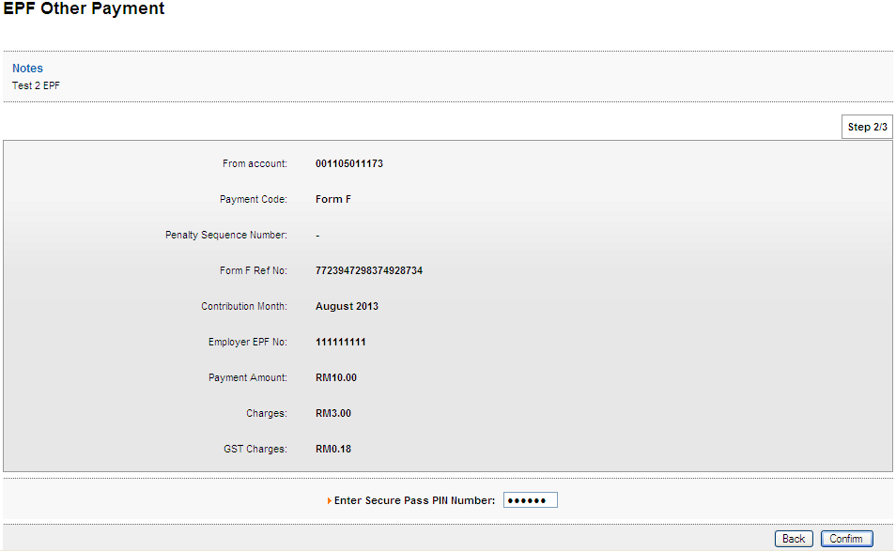

Result Page
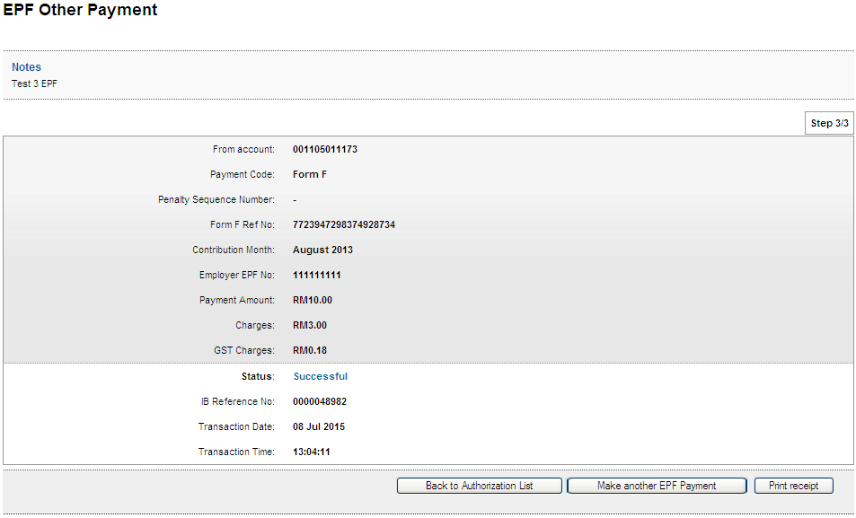
Print Receipt
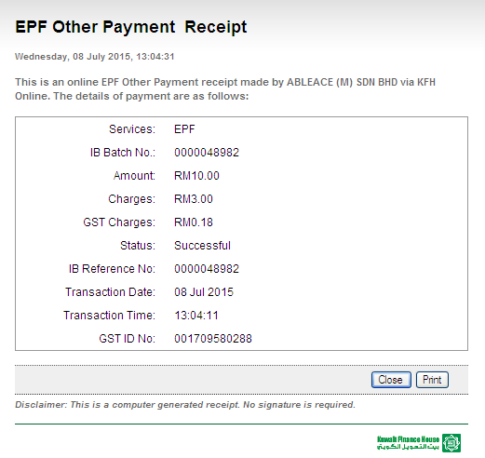
Transaction History
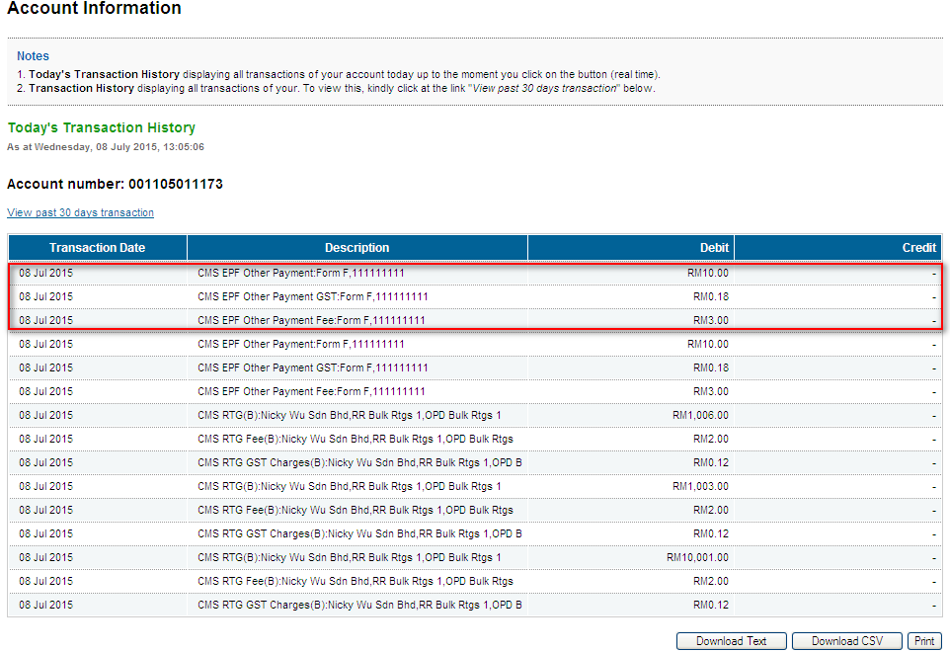

Late Charges Payment
Confirm Page
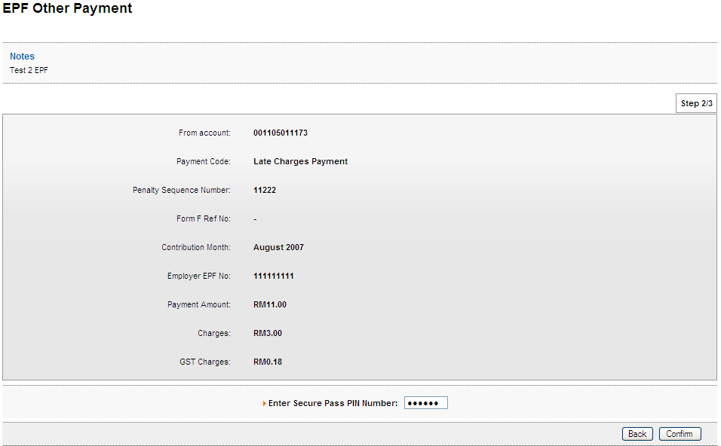

Result Page
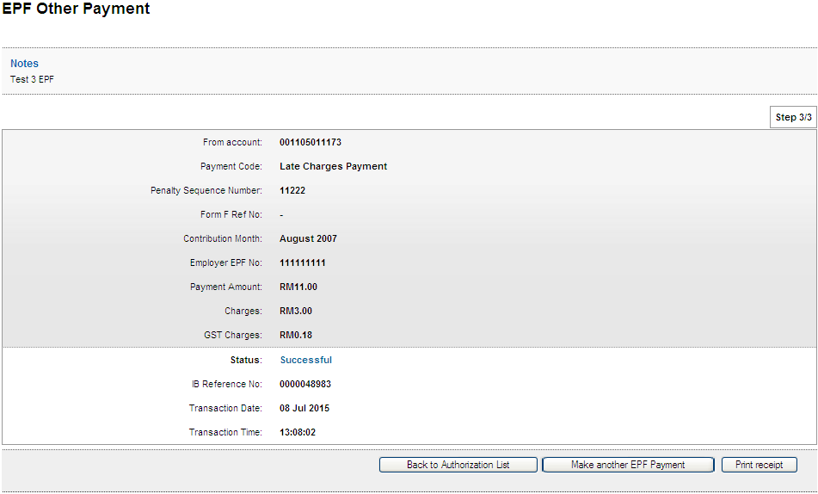
Print Receipt
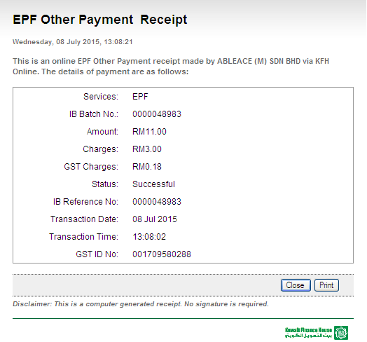
Transaction History
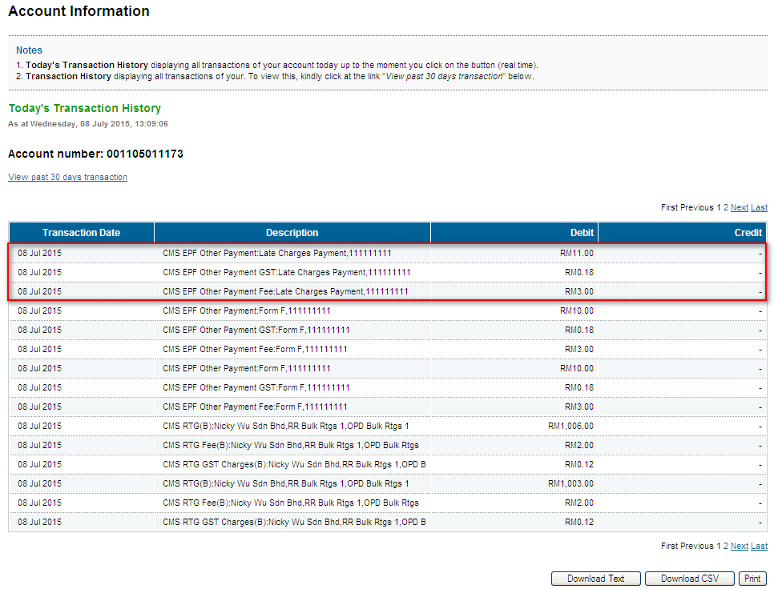

Dividend Loss Payment
Confirm Page
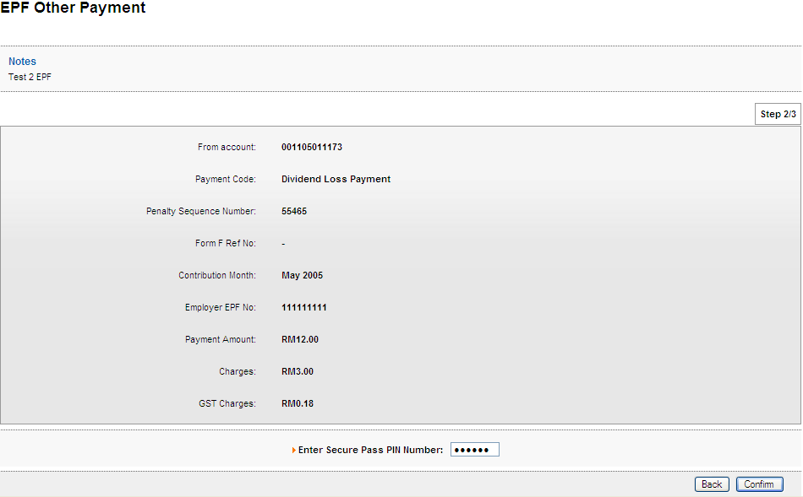

Result Page
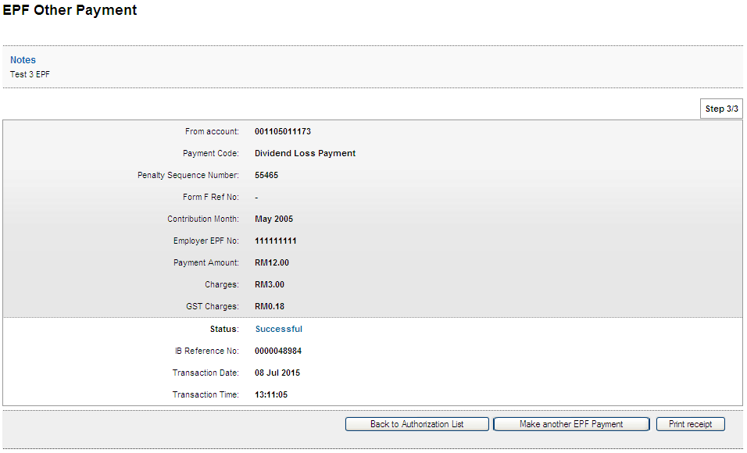

Print Receipt
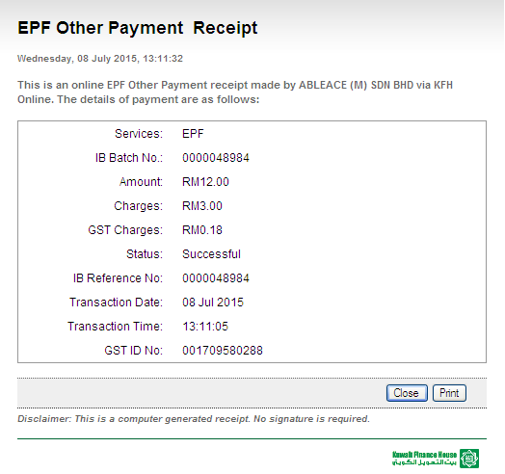
Transaction History
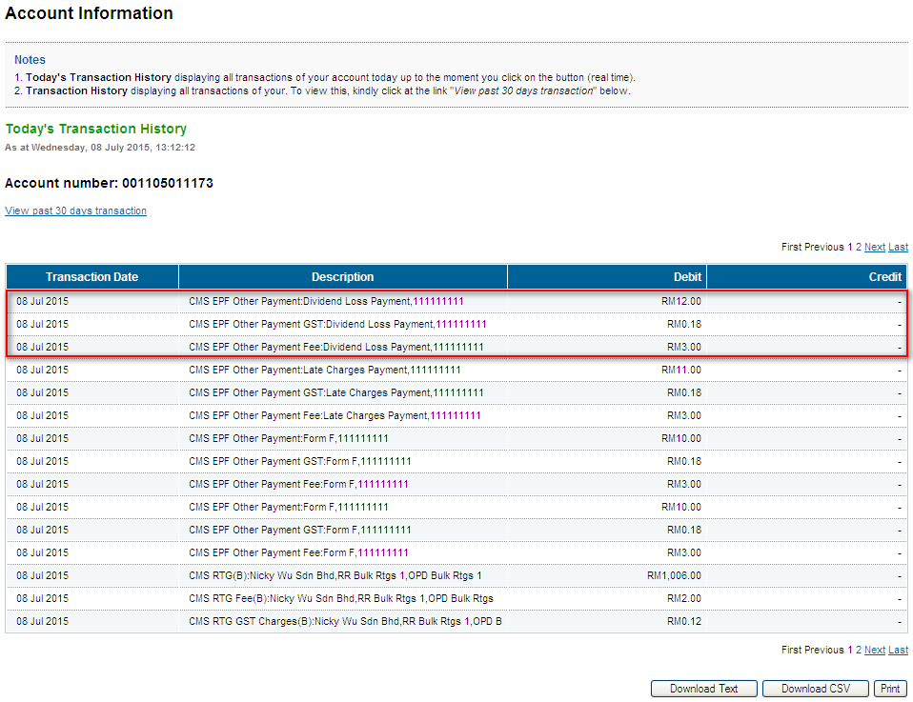

Other Charges
Confirm Page
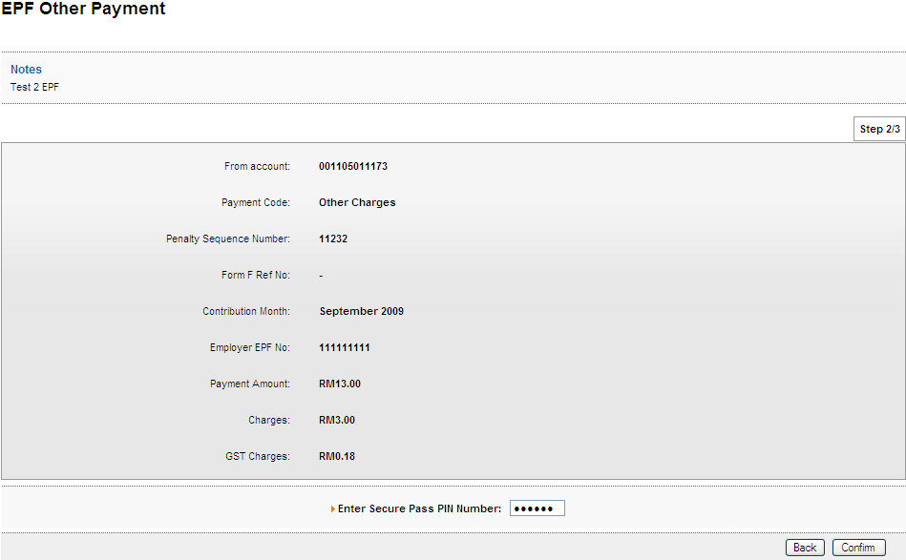

Result Page
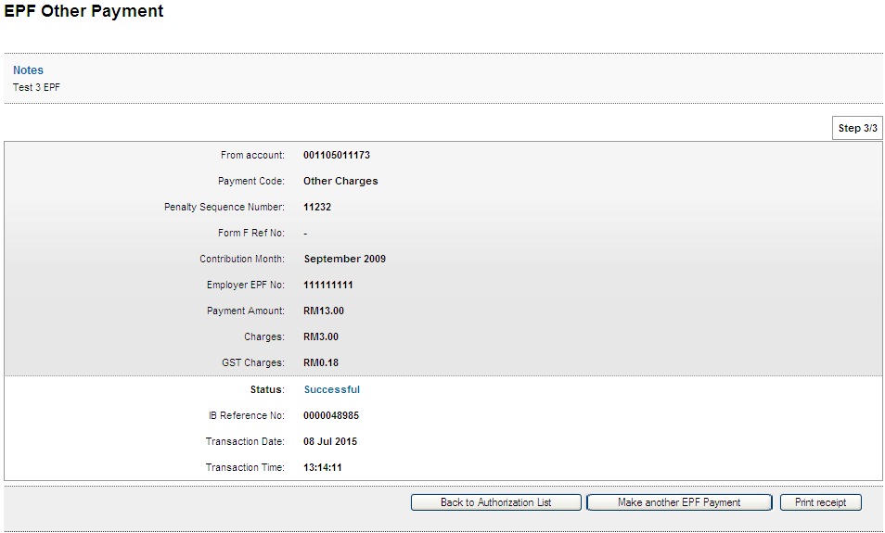

Print Receipt
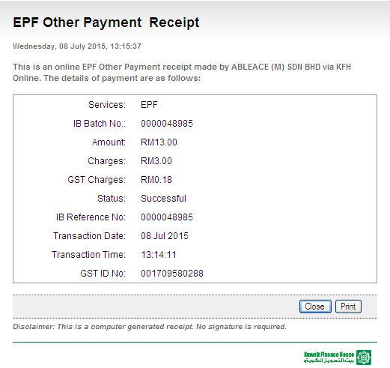
Transaction History
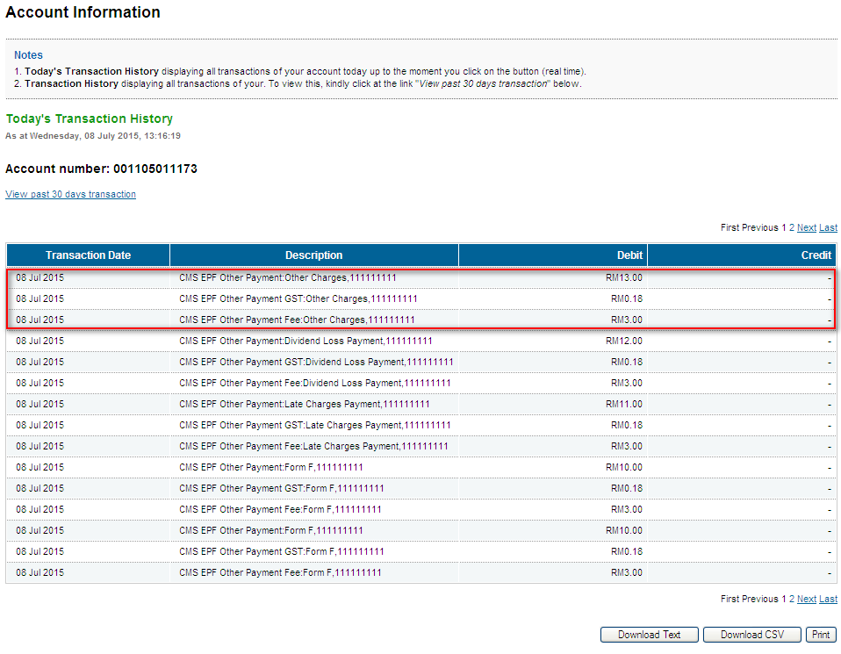

Role: Initiator>Verifier>Approver

Form F

Initiator
Confirm Page
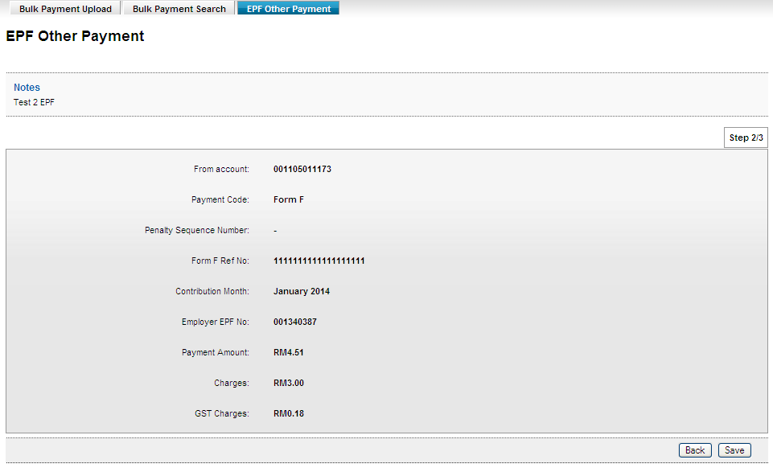

Result Page
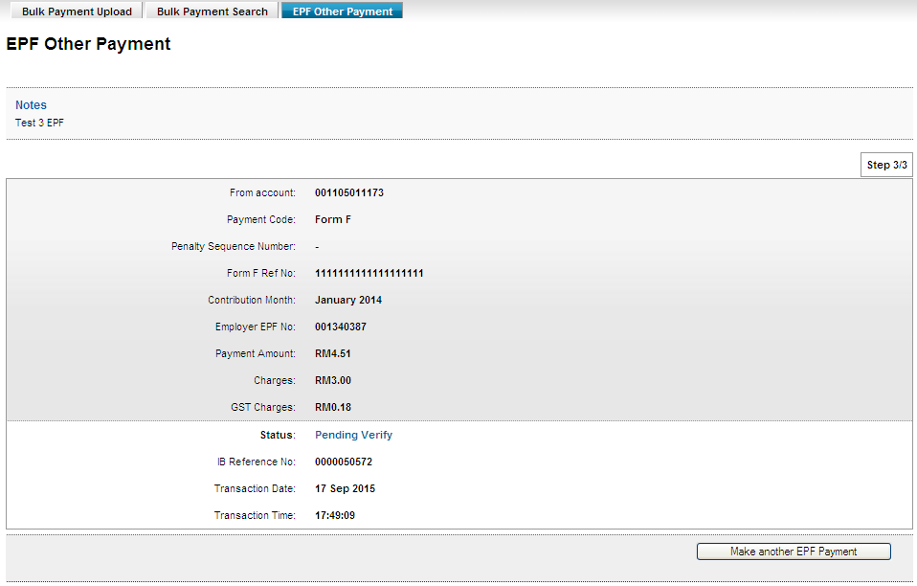

Verifier
Confirm Page
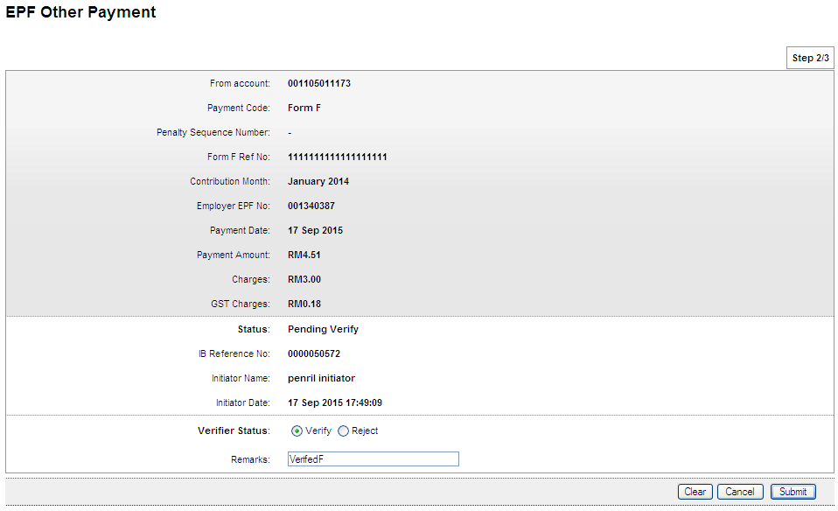

Result Page
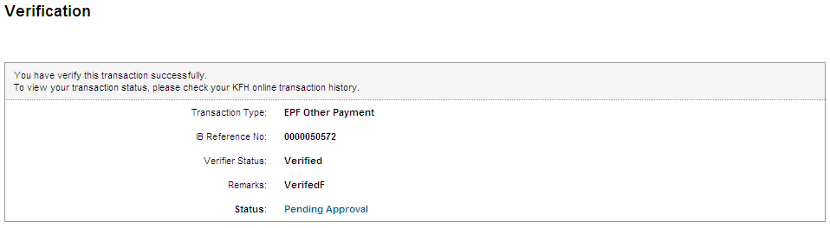

Approver
Confirm Page
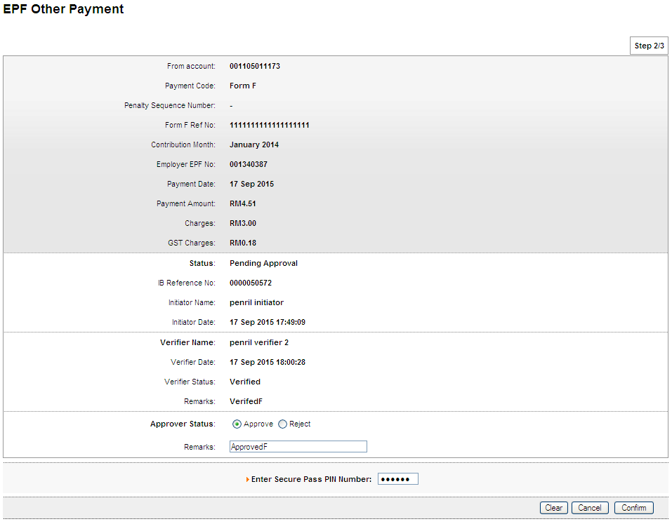

Result Page

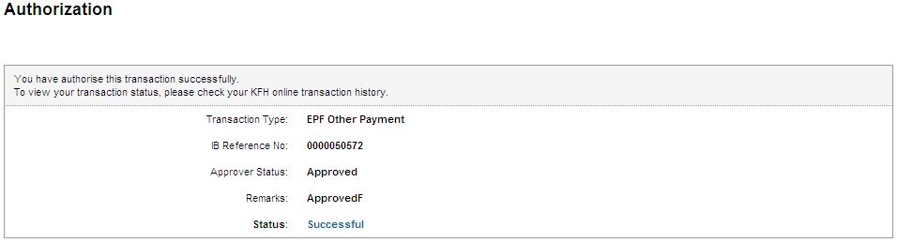

Print Receipt
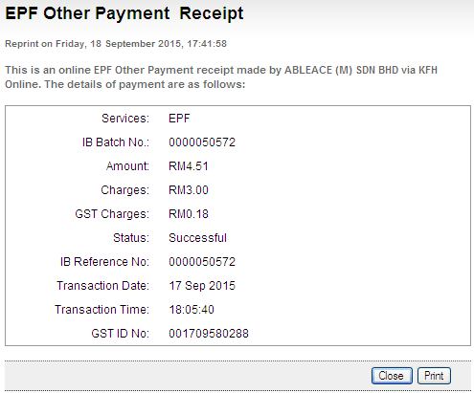

Transaction History
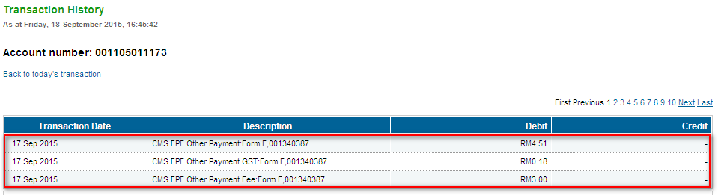

Late Charges Payment

Initiator
Confirm Page
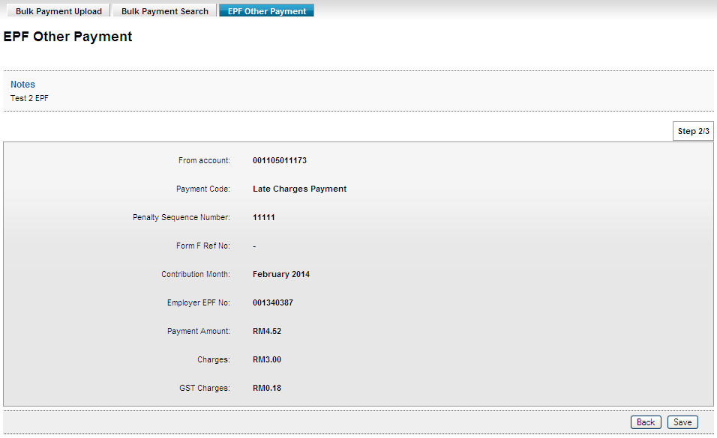

Result Page
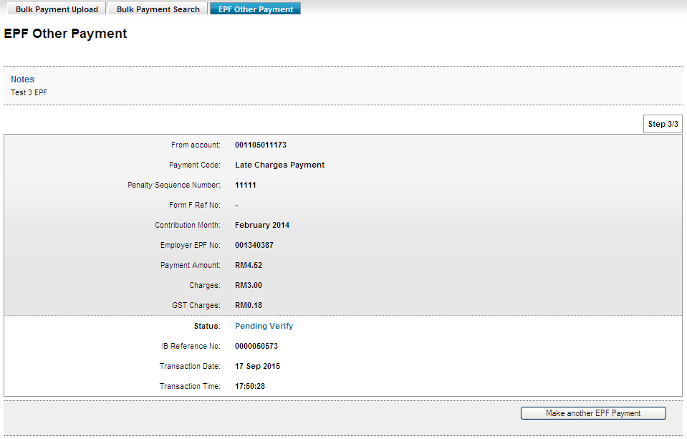

Verifier
Confirm Page
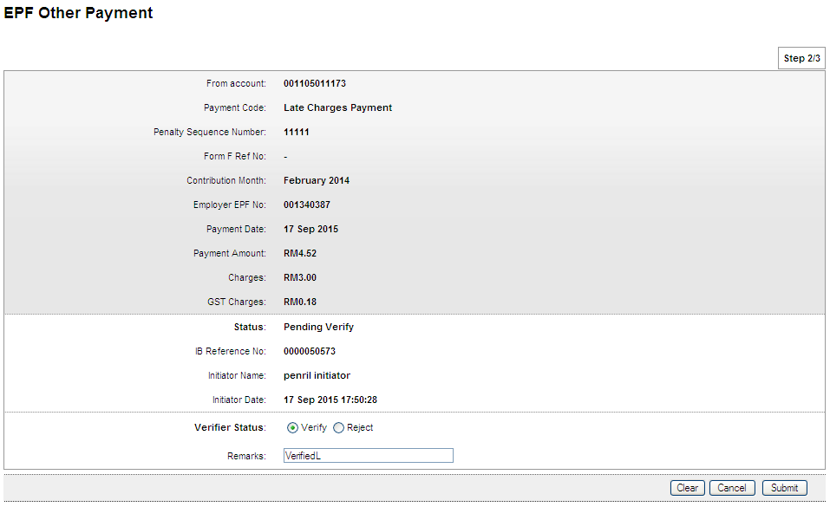

Result Page

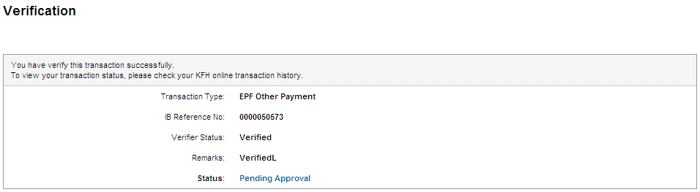

Approver
Confirm Page
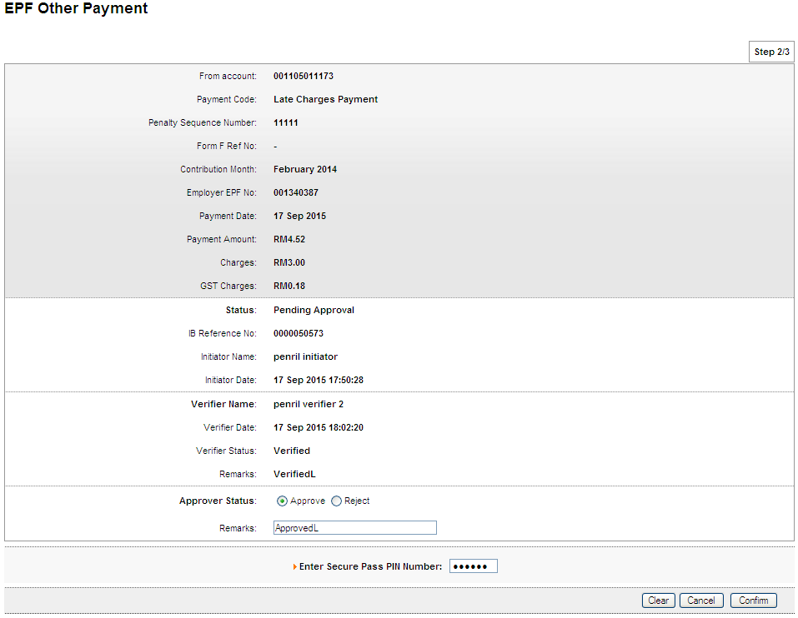

Result Page

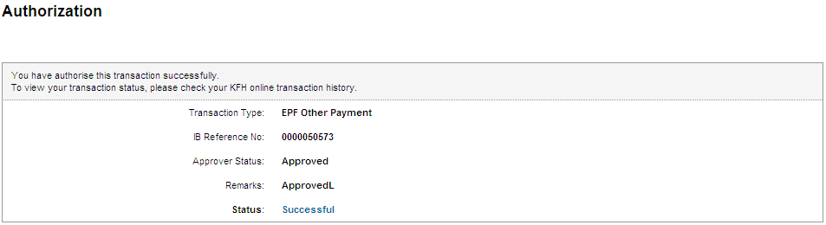

Print Receipt
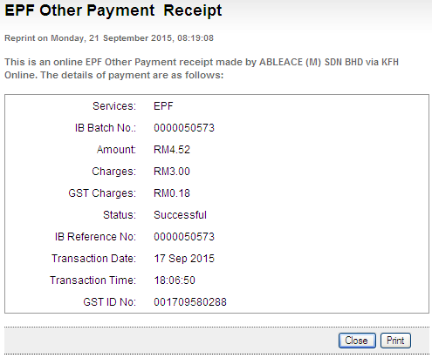

Transaction History
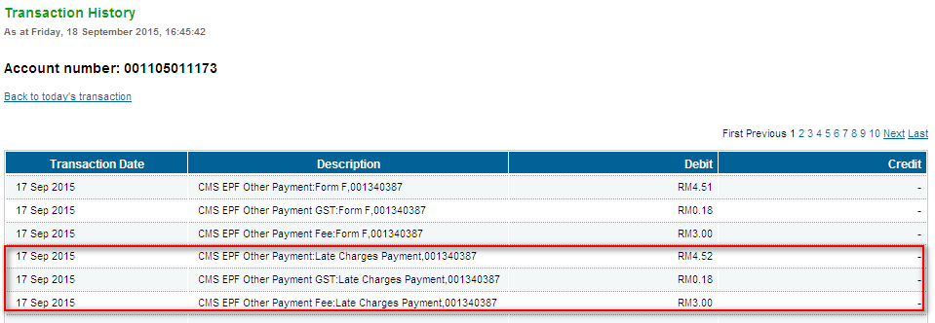

Dividend Loss Payment

Initiator
Confirm Page
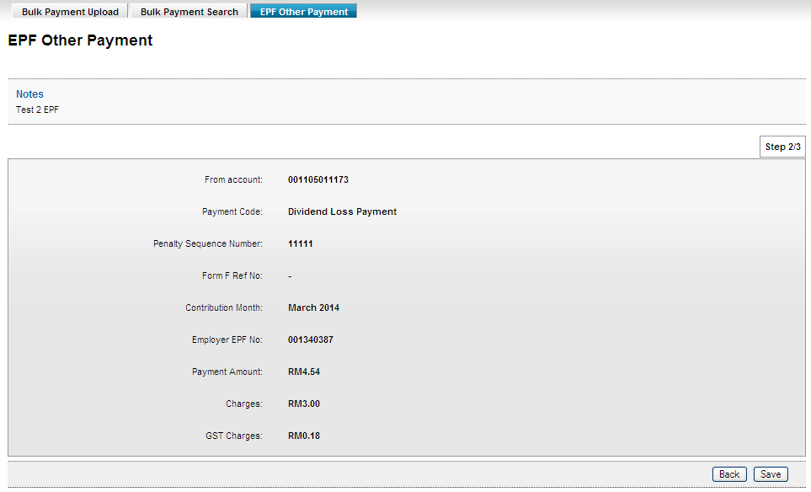

Result Page
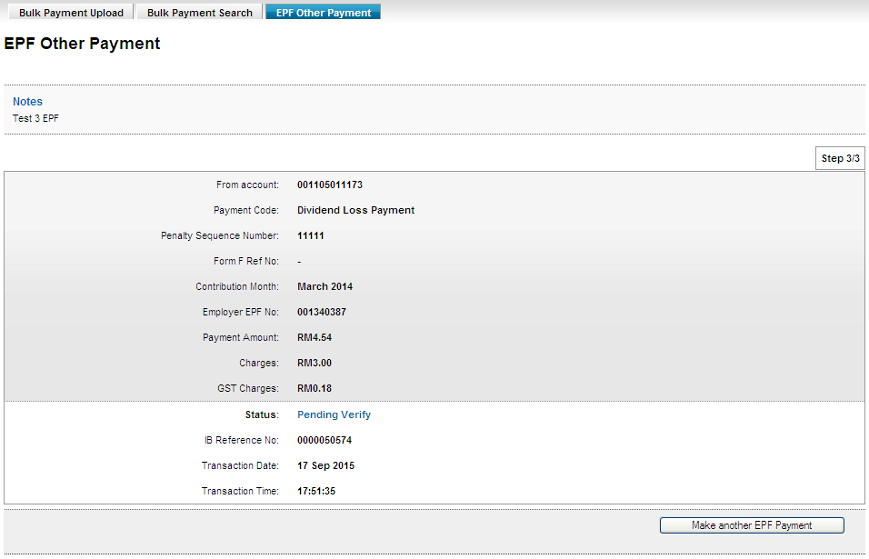

Verifier
Confirm Page
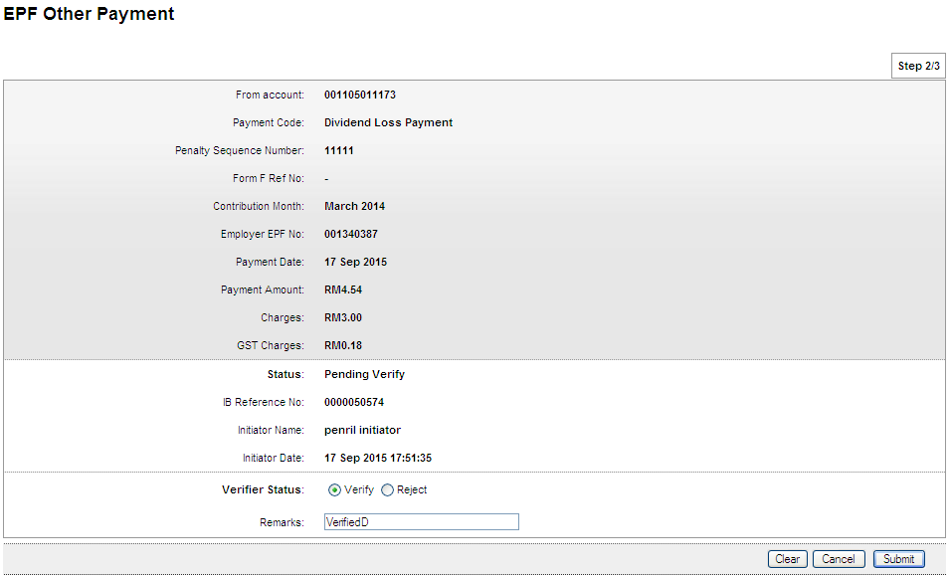

Result Page
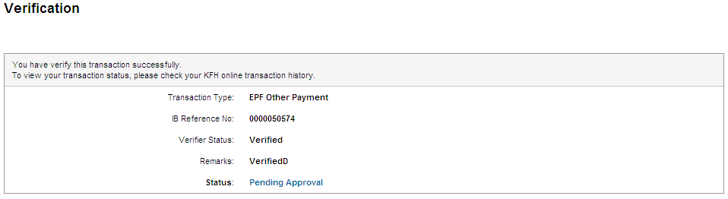

Approver
Confirm Page
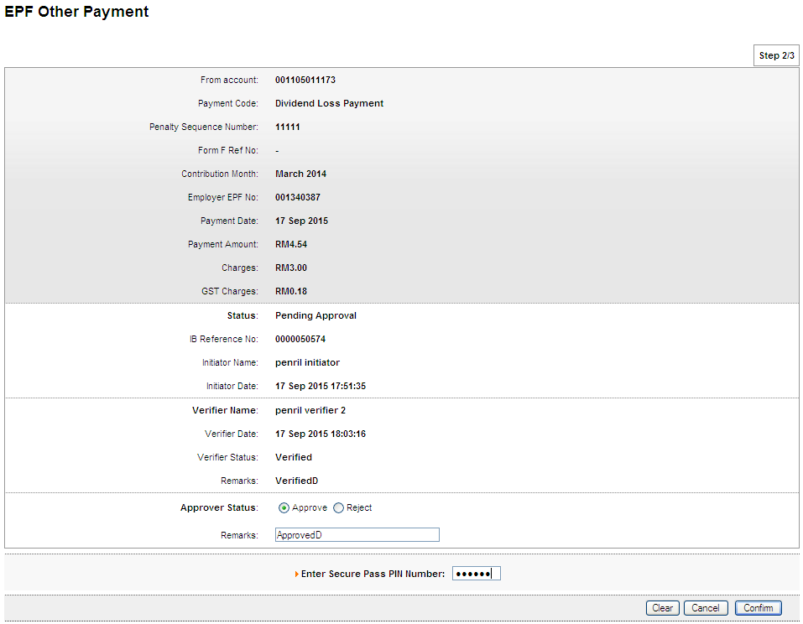

Result Page
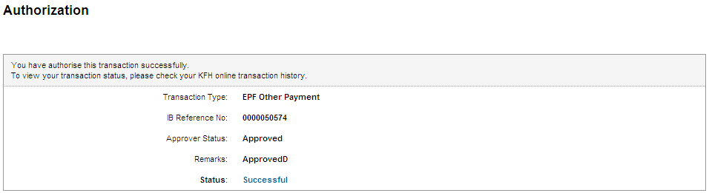

Print Receipt
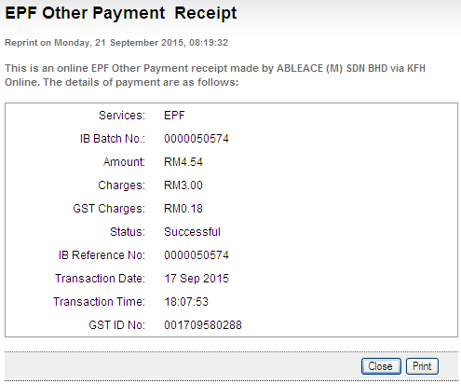

Transaction History
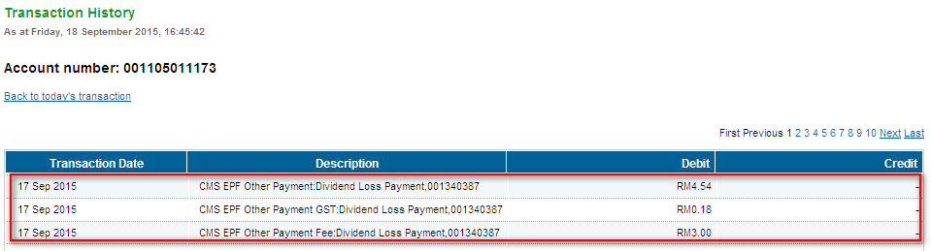

Other Charges

Initiator
Confirm Page
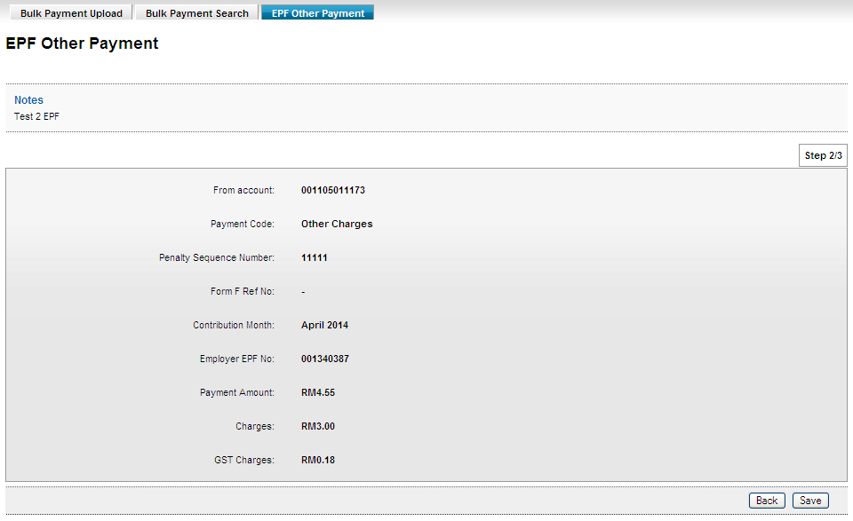

Result Page
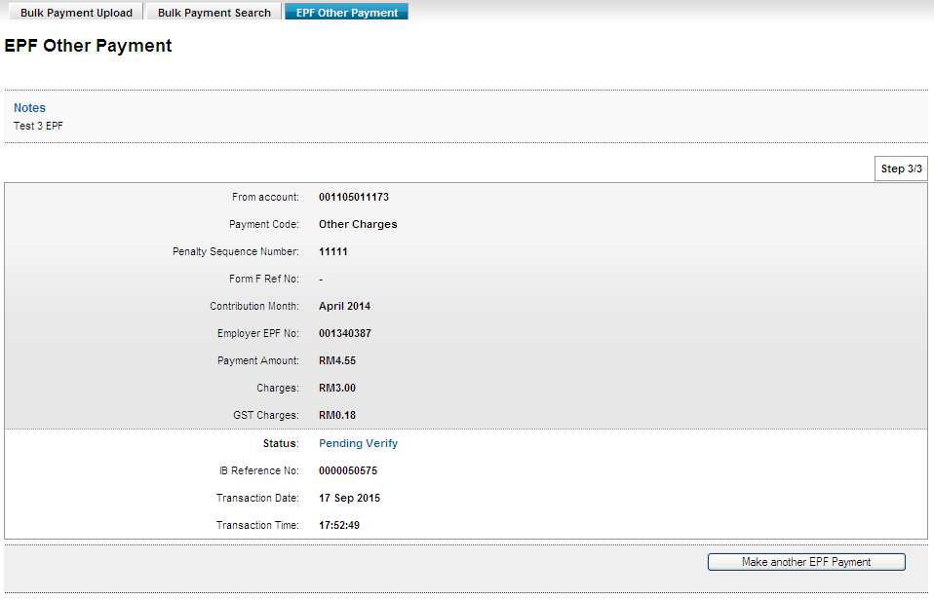

Verifier
Confirm Page
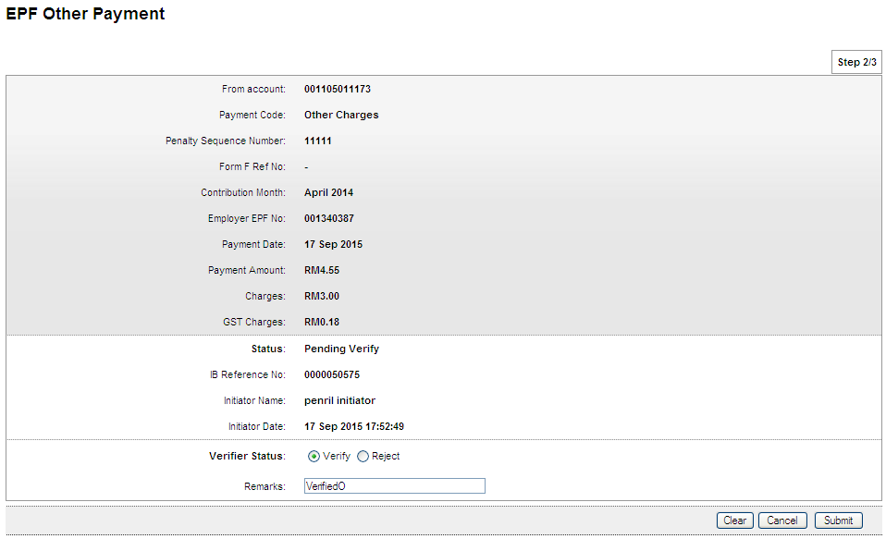

Result Page
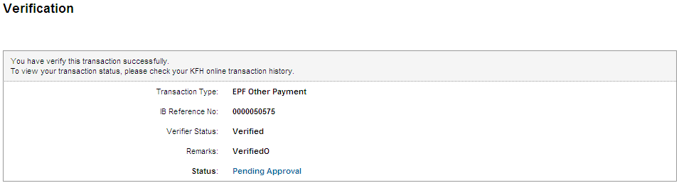

Approver
Confirm Page
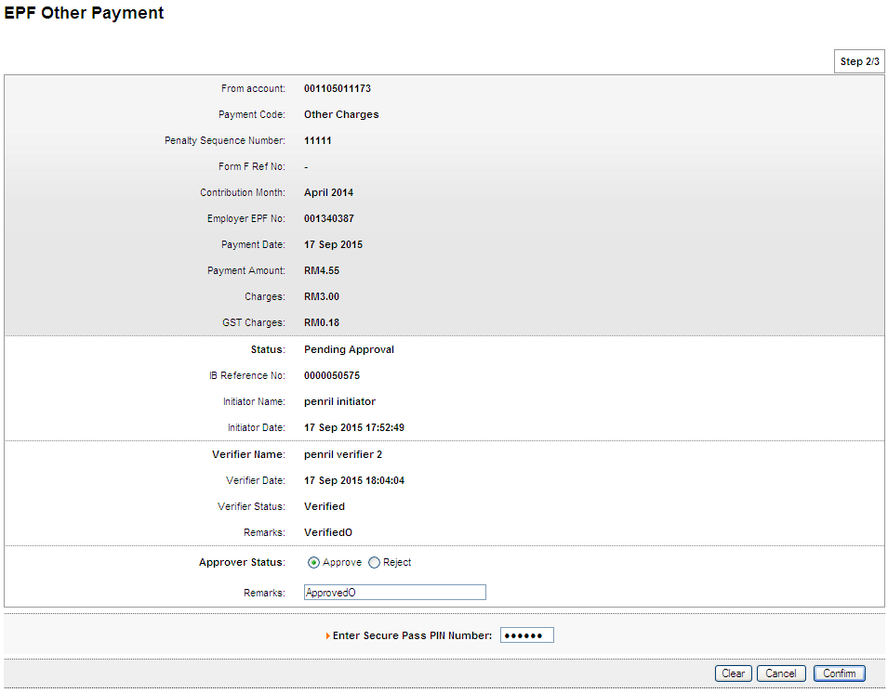

Result Page

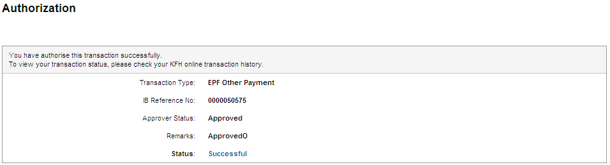

Print Receipt
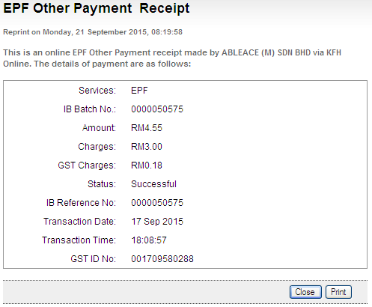

Transaction History
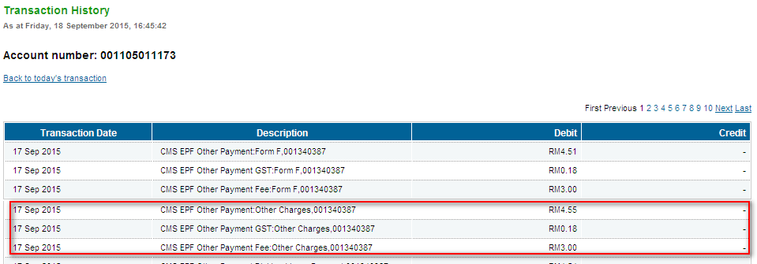

Role: Init-Veri>Approver

Form F

Init-Veri
Confirm Page
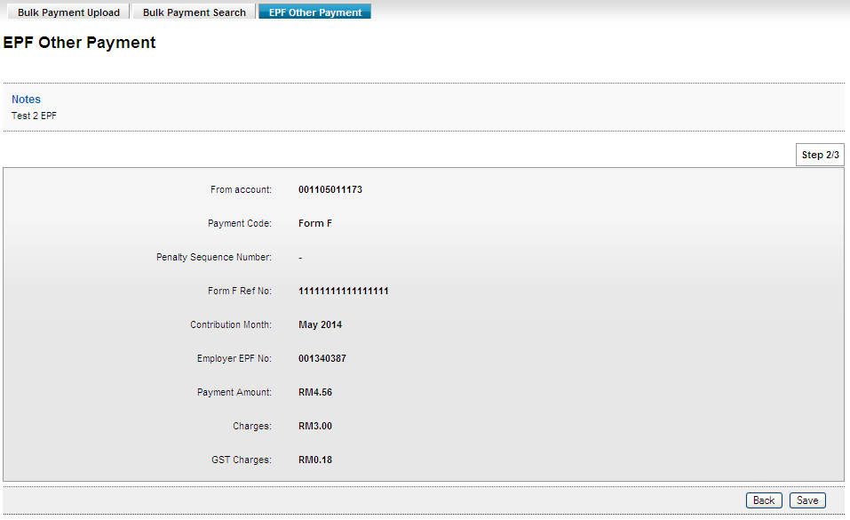

Result Page
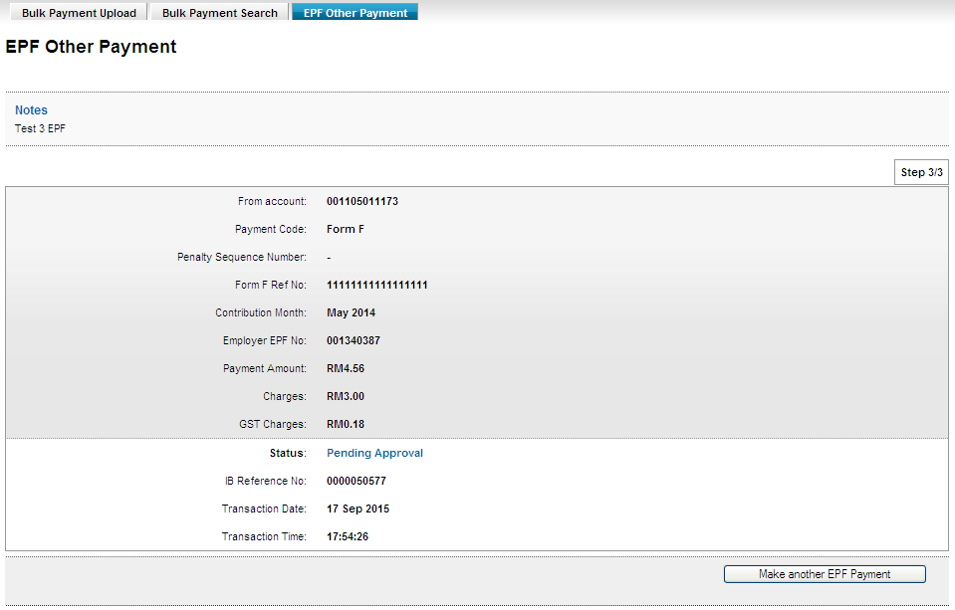

Approver
Confirm Page
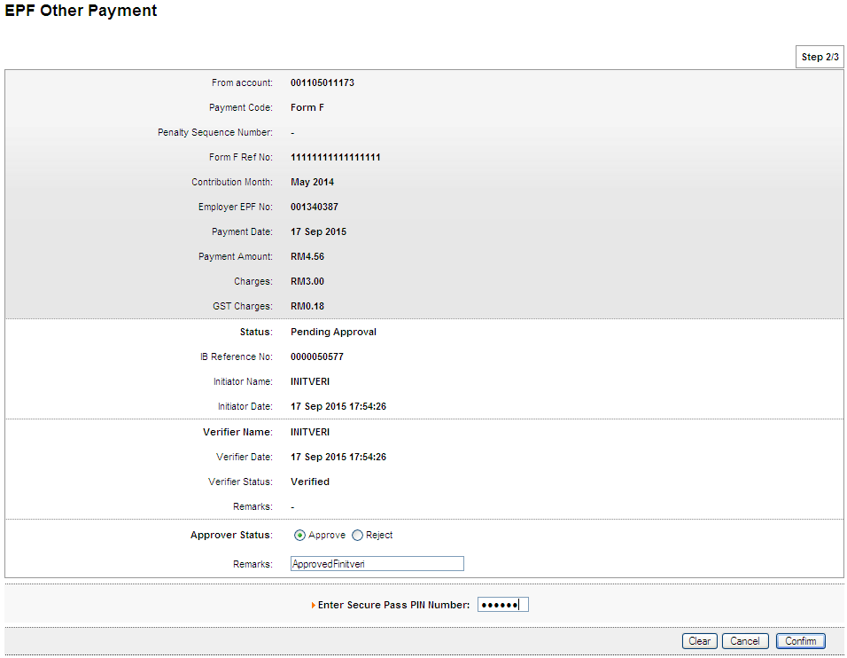

Result Page
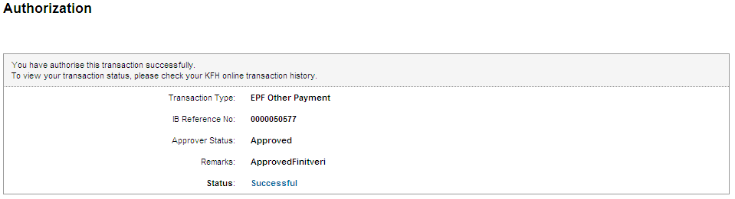

Print Receipt
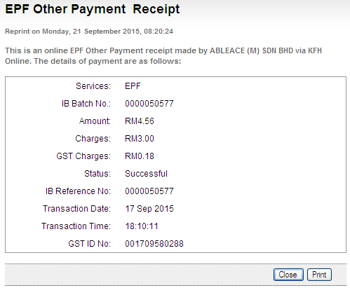

Transaction History
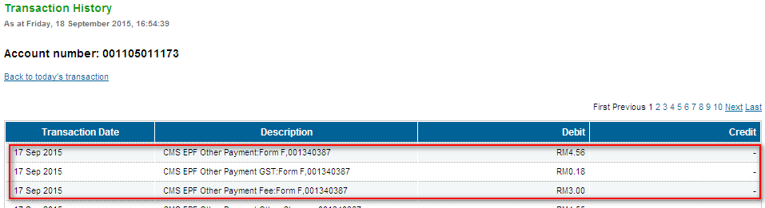

Late Charges Payment

Init-Veri
Confirm Page
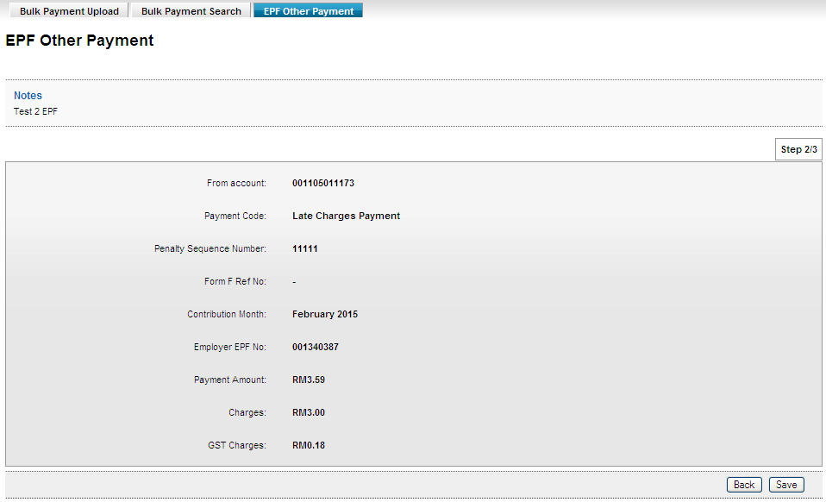

Result Page
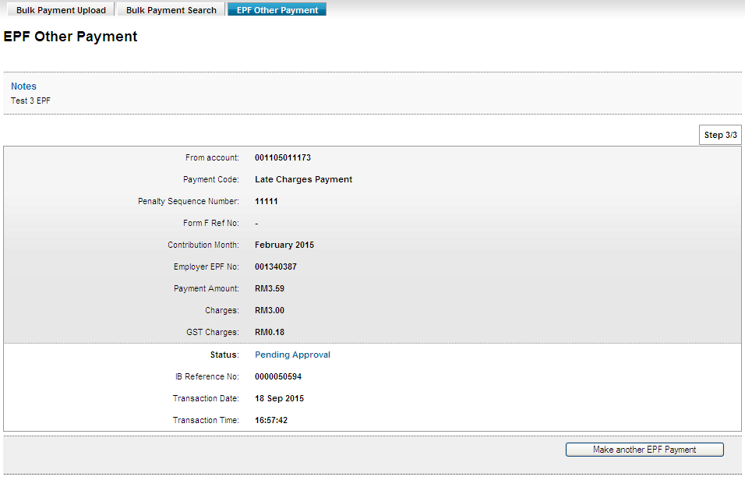

Approver
Confirm Page
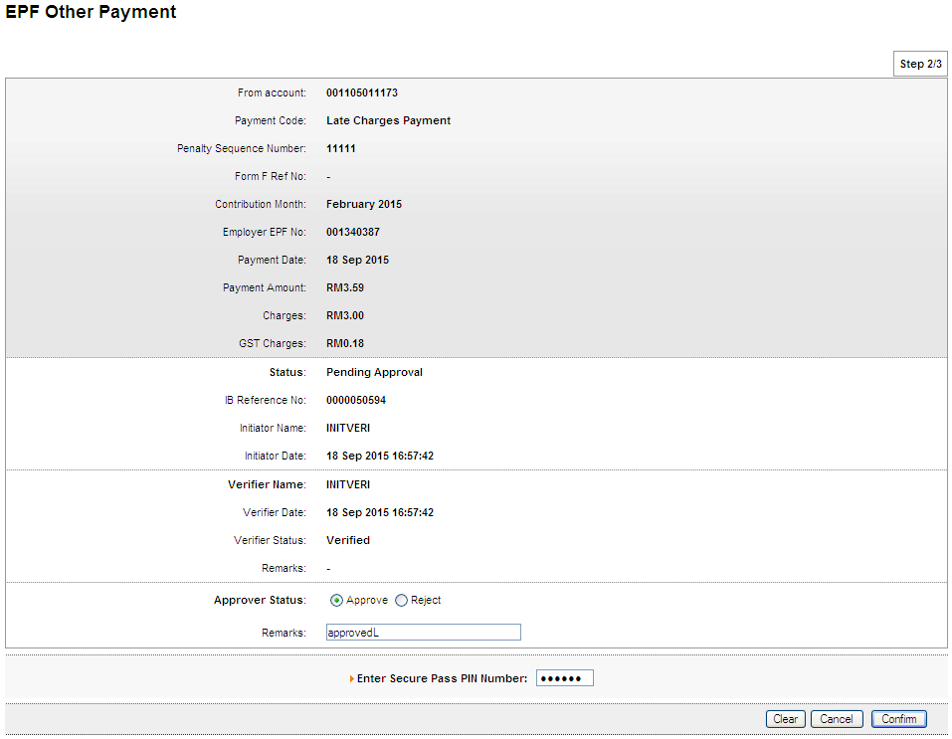

Result Page
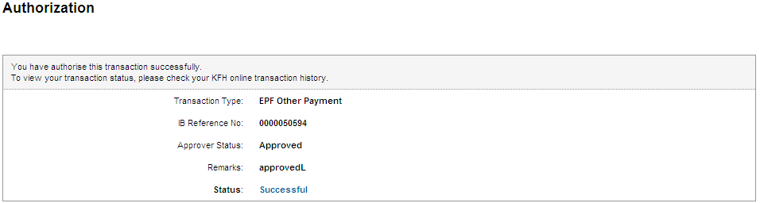

Print Receipt
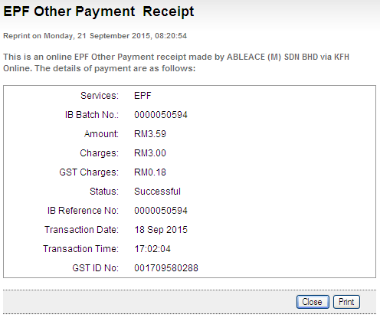

Transaction History
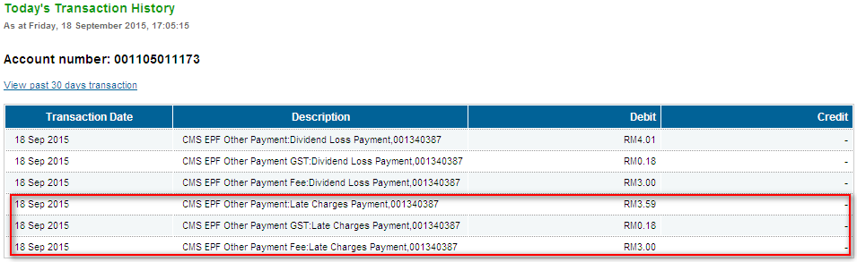

Dividend Loss Payment

Init-Veri
Confirm Page
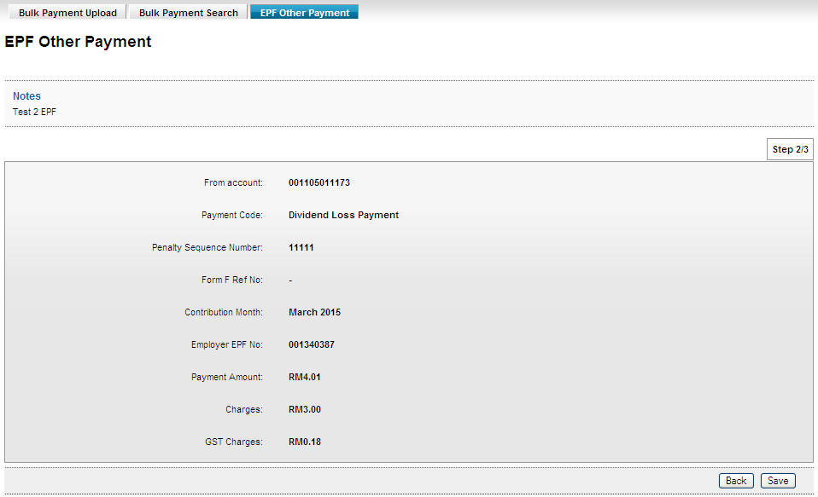

Result Page
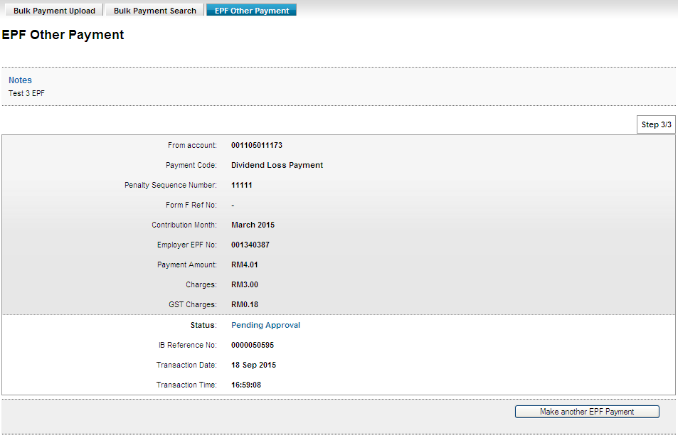

Approver
Confirm Page
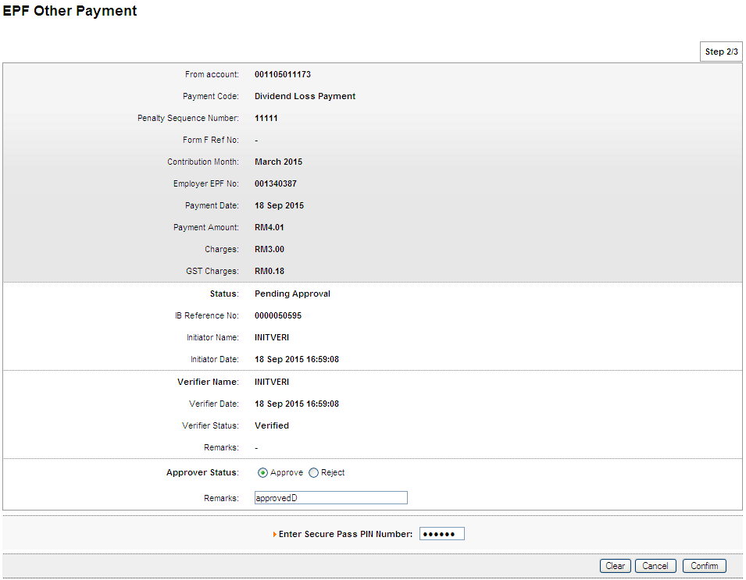

Result Page

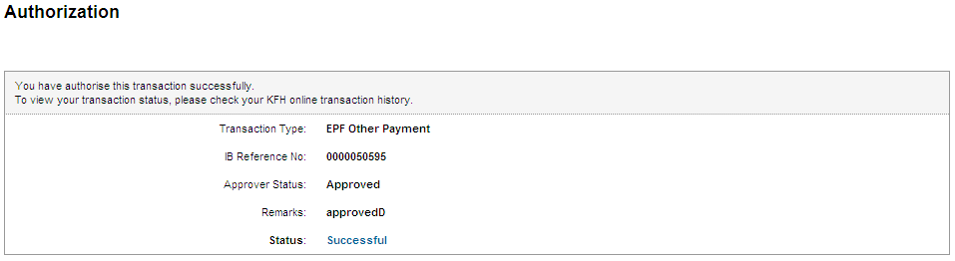

Print Receipt
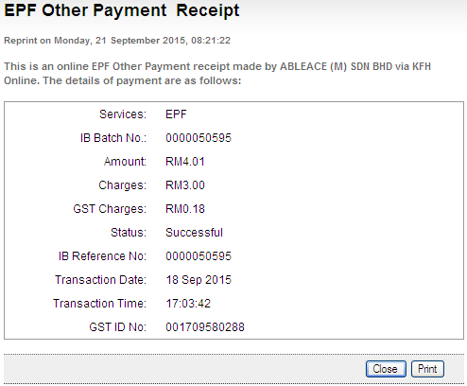

Transaction History
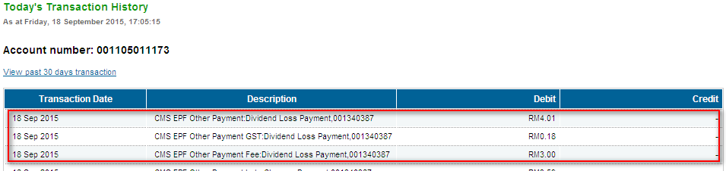

Other Charges

Init-Veri
Confirm Page
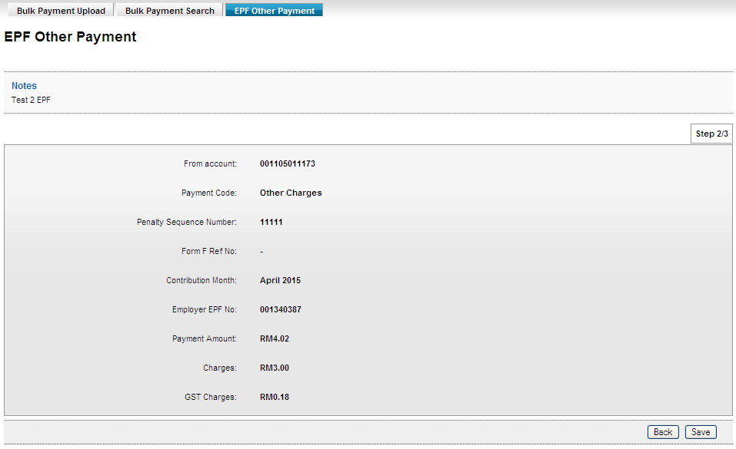

Result Page
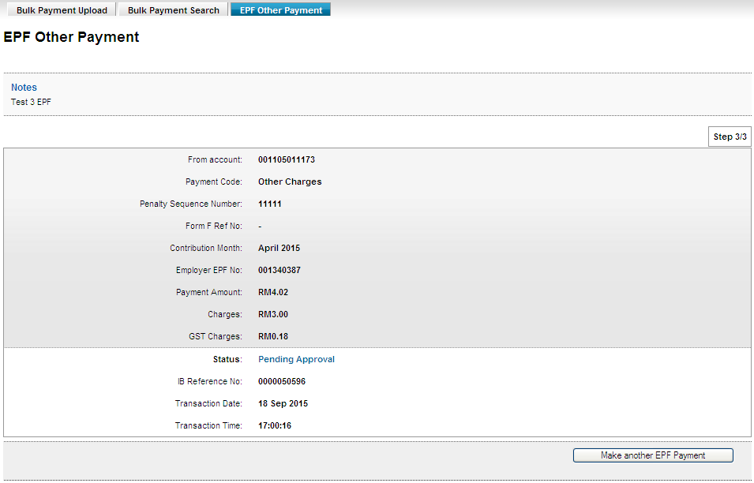

Approver
Confirm Page
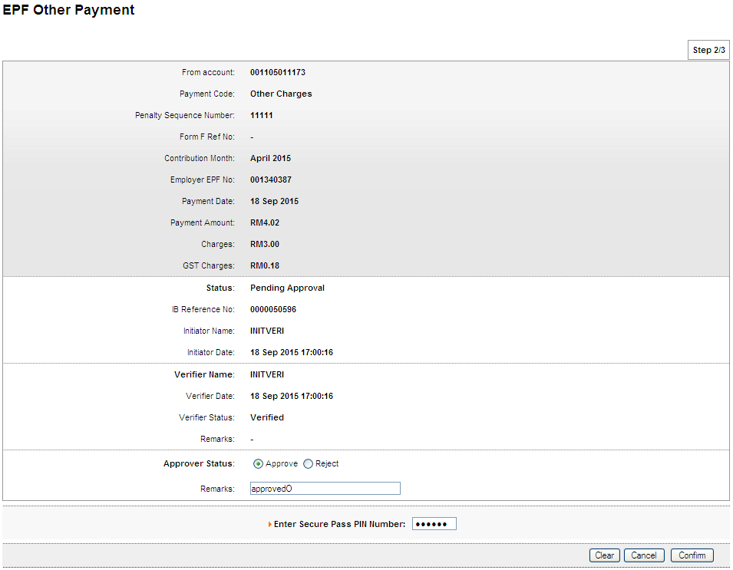

Result Page
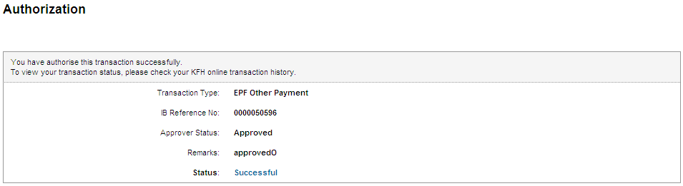

Print Receipt
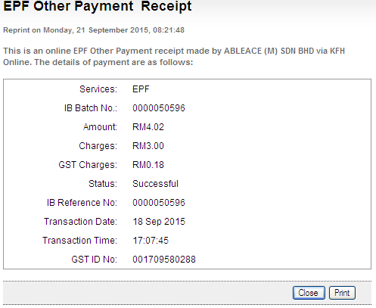

Transaction History

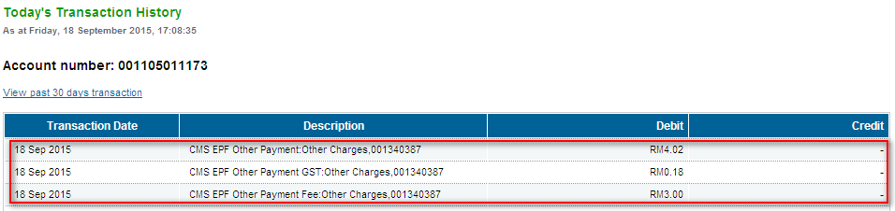

Bulk EPF Upload

Role: Approver All

Confirm Page
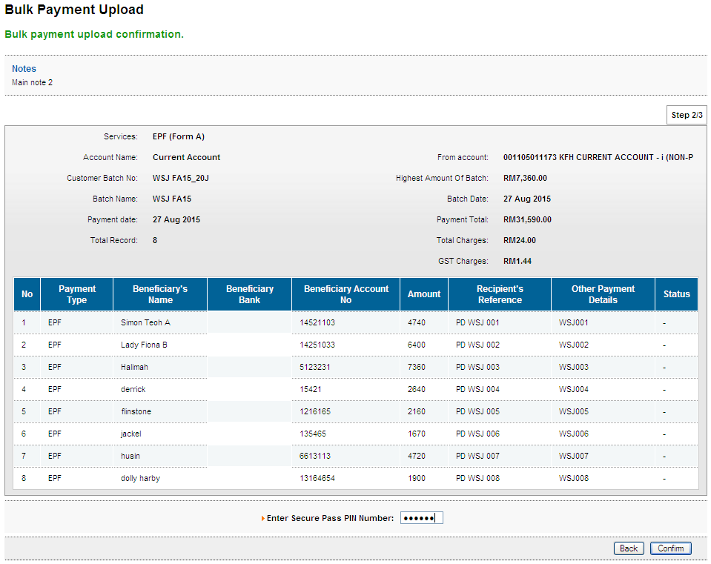

Result Page
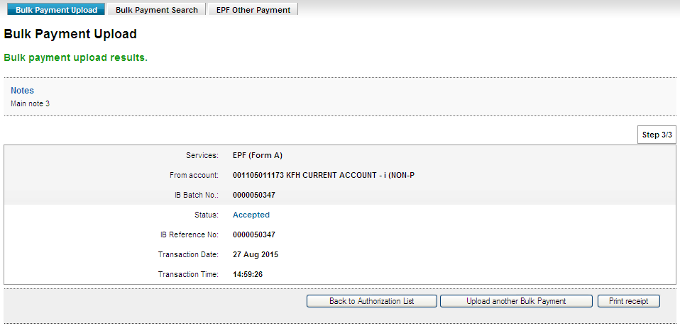
Print Receipt
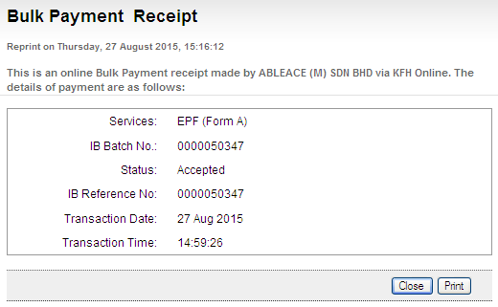

Transaction History
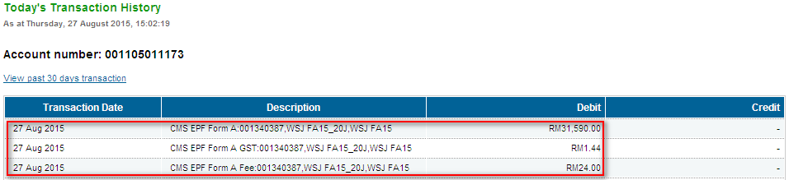

Role: Initiator>Verifier>Approver

Initiator
Confirm Page
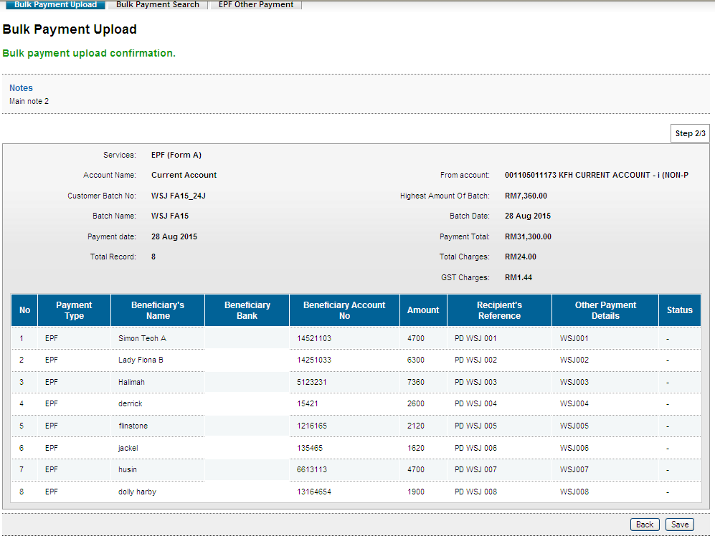

Result Page
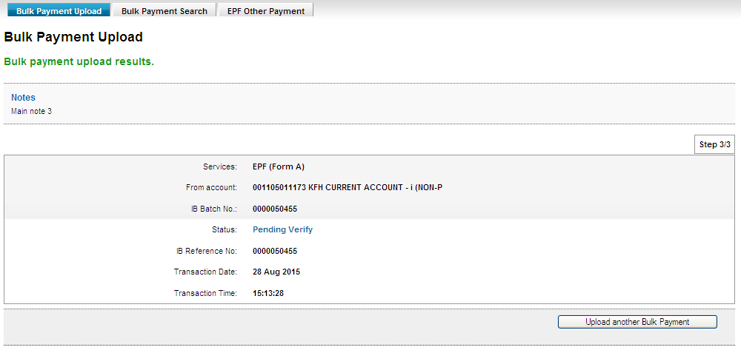

Verifier
Confirm Page
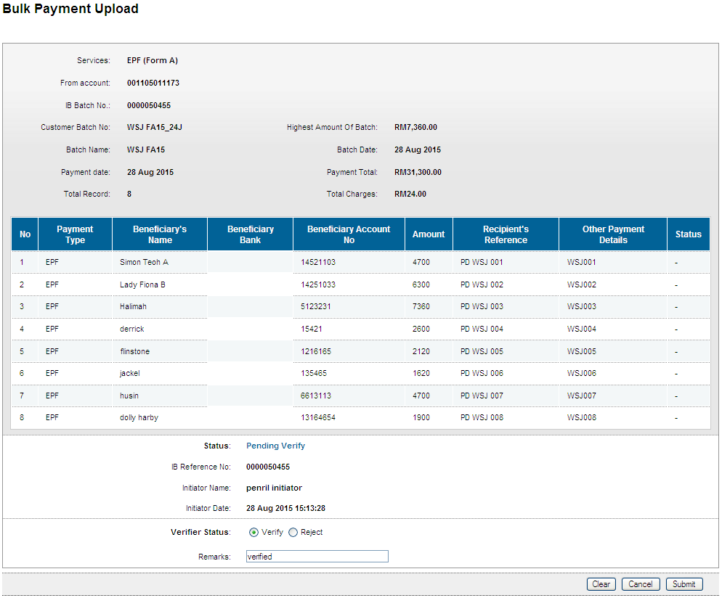

Result Page
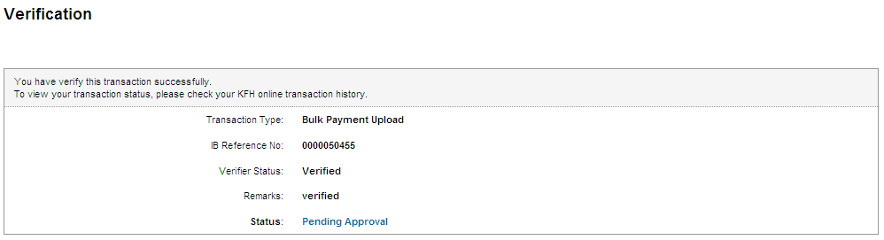

Role: Approver
Confirm Page
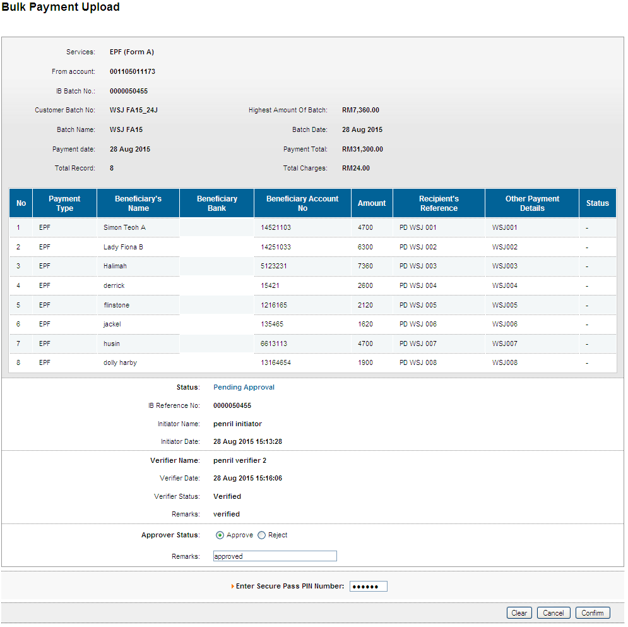

Result Page
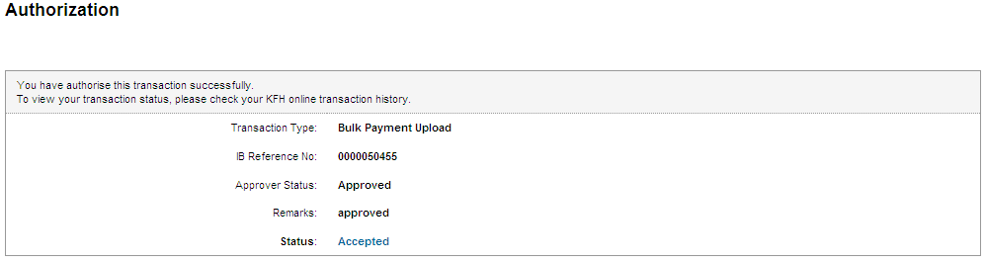

Print Receipt
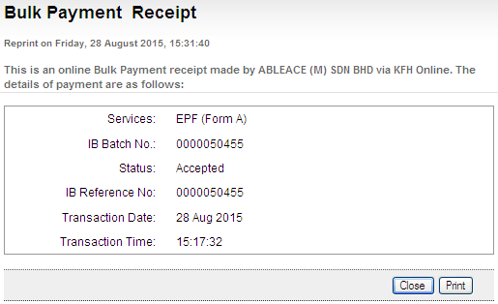

Transaction History
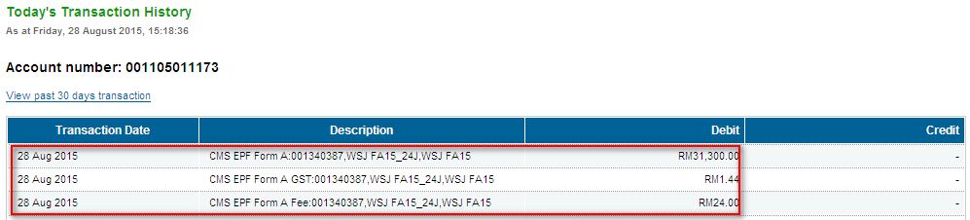

Role: Init-Veri>Approver

Init-Veri
Confirm Page
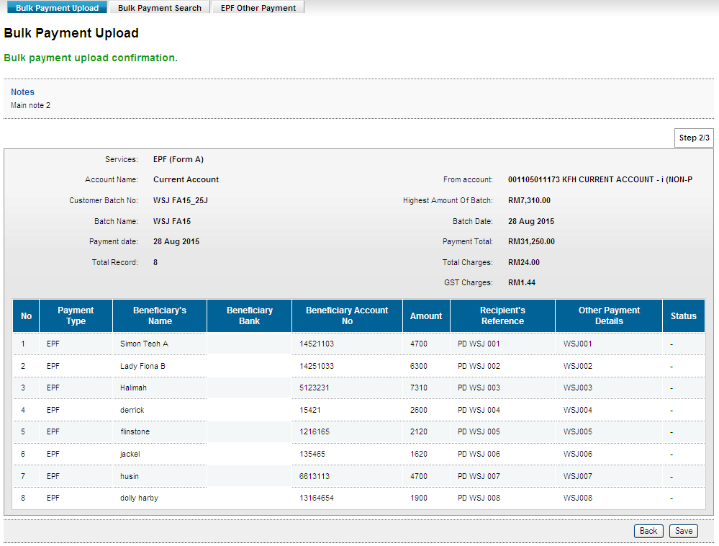
Result Page
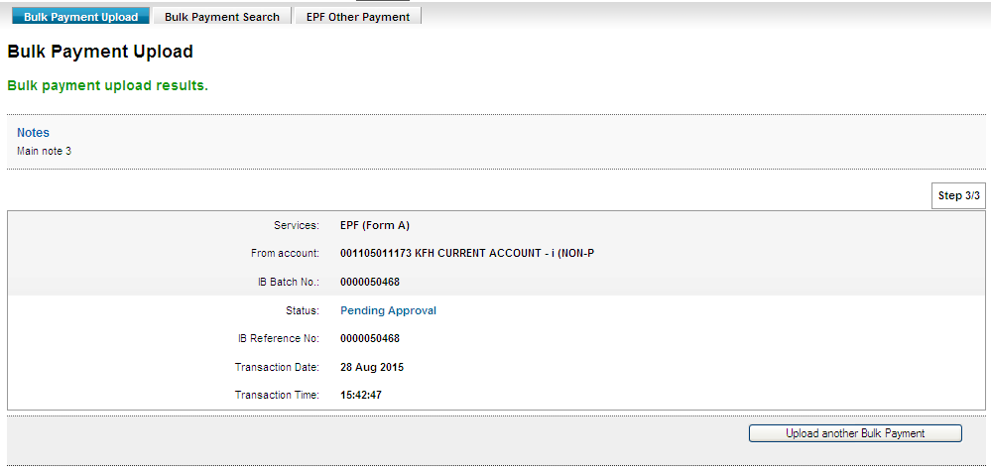

Role: Approver
Confirm Page
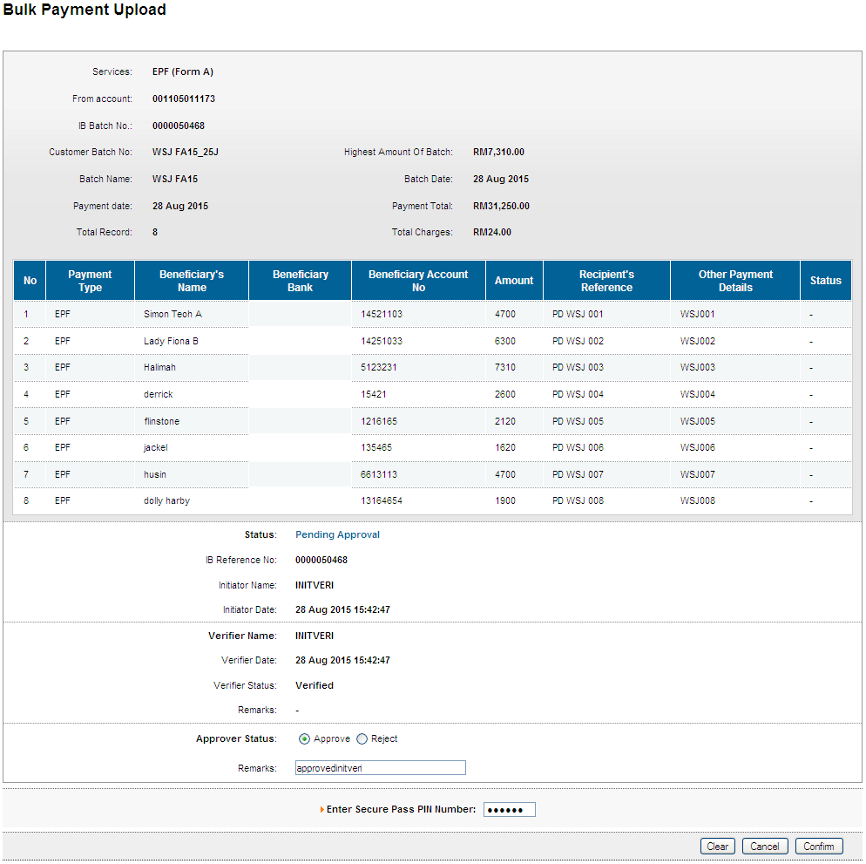
Result Page
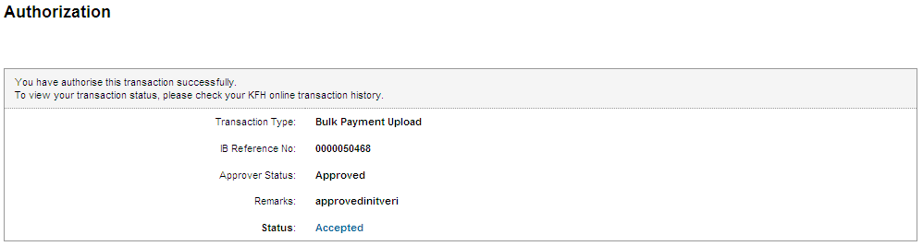

Print Receipt
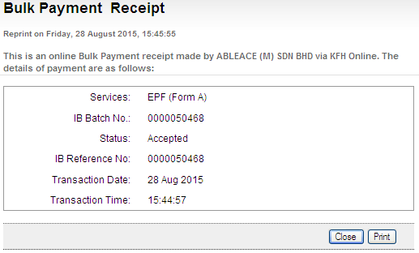
Transaction History
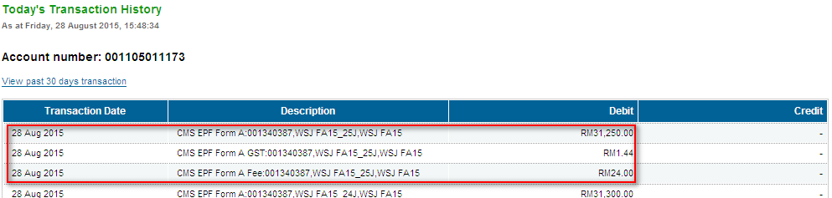

Reviewed By: (PMO)
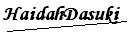 |  | Name/Position : NorhaidahBintiMdDasuki / Senior Manager, Quality Assurance and Support  Date :

