Test Issue Log |  |  |  |  | TIL No.: URF-14-09-126
Project Name: | Conditional Sign-off IBSCR074 - GST Implementation (Other Issue)
Test Stage: | Unit Functionality Integration System Interface  Performance Regression Acceptance Pilot
Test Case Number: | GST-040 |  |  | Test Started Date: |  | 30/11/2015
Test Title: | FTT details for Staff Account
Test Description: | To remove the entry for FTT charges since the amount is RM0.00
Test Functionality: | CIB  - Fund Transfer  - Open FTT  - Registered FTT
Test Procedure: | CIB  - Perform Open/Registered FTT transfer with SI  - View the details in confirm page, result page and receipt
Test Result: | Pass: Fail: Conditional Pass: |  | Tested by: |  | Lizahwati binti Basirun
Reason for Failed / Conditional Pass:
TEST DESCRIPTION

Open Foreign Telegraphic Transfer (FTT)

Non-staff
Confirm Page
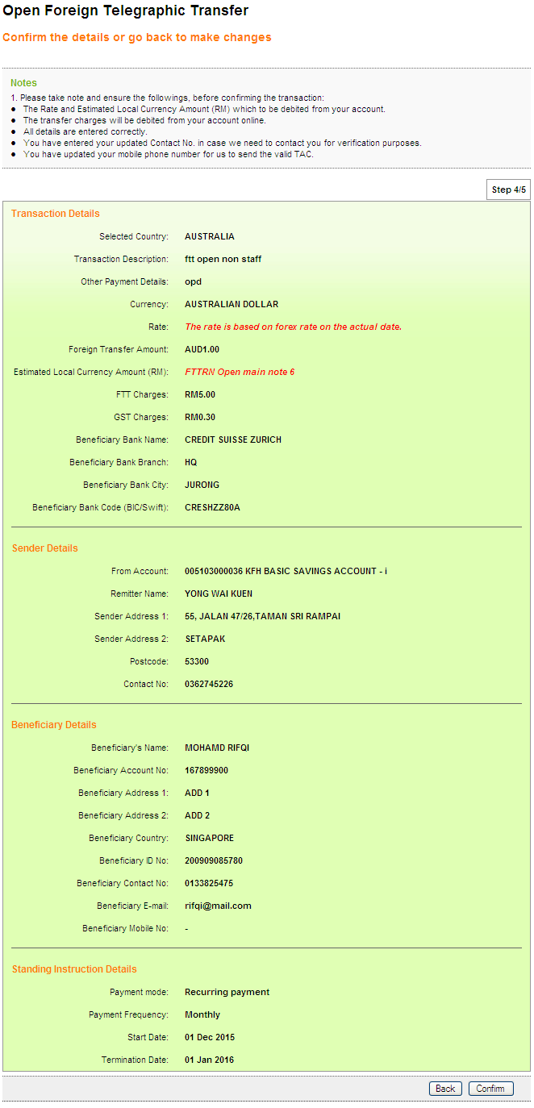

Result Page
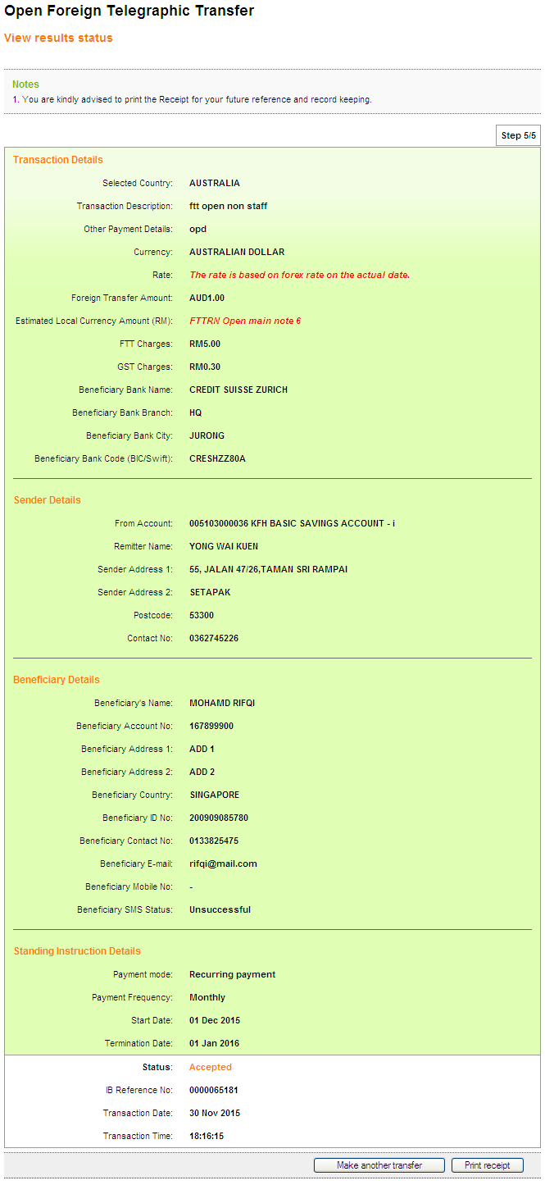

Receipt
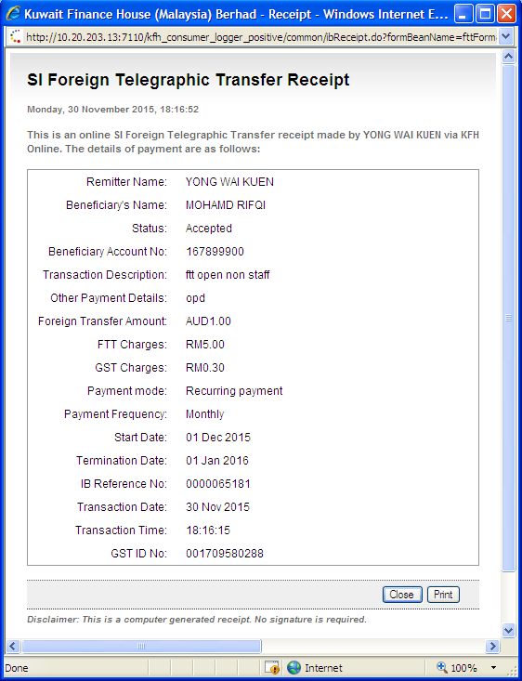

Staff
Confirm Page
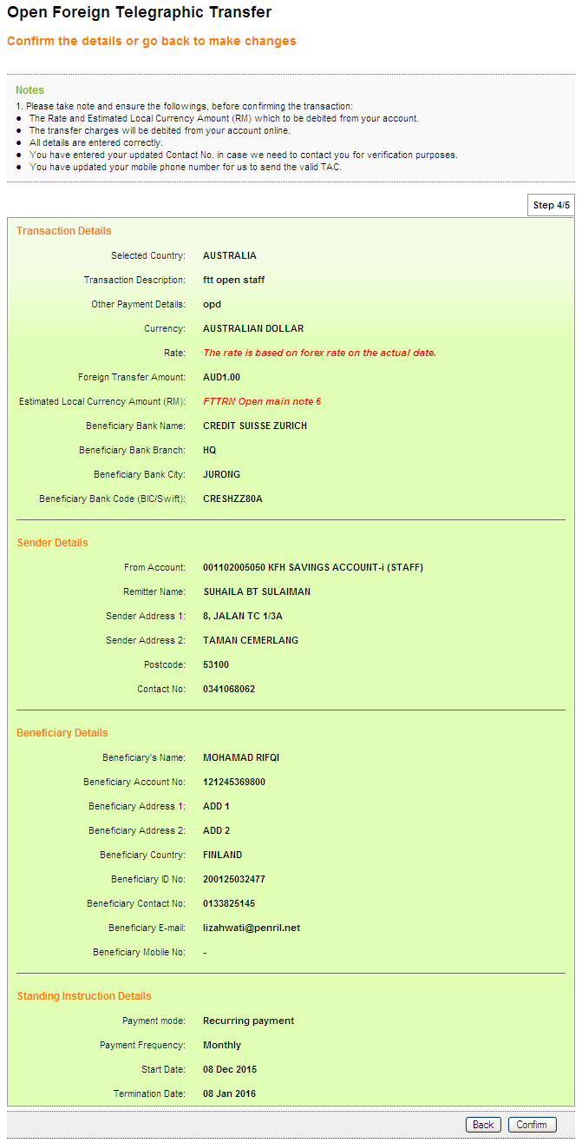

Result Page
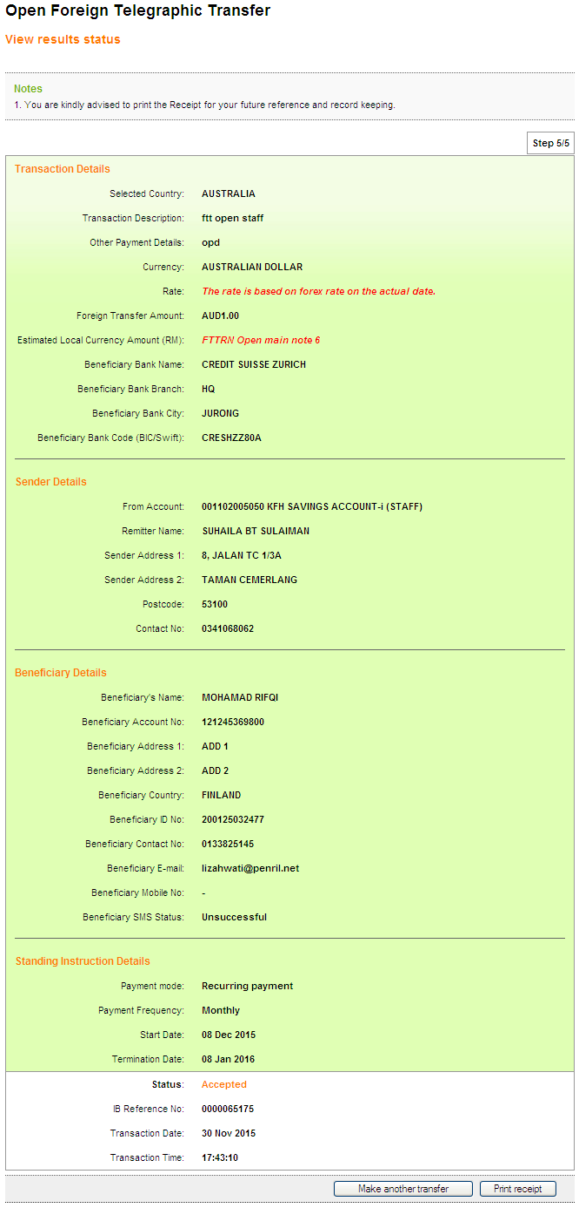

Receipt
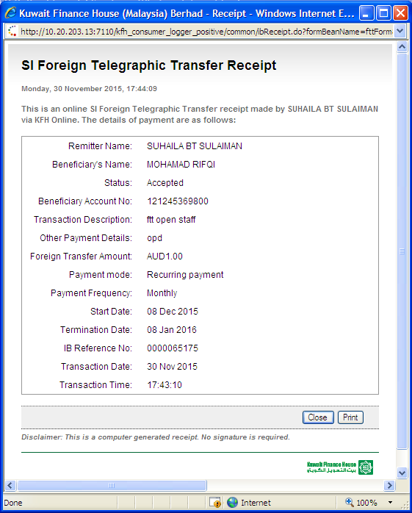

Registered Foreign Telegraphic Transfer (FTT)

Non-staff
Confirm Page
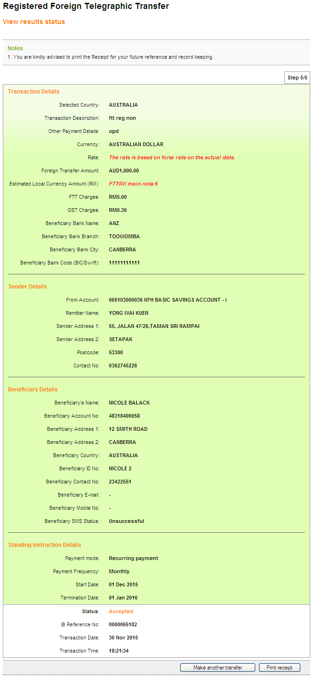

Result Page

Receipt
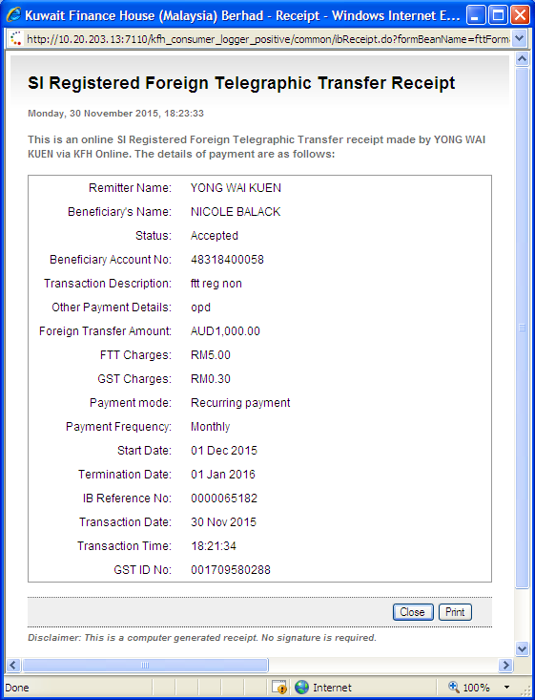

Staff
Confirm Page
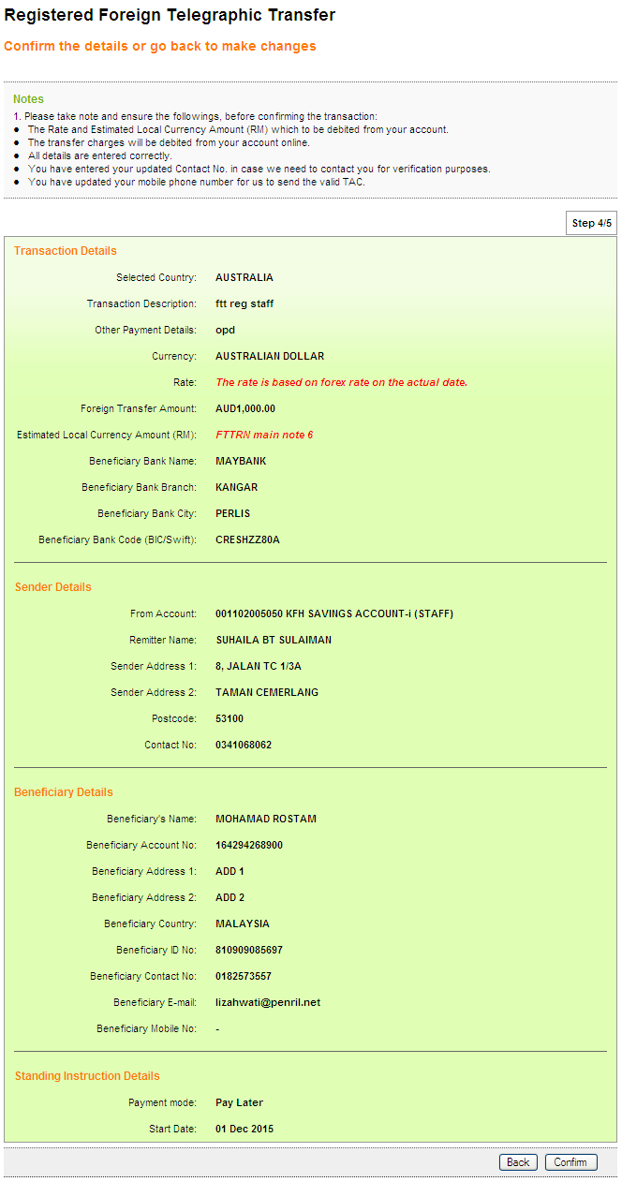

Result Page
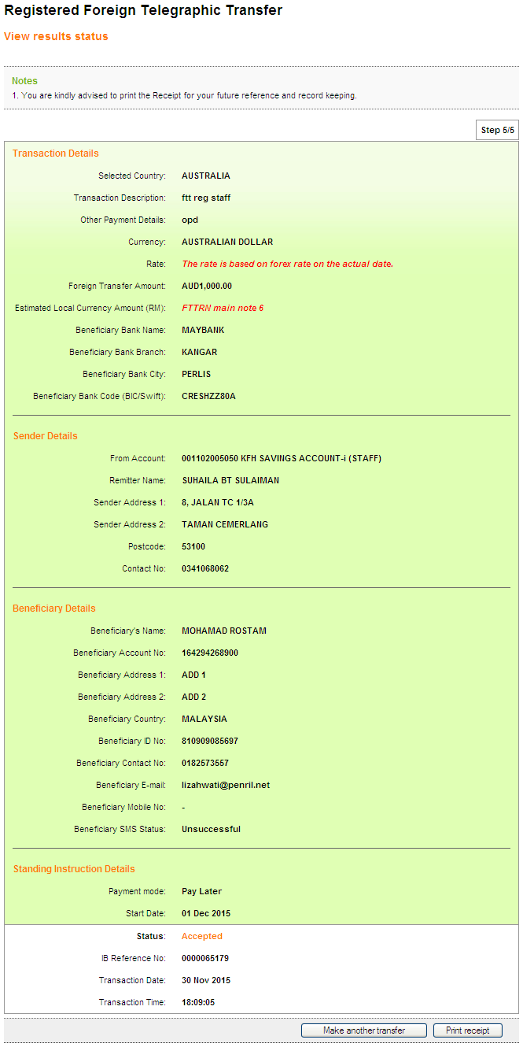

Receipt
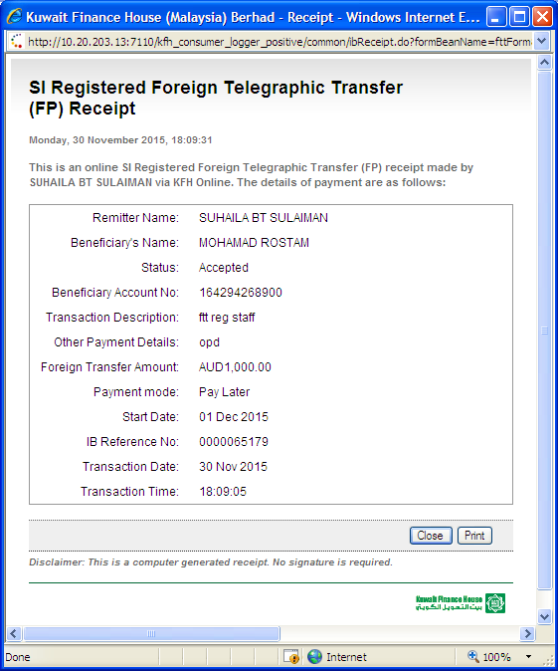

Reviewed By: (PMO)
 |  | Name/Position : Norhaidah Binti Md Dasuki / Senior Manager, Quality Assurance and Support  Date : 01/12/2015

