Test Dashboard (Download data as CSV / XLSX)
- OVERALL

- a) APPROVED BUDGET – OVERALL BY BUDGET TYPE IN 2015 (download data as csv)

- To display title Approved Budget – By Budget Type in 2015 in a single line
- Label Approved Budget change to Approved Budget (RM)
- To display budget approved amount in decimal and pointer format

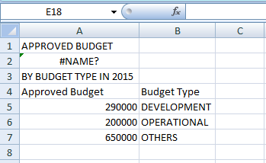

- APPROVED BUDGET – OVERALL BY BUDGET TYPE IN 2015 (download data as xlsx)
- Cannot open xlsx file format
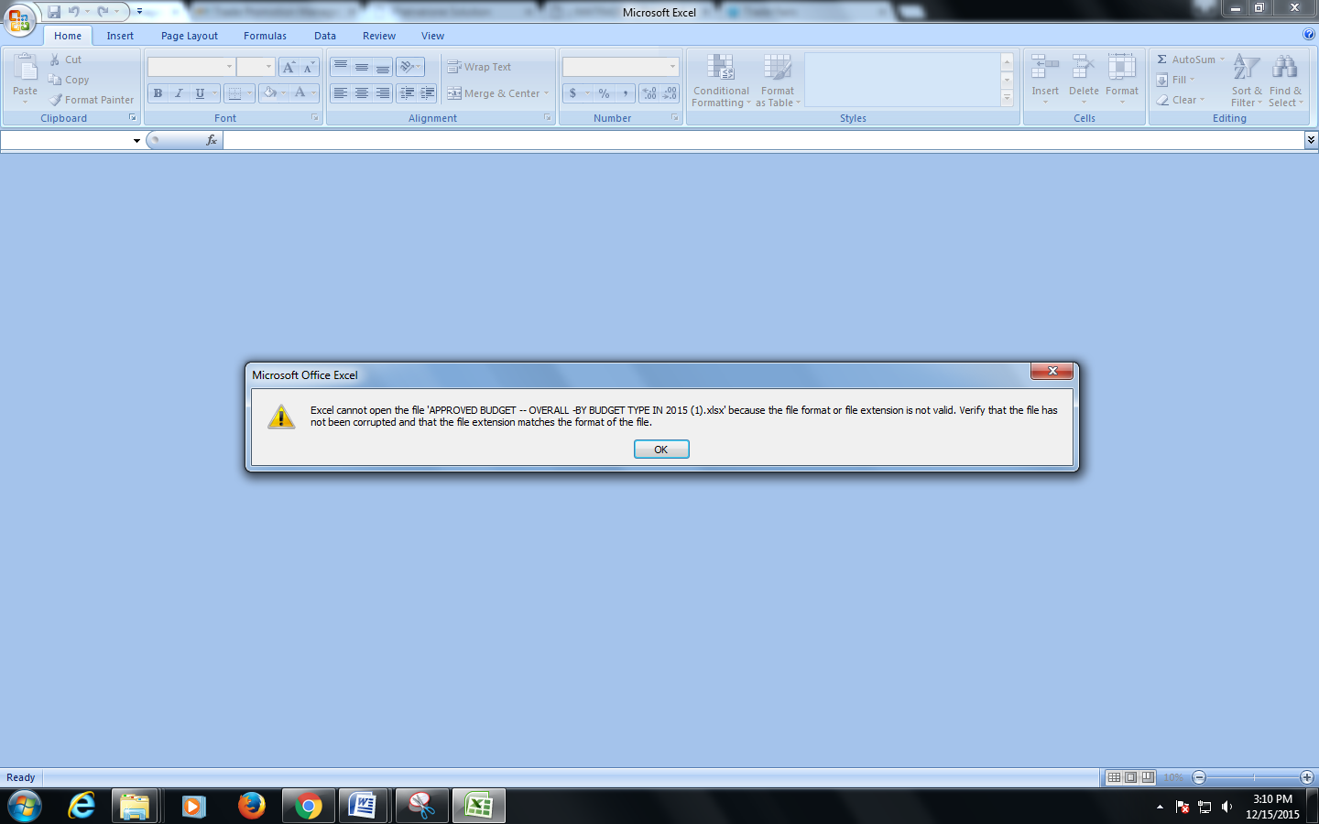

- a) NUMBER OF APPROVED EVENT BY PROGRAM TYPE IN 2015 (download data as csv)
- To remove color column
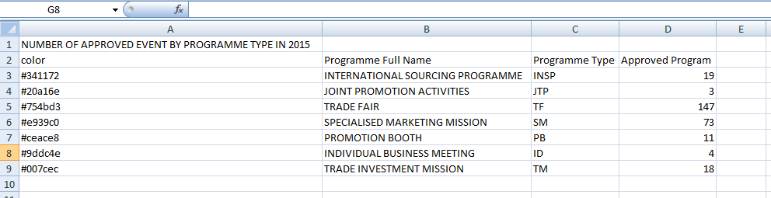
- NUMBER OF APPROVED EVENT BY PROGRAM TYPE IN 2015 (download data as xlsx)
- Cannot open xlsx file format

- a) IMPACT – TARGET SALES VS SALES GENERATED BY PROGRAM TYPE IN 2015 (download data as csv)
- Label Sales Generated change to Sales Generated (RM)
- To display sales generated amount in decimal and pointer format
- Label Target Sales change to Target Sales(RM)
- To display target sales amount in decimal and pointer format

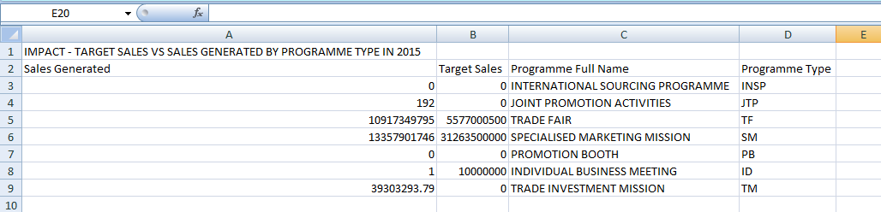

b) IMPACT – TARGET SALES VS SALES GENERATED BY PROGRAM TYPE IN 2015 (download data as xslx)
- Cannot open xlsx file format

- a) IMPACT - ROI BY PROGRAMME TYPE IN 2015 (download data as csv)
- To remove color column
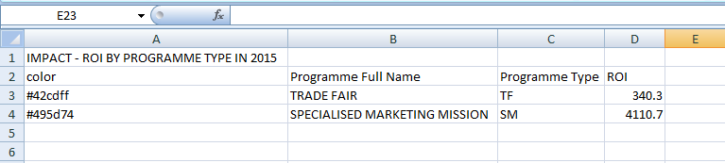

- IMPACT - ROI BY PROGRAMME TYPE IN 2015 (download data as xlsx)
- Cannot open xlsx file format

- a) PROGRAMME TYPE BY STATUS & SECTION IN 2015 (download data as xlsx)

- BUDGET (FILTER : APPROVED BUDGET)

- a) APPROVED BUDGET - OVERALL BY BUDGET TYPE IN 2015 (download data as csv)
- To display title Approved Budget – By Budget Type in 2015 in a single line
- Label Approved Budget change to Approved Budget (RM)
- To display budget approved amount in decimal and pointer format

b) APPROVED BUDGET - OVERALL BY BUDGET TYPE IN 2015 (download data as xlsx)
- Cannot open xlsx file format

- a) APPROVED BUDGET - BY SECTION IN 2015 (download data as csv)
- To remove color column
- Label Approved Budget change to Approved Budget (RM)
- To display budget approved amount in decimal and pointer format
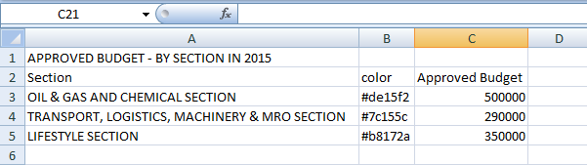
b) APPROVED BUDGET - BY SECTION IN 2015 (download data as xlsx)
- Cannot open xlsx file format

- a) APPROVED BUDGET - BY PROGRAMME TYPE IN 2015 (download data as csv)
- To remove color column
- Label Approved Budget change to Approved Budget (RM)
- To display budget approved amount in decimal and pointer format

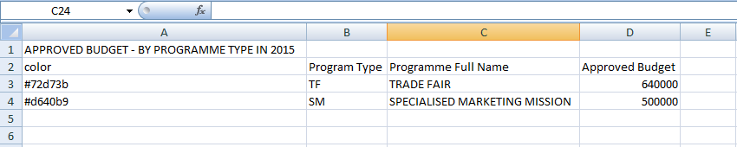

b) APPROVED BUDGET - BY PROGRAMME TYPE IN 2015 (download data as xlsx)
- Cannot open xlsx file format

- a) APPROVED BUDGET -BY SECTOR IN 2015 (download data as csv)
- To remove color column
- Label Approved Budget change to Approved Budget (RM)
- To display budget approved amount in decimal and pointer format

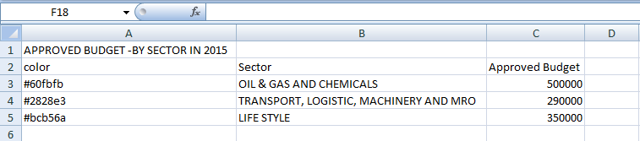

b) APPROVED BUDGET -BY SECTOR IN 2015 (download data as xlsx)
- cannot open xlsx file format

- a) APPROVED BUDGET VS UTILIZED BUDGET -BY SECTION IN 2015 (download data as csv)
- Label Approved Budget change to Approved Budget (RM)
- To display budget approved amount in decimal and pointer format
- Label Utilized Budget change to Utilized Budget (RM)
- To display utilized budget amount in decimal and pointer format

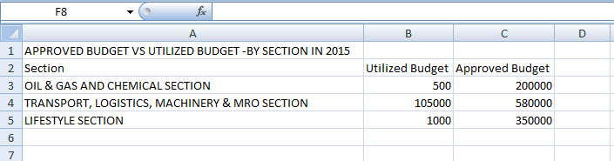

b) APPROVED BUDGET VS UTILIZED BUDGET -BY SECTION IN 2015 (download data as xlsx)
- cannot open xlsx file format

- BUDGET (FILTER : UTILIZED BUDGET)

- a) UTILIZED BUDGET - OVERALL BY BUDGET TYPE IN 2015 (download data as csv)
- Label Utilized Budget change to Utilized Budget (RM)
- To display utilized budget amount in decimal and pointer format

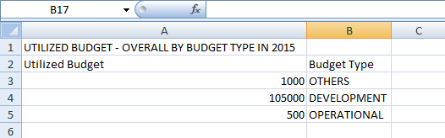

b) UTILIZED BUDGET - OVERALL BY BUDGET TYPE IN 2015 (download data as xlsx)
- cannot open xlsx file format

- a)UTILIZED BUDGET - BY SECTION IN 2015 (download data as csv)
- To remove color column
- Label Utilized Budget change to Utilized Budget (RM)
- To display utilized budget amount in decimal and pointer format
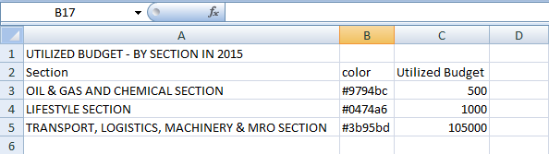

b) UTILIZED BUDGET - BY SECTION IN 2015 (download data as xlsx)
- cannot open xlsx file format

- a) UTILIZED BUDGET -BY PROGRAMME TYPE IN 2015 (download data as csv)

- To remove color column
- Label Utilized Budget change to Utilized Budget (RM)
- To display utilized budget amount in decimal and pointer format
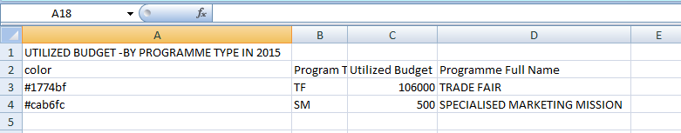

b) UTILIZED BUDGET -BY PROGRAMME TYPE IN 2015 (download data as xlsx)

- cannot open xlsx file format

- a) UTILIZED BUDGET -BY SECTOR IN 2015 (download data as csv)
- To remove color column
- Label Utilized Budget change to Utilized Budget (RM)
- To display utilized budget amount in decimal and pointer format

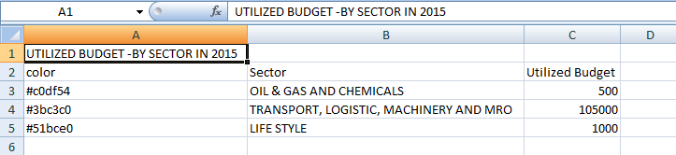

b) UTILIZED BUDGET -BY SECTOR IN 2015 (download data as xlsx)

- cannot open xlsx file format

- a) APPROVED BUDGET VS UTILIZED BUDGET -BY SECTION IN 2015 (download data as csv)

- Label Utilized Budget change to Utilized Budget (RM)
- To display utilized budget amount in decimal and pointer format
- Label Approved Budget change to Approved Budget (RM)
- To display approved budget amount in decimal and pointer format
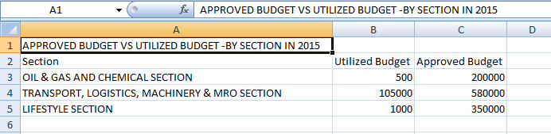

b) APPROVED BUDGET VS UTILIZED BUDGET -BY SECTION IN 2015 (download data as xlsx)
- - cannot open xlsx file format

- PROGRAMME
- a) NUMBER OF APPROVED EVENT - BY PROGRAMME TYPE IN 2015 (download data as csv)

- to remove color column

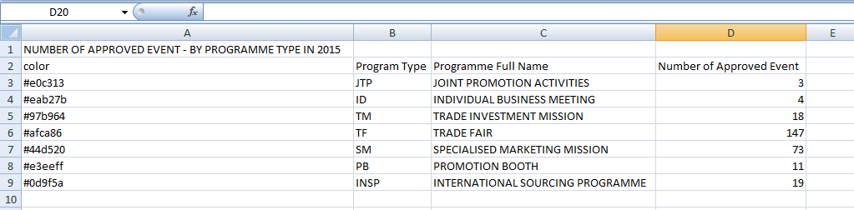

b) NUMBER OF APPROVED EVENT - BY PROGRAMME TYPE IN 2015 (download data as xlsx)
- cannot open xlsx file format

- a) NUMBER OF APPROVED EVENT - BY SECTION IN 2015 (download data as csv)
- To remove color column
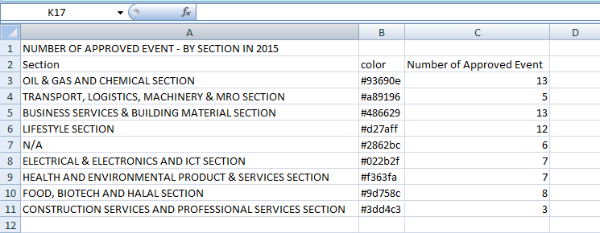

b) NUMBER OF APPROVED EVENT - BY SECTION IN 2015 (download data as xlsx)

- cannot open xlsx file format

- a) NUMBER OF APPROVED EVENT - BY SECTOR IN 2015 (download data as csv)
- To remove color column

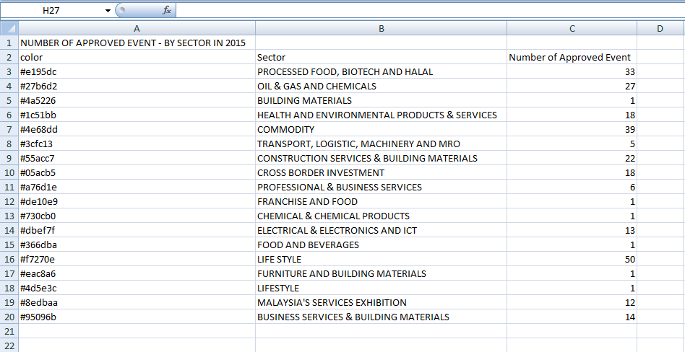

b) NUMBER OF APPROVED EVENT - BY SECTOR IN 2015 (download data as xlsx)
- cannot open xlsx file format

- IMPACT SALES

- a) IMPACT - TARGET SALES VS SALES GENERATED - BY PROGRAMME TYPE IN 2015 (download data as csv)
- Label Sales Generated change to Sales Generated (RM)
- To display sales generated amount in decimal and pointer format
- Label Target Sales change to Target Sales(RM)
- To display target sales amount in decimal and pointer format

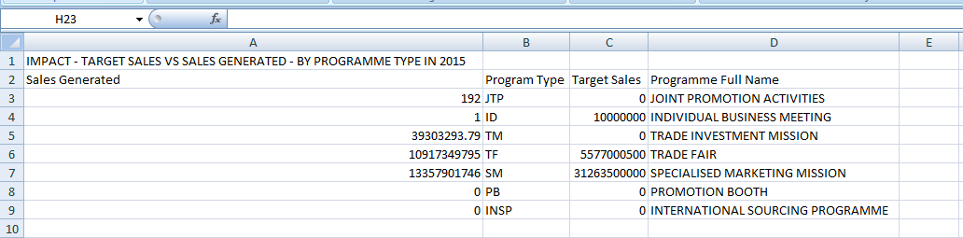

b) IMPACT - TARGET SALES VS SALES GENERATED - BY PROGRAMME TYPE IN 2015(download data as xlsx)
- cannot open xlsx file format

- a) IMPACT - TARGET SALES VS SALES GENERATED - BY SECTOR IN 2015 (download data as csv)
- Label Sales Generated change to Sales Generated (RM)
- To display sales generated amount in decimal and pointer format
- Label Target Sales change to Target Sales(RM)
- To display target sales amount in decimal and pointer format

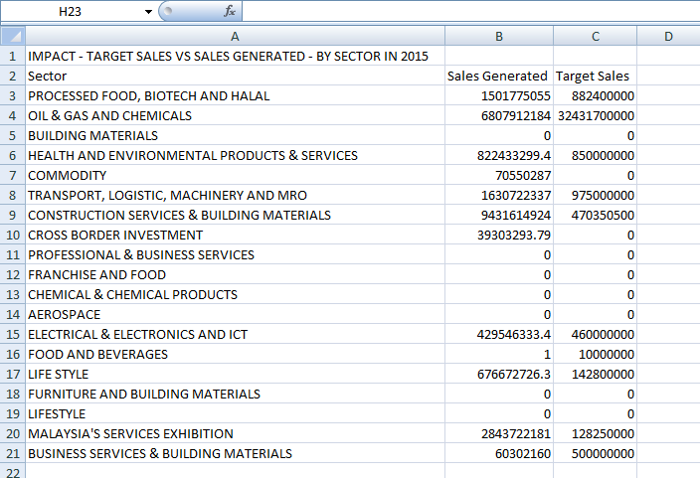

b) IMPACT - TARGET SALES VS SALES GENERATED - BY SECTOR IN 2015 (download data as xlsx)
- cannot open xlsx file format

- a) IMPACT - TARGET SALES VS SALES GENERATED - BY SECTION IN 2015 (download data as csv)

- Label Sales Generated change to Sales Generated (RM)
- To display sales generated amount in decimal and pointer format
- Label Target Sales change to Target Sales(RM)
- To display target sales amount in decimal and pointer format

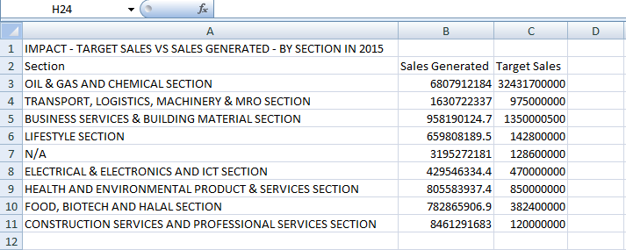

b) IMPACT - TARGET SALES VS SALES GENERATED - BY SECTION IN 2015 (download data as xlsx)
- cannot open xlsx file format

- a) IMPACT - TARGET SALES VS SALES GENERATED - BY REGION IN 20152015 (download data as csv)

- Label Sales Generated change to Sales Generated (RM)
- To display sales generated amount in decimal and pointer format
- Label Target Sales change to Target Sales(RM)
- To display target sales amount in decimal and pointer format

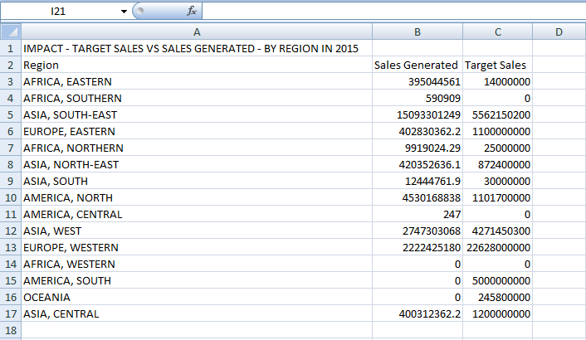

b) IMPACT - TARGET SALES VS SALES GENERATED - BY REGION IN 2015 (download data as xlsx)

- cannot open xlsx file format

- ROI

- a) IMPACT - ROI - BY PROGRAMME TYPE IN 2015(download data as csv)
- To remove color column

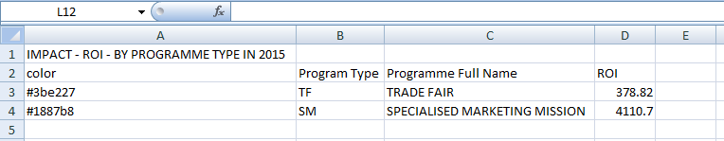

b) IMPACT - ROI - BY PROGRAMME TYPE IN 2015 (download data as xlsx)
- cannot open xlsx file format

- a) IMPACT - ROI - BY SECTOR IN 2015 (download data as csv)
- To remove color column

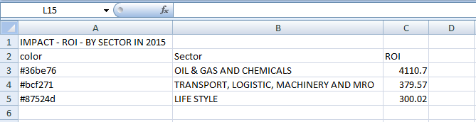

b) IMPACT - ROI - BY SECTOR IN 2015 (download data as xlsx)
- cannot open xlsx file format

- a) IMPACT - ROI - BY SECTION IN 2015 (download data as csv)
- To remove color column

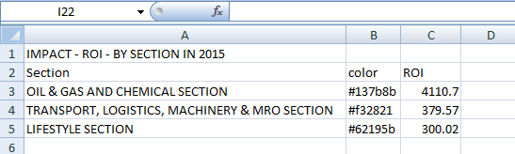

b) IMPACT - ROI - BY SECTION IN 2015 (download data as xlsx)
- cannot open xlsx file format

- a) IMPACT - ROI - BY REGION IN 2015(download data as csv)
- To remove color column

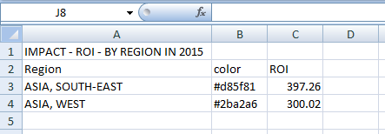

b) IMPACT - ROI - BY REGION IN 2015(download data as xlsx)
- cannot open xlsx file format

- JPPPA

- a) NUMBER OF PROGRAMME BY MINISTRY IN 2015 (download data as csv)
- To remove color column
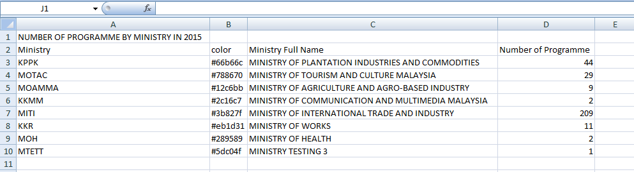

b) NUMBER OF PROGRAMME BY MINISTRY IN 2015 (download data as xlsx)
- cannot open xlsx file format

- a) IMPACT BY MINISTRY - BY ACTUAL SALES IN 2015 (download data as csv)
- To remove color column
- Label Actual Sales change to Actual Sales (RM)
- To display actual sales amount in decimal pointer format

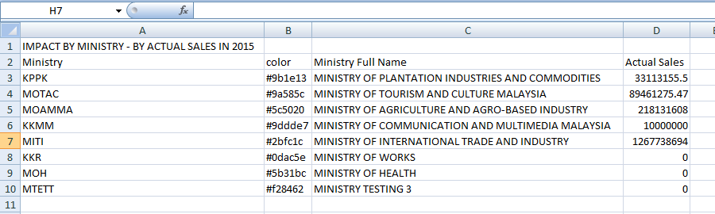
b) IMPACT BY MINISTRY - BY ACTUAL SALES IN 2015 (download data as xlsx)
- cannot open xlsx file format

- a) NUMBER OF PROGRAMME BY SECTOR IN 2015 (download data as csv)
- To remove color column

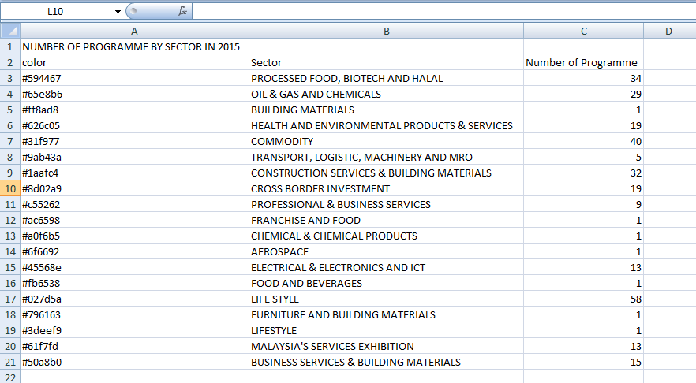

b) NUMBER OF PROGRAMME BY SECTOR IN 2015(download data as xlsx)
- cannot open xlsx file format

- a) IMPACT BY SECTOR - BY ACTUAL SALES IN 2015 (download data as csv)
- To remove color column
- Label Actual Sales change to Actual Sales (RM)
- To display actual sales amount in decimal pointer format

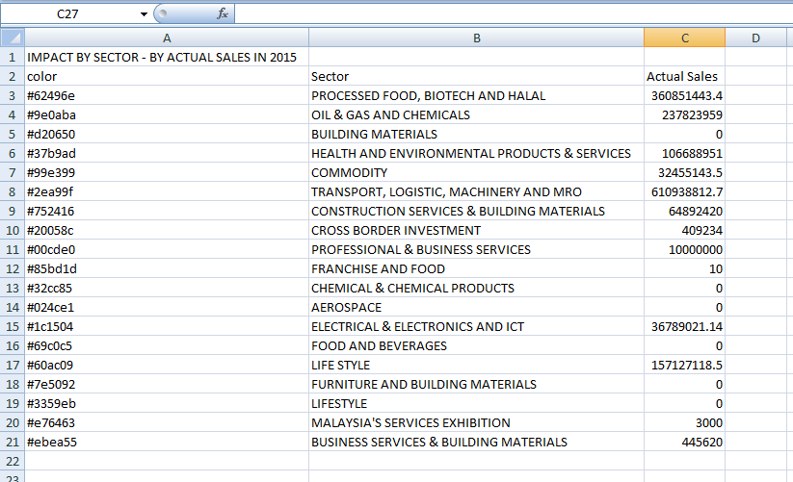

b) IMPACT BY SECTOR - BY ACTUAL SALES IN 2015 (download data as xlsx)
- cannot open xlsx file format

