1. Demand Draft Print, Two partition of amount.

Actual Result:

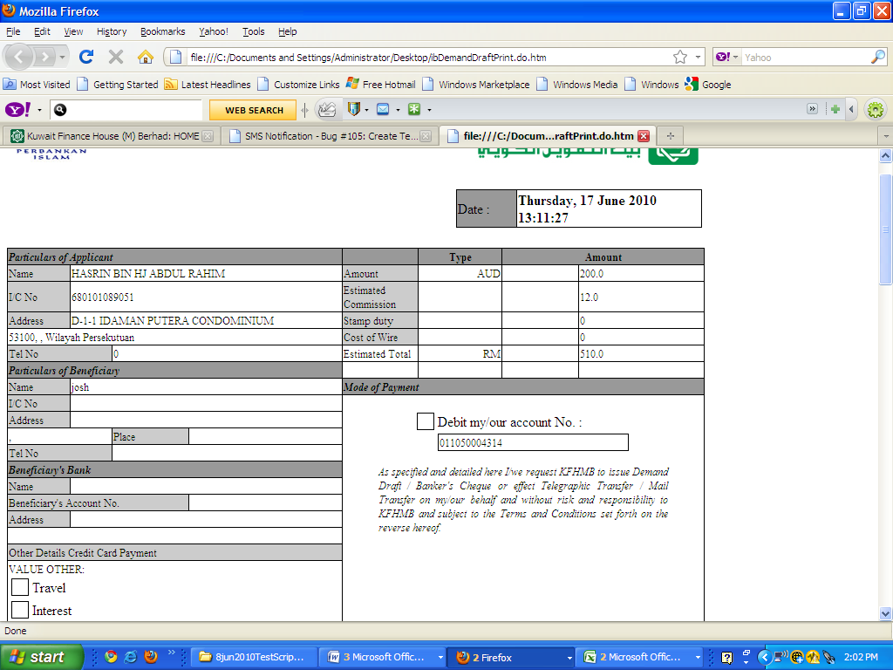

Expected Result from BRS:

