Test Issue Log |  |  |  |  |  | Issue ID# : TPMS_Prod006
Project Name: | Trade Promotion Management System (TPMS)
Test Stage: | Unit Functionality Integration System Interface  Performance Regression Acceptance Pilot
Test Case Number: | Support # 5881 |  |  | Test Started Date: |  |  | 29/12/2015
Test Title: | Internal Registration Problem
Test Description: | Internal user able to view the correct gender after creating new representative
Test Functionality: | TPMS>Promotion>Event – View > Registration > New Registration
Test Procedure: | Issue :  - Click on Registration Sub-Module to access the Event Registration page.  - Click on the New Registration button  - Add new Representative
Test Result: | Pass: Fail:  Conditional Pass: : |  | Tested by: |  | Siti Aishah
Reason for Failure:
TEST DESCRIPTION
Issue : Test to access Internal Registration page

Login as Project Officer (Tester3)
Select Promotion Tab

Select respective event and click “View” button
Select “Registration” drop down list

Click on New Registration button

Add New Representative

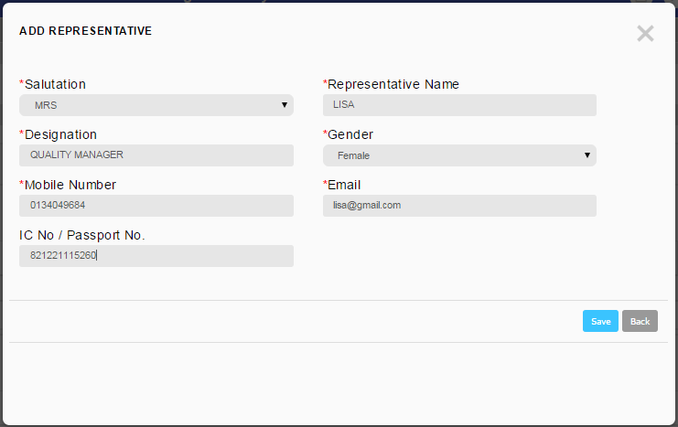

Result: Able to view the correct gender

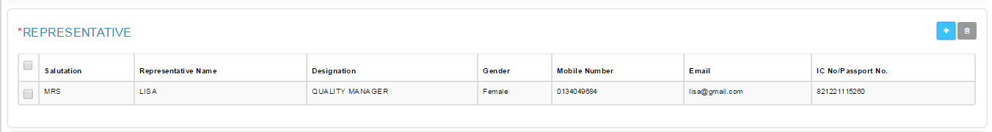

Reviewed By: (PMO)
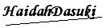 |  | Name/Position : Norhaidah Binti Md Dasuki / Senior Manager, Quality Assurance and Support  Date : 30/12/2015

