Test Issue Log |  |  |  |  |  | Issue ID# : TPMS_Prod009
Project Name: | Trade Promotion Management System (TPMS)
Test Stage: | Unit Functionality Integration System Interface  Performance Regression Acceptance Pilot
Test Case Number: | Support # 5883 |  |  | Test Started Date: |  |  | 29/12/2015
Test Title: | Access Currency Exchange Rate Sub-Menu Problem
Test Description: | User should be able to access currency rate module as per group management permission setting
Test Functionality: | TPMS>Administration>Currency Exchange Rate
Test Procedure: | Issue :  - Click on Currency Exchange Rate Sub-Menu
Test Result: | Pass: Fail:  Conditional Pass: : |  | Tested by: |  | Siti Aishah
Reason for Failure:
TEST DESCRIPTION
Issue : Test to access Currency Exchange Rate

Login as Administrator (Tester5)
Select Administration Tab
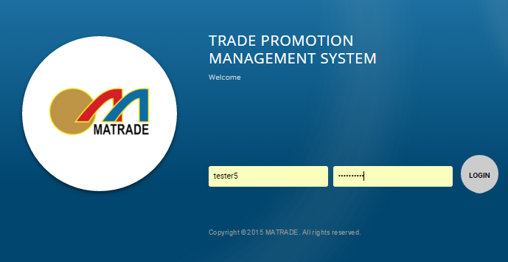

Select “Currency Exchange Rate” from the sub menu drop down list

Result: Able to access Currency Exchange Rate page

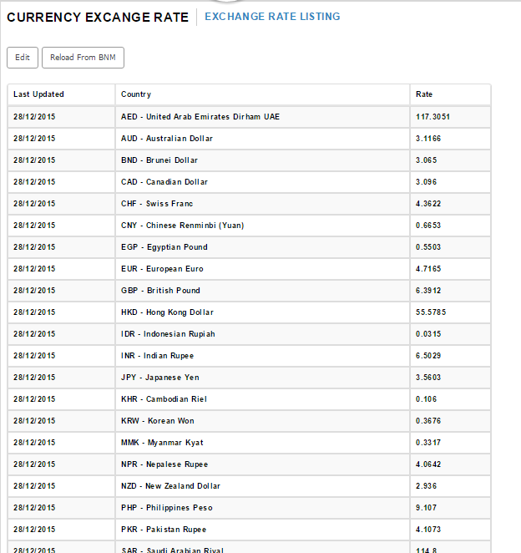

Reviewed By: (PMO)
 |  | Name/Position : Norhaidah Binti Md Dasuki / Senior Manager, Quality Assurance and Support  Date : 30/12/2015

