***Issue Form (PROD)***

|  |  |
| --- | --- |
| **Originator's Name:** Nor Fadzilah bt Nawawi  **Project:** Trade Promotion Management System (TPMS)  **Project Manager:** Norharizal b. Ishak  **Module :** Promotion  **Date Raised:** 31/12/2015  **Phase :** Phase 2_Module 3 - 9  **Functional Area : Promotion and Planning** | **Issue ID Number:** TPMS_Prod015  **Related Issue ID Number:**  **Classification:**  **Priority:** Critical/High/Medium/Low  **Assigned to: Vendor / IT / PMO SA / UPA**  **Actual Closed Date:** |
| **Status:** Open/Assigned/Investigated/Resolved/Approved/Deferred/No Action  *(Circle one)* | |
| **Description :**  When update the exact event date in the Event Info in Promotion Tab, the event date in Planning still display as Tentative. Use CAEXPO 2016 event to replicate.  *Please refer to file attached for further details.* | **Impact:** |
| **Findings/Root Caused (Description):** | **Resolution:** |
| **Estimated Impact :** |  |
| **Recommendation:** | |
| **Accepted : Haidah Dasuki (Penril)**  **(Vendor / IT / PMO SA / UPA)**  **Date: 31/12/2015** | **Accepted (MATRADE Tester):**  **Date:** |

**Promotion> Event Info – Edit Screen**

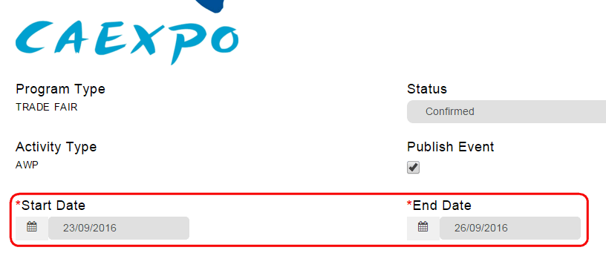

**Planning> Activity – Edit Screen**

