Test Issue Log |  |  |  |  | Issue ID#: TPMS_Prod008
Project Name: | Trade Promotion Management System (TPMS)
Test Stage: | Unit Functionality Integration System Interface  Performance Regression Acceptance Pilot
Test Case Number: | Support #5882 |  |  | Test Started Date: |  | 5/1/2016
Test Title: | To allow multiple select for event publication filter
Test Description: | System should allow to search for each event filter.
Test Functionality: | External – Matrade Portal > Event Publication List  Internal - Promotion > Event Publication List
Test Procedure: | - Click on Promotion > Event Publication List button  - Select any filter.  - Click on Clear Search button
Test Result: | Pass: Fail: Conditional Pass: |  | Tested by: |  | Siti Norahayu
Reason for Failed / Conditional Pass:
TEST DESCRIPTION
Click on Promotion > Event Publication List button
Result:
System display event listing page

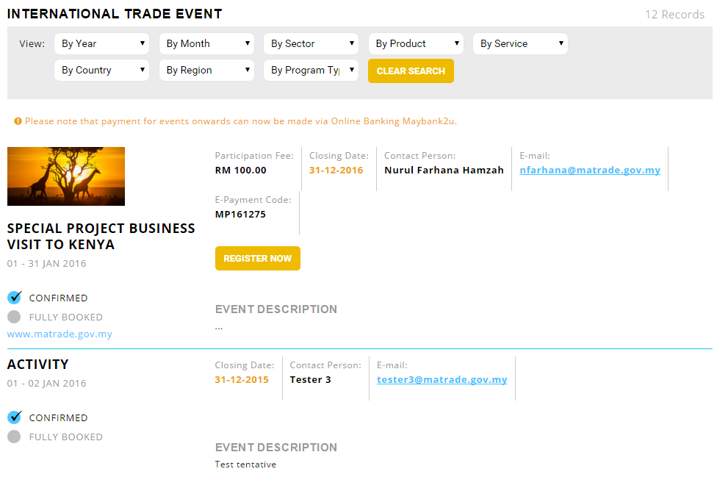

Select/choose any filter.
Result:
System display event based on filter selection.

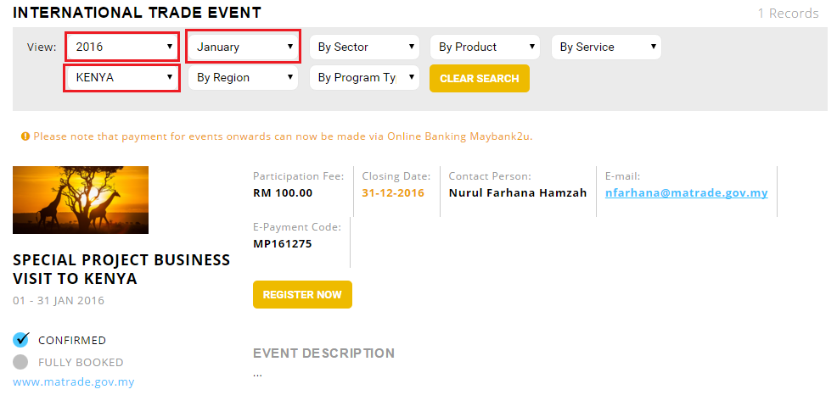

Click on Clear Search button
Result:
System clear all filters selection.

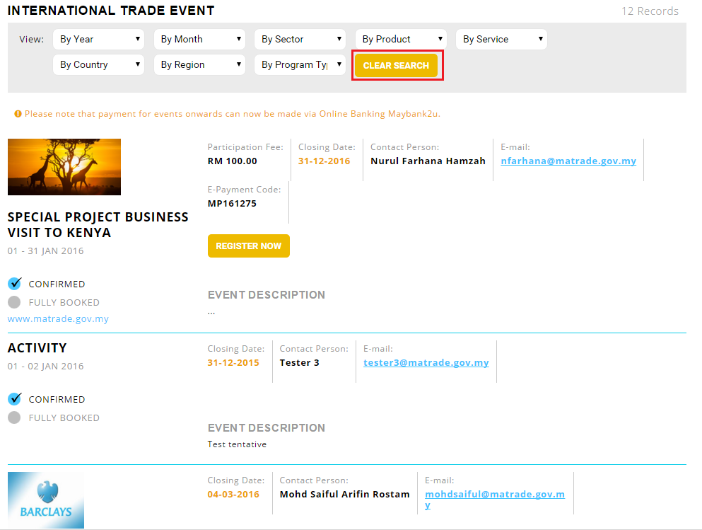

Reviewed By: (PMO)
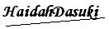 |  | Name/Position : NorhaidahBintiMdDasuki / Senior Manager, Quality Assurance and Support  Date : 5/1/2016

