Test Issue Log |  |  |  |  | Issue ID#: TPMS_Prod026
Project Name: | Trade Promotion Management System (TPMS)
Test Stage: | Unit Functionality Integration System Interface  Performance Regression Acceptance Pilot
Test Case Number: | Support #5902 |  |  | Test Started Date: |  | 7/1/2016
Test Title: | Update the Budget approved and Budget requested value to null.
Test Description: | Budget approved and Budget requested are migrated based on “budget” from source data files.
Test Functionality: | Click on Planning > Budget > Activity Budget Allocation
Test Procedure: | - Click on Planning > Budget > Activity Budget Allocation  - Search for related event  - View search result
Test Result: | Pass: Fail: Conditional Pass: |  | Tested by: |  | Siti Norahayu
Reason for Failed / Conditional Pass:
TEST DESCRIPTION
Click on Planning > Budget > Activity Budget Allocation
Result:
System display the user listing page

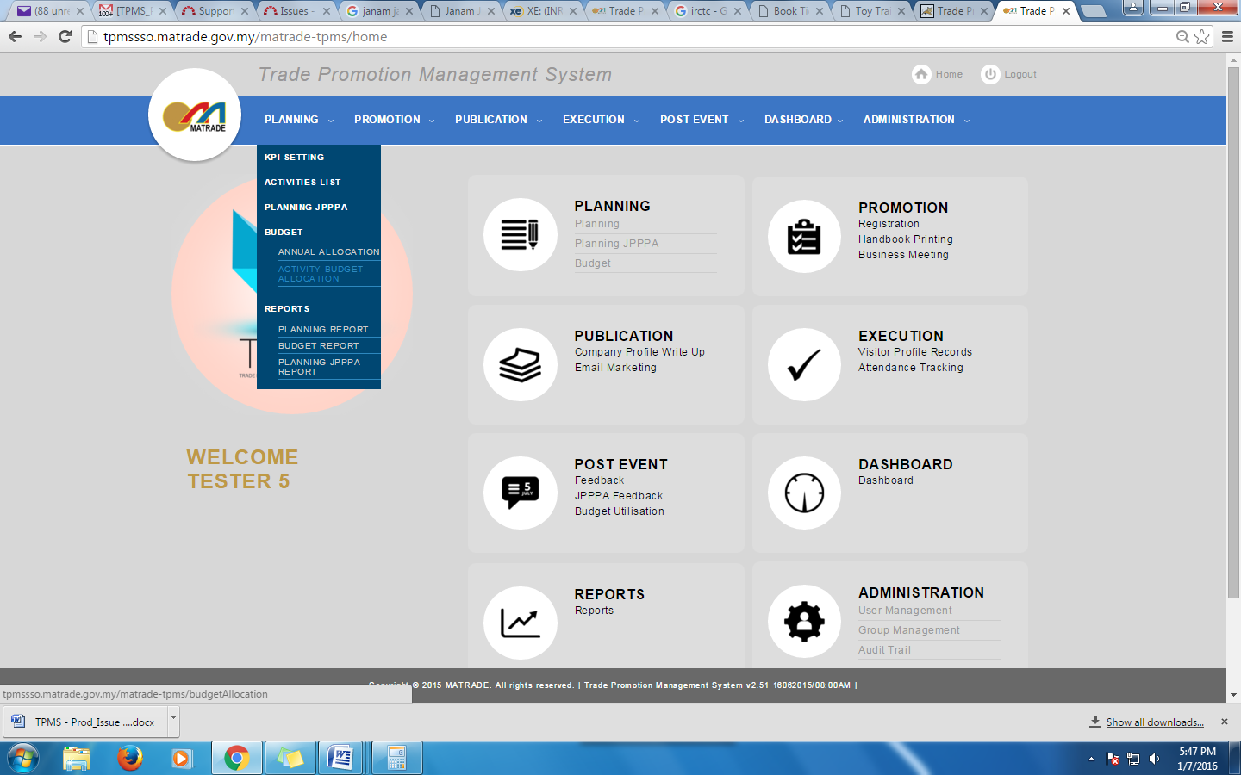
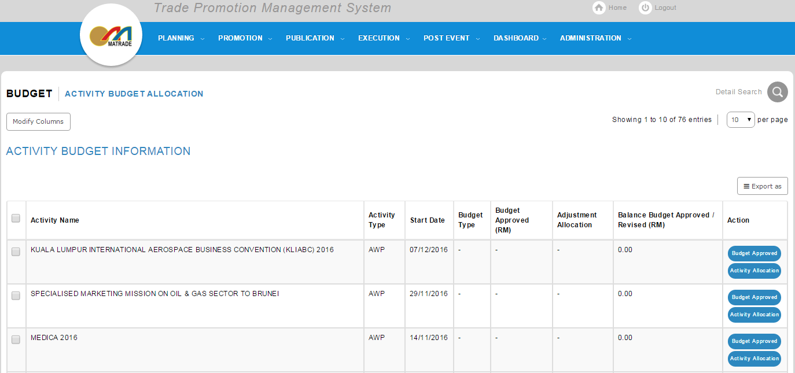

Search for event SPECIALISED MARKETING MISSION (SMM) FOR CONSTRUCTION AND BUILDING MATERIALS TO SYDNEY AND PERTH, AUSTRALIA
Result:
System display the search result page

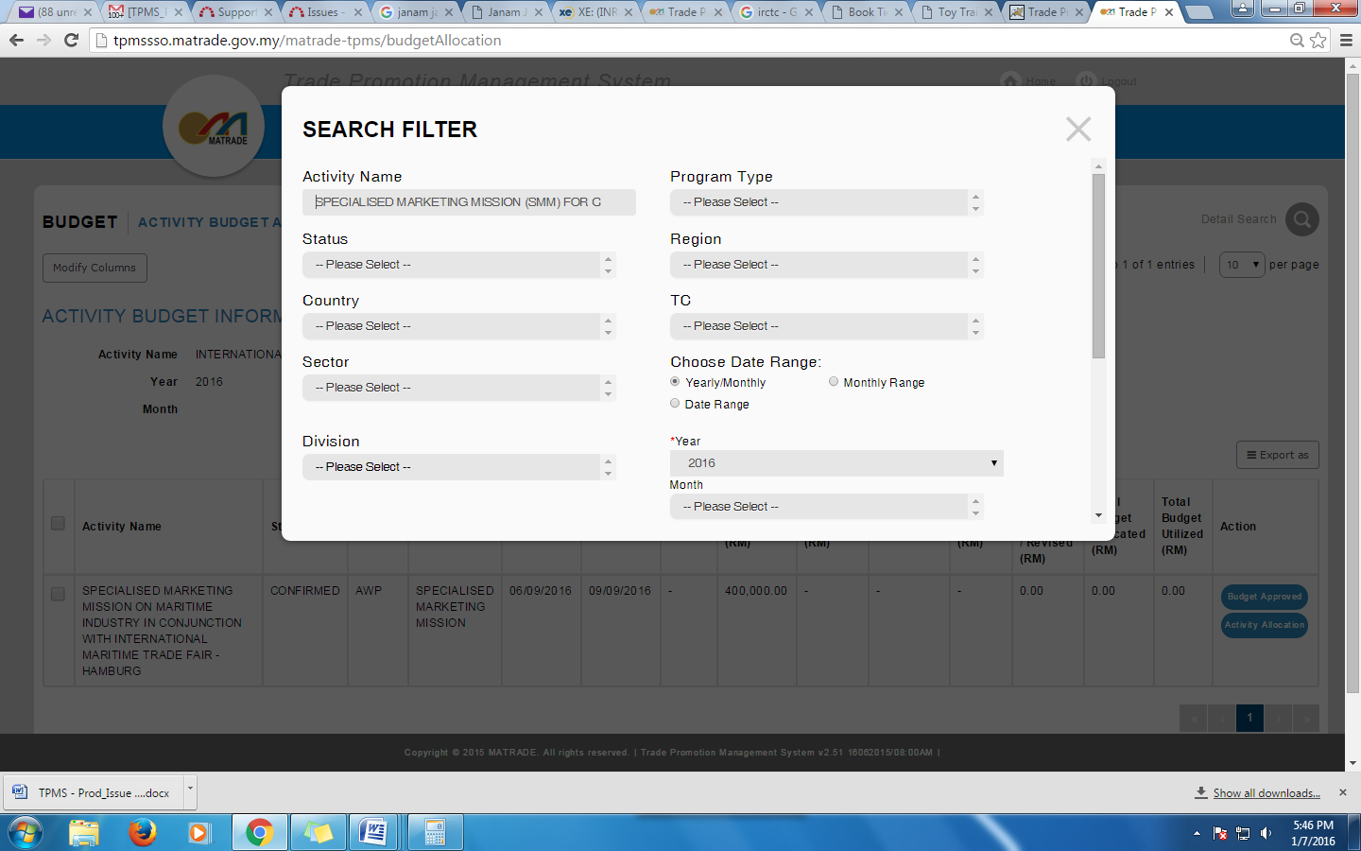
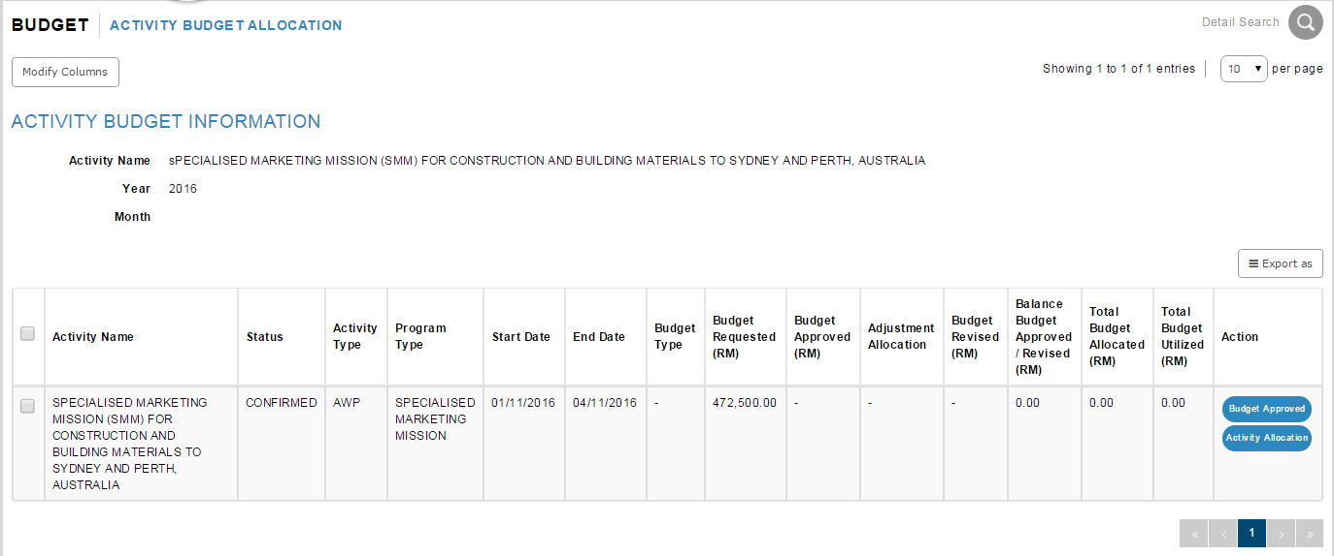

Search for event SPECIALISED MARKETING MISSION ON MARITIME INDUSTRY IN CONJUNCTION WITH INTERNATIONAL MARITIME TRADE FAIR - HAMBURG
Result:
System display the search result page

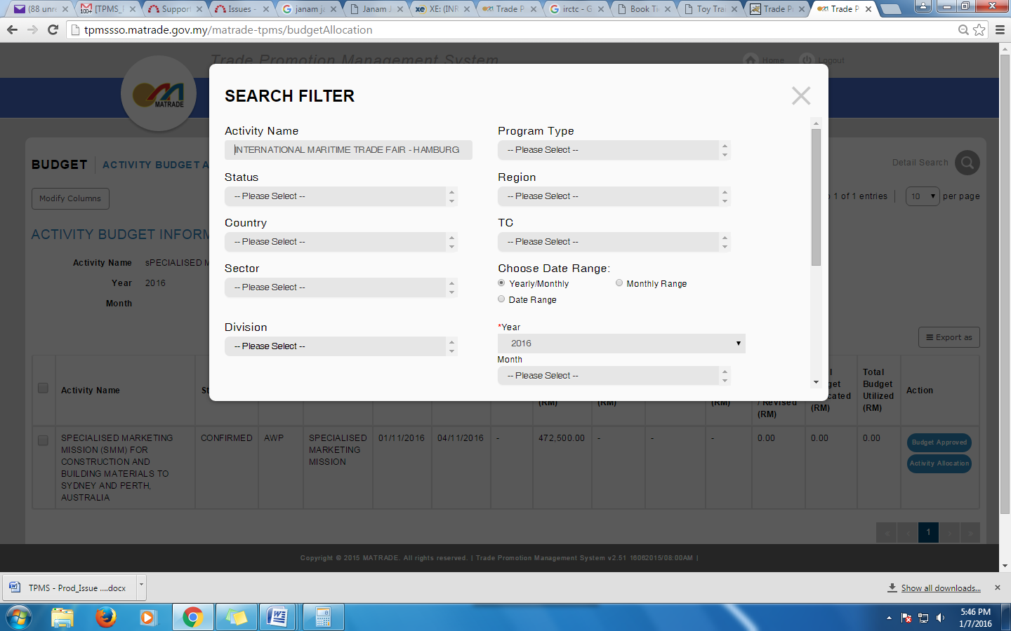
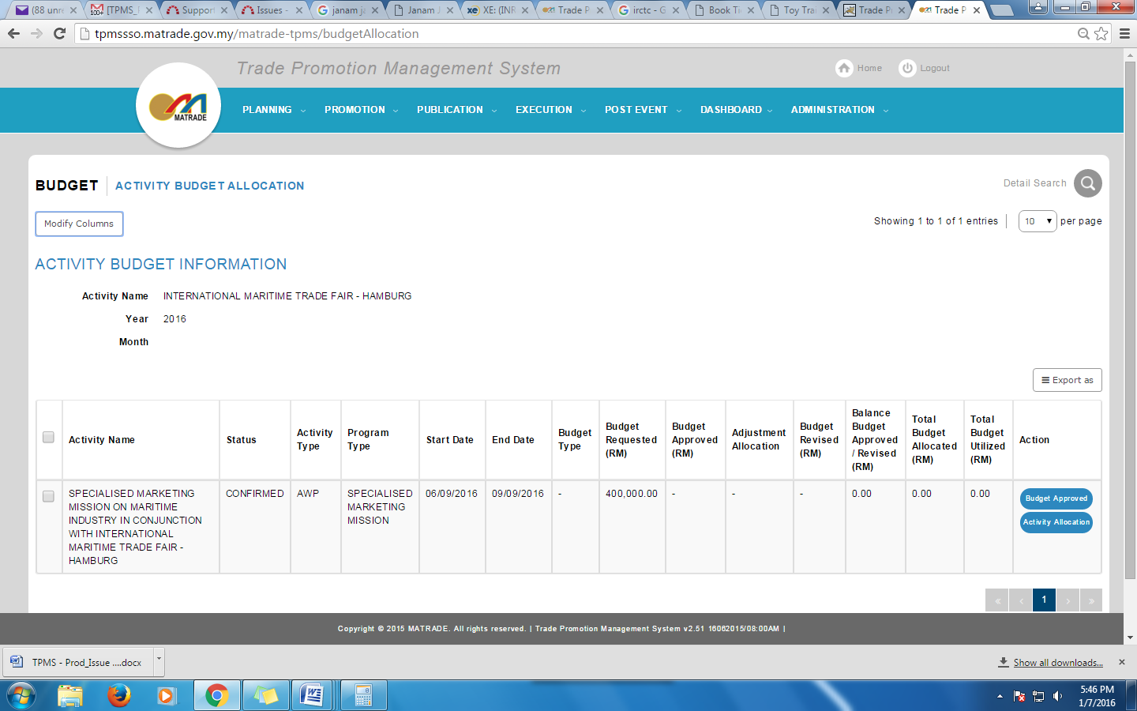

Reviewed By: (PMO)
 |  | Name/Position : NorhaidahBintiMdDasuki / Senior Manager, Quality Assurance and Support  Date : 7/1/2016

