Bug 1.5 - Upload file
- Contribution Month : 000000
Header Record,Customer ID,Customer Batch No,Batch Name,Batch Date,Payment Date/Value Date (VD),Payment Currency,Employer EPF No,Contribution Month,Contact Person Name,Contact Phone No,,,,,,
H,2,455,Batch Name,20101120,20101129,MYR,102147661,000000,,,,,,,,
Payment Record,Payment Type,Payment Reference No,Payment Detail,Employer Contribution,Member Contribution,Member Wages,Bene IC / ID / Registration No,Bene Name,Member EPF No,,,,,,,
P,EPF,1,,100.00,100.00,1500.00,8312021123,Bene Name,00110505,,,,,,,
Trailer Record,Total Record,Total Amount,,,,,,,,,,,,,,
T,1,200.00,,,,,,,,,,,,,,

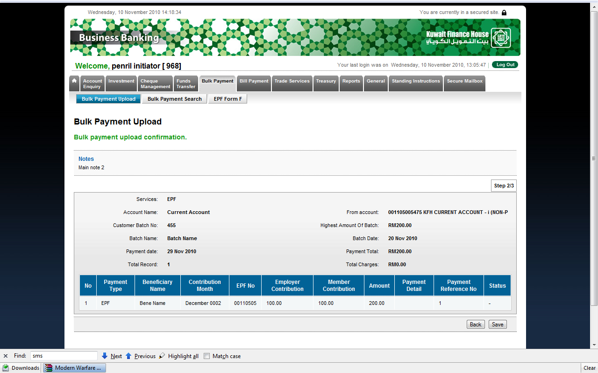

- Contact Person Name : zxczxc ._32423423(BRS = Alphabet , System = alphanumeric, space, dot and underscore) which one is correct

Header Record,Customer ID,Customer Batch No,Batch Name,Batch Date,Payment Date/Value Date (VD),Payment Currency,Employer EPF No,Contribution Month,Contact Person Name,Contact Phone No,,,,,,
H,2,455,Batch Name,20101120,20101129,MYR,102147661,102009,zxczxc ._32423423,,,,,,,
Payment Record,Payment Type,Payment Reference No,Payment Detail,Employer Contribution,Member Contribution,Member Wages,Bene IC / ID / Registration No,Bene Name,Member EPF No,,,,,,,
P,EPF,1,,100.00,100.00,1500.00,8312021123,Bene Name,00110505,,,,,,,
Trailer Record,Total Record,Total Amount,,,,,,,,,,,,,,
T,1,200.00,,,,,,,,,,,,,,

- Contact Phone No : werewrwer23432432 _.(BRS = Numeric , System = alphanumeric, space, dot and underscore) which one is correct

Header Record,Customer ID,Customer Batch No,Batch Name,Batch Date,Payment Date/Value Date (VD),Payment Currency,Employer EPF No,Contribution Month,Contact Person Name,Contact Phone No,,,,,,
H,2,455,Batch Name,20101120,20101129,MYR,102147661,102009,,zxczxc ._32423423,,,,,,
Payment Record,Payment Type,Payment Reference No,Payment Detail,Employer Contribution,Member Contribution,Member Wages,Bene IC / ID / Registration No,Bene Name,Member EPF No,,,,,,,
P,EPF,1,,100.00,100.00,1500.00,8312021123,Bene Name,00110505,,,,,,,
Trailer Record,Total Record,Total Amount,,,,,,,,,,,,,,
T,1,200.00,,,,,,,,,,,,,,

- Payment Type : empty (required field)

Header Record,Customer ID,Customer Batch No,Batch Name,Batch Date,Payment Date/Value Date (VD),Payment Currency,Employer EPF No,Contribution Month,Contact Person Name,Contact Phone No,,,,,,
H,2,455,Batch Name,20101120,20101129,MYR,102147661,102009,,,,,,,,
Payment Record,Payment Type,Payment Reference No,Payment Detail,Employer Contribution,Member Contribution,Member Wages,Bene IC / ID / Registration No,Bene Name,Member EPF No,,,,,,,
P,,1,,100.00,100.00,1500.00,8312021123,Bene Name,00110505,,,,,,,
Trailer Record,Total Record,Total Amount,,,,,,,,,,,,,,
T,1,200.00,,,,,,,,,,,,,,

- Amount : 200000000000.00 (BRS = 12.2 , System = 10.2)

Header Record,Customer ID,Customer Batch No,Batch Name,Batch Date,Payment Date/Value Date (VD),Payment Currency,Employer EPF No,Contribution Month,Contact Person Name,Contact Phone No,,,,,,
H,2,455,Batch Name,20101120,20101129,MYR,102147661,102009,,,,,,,,
Payment Record,Payment Type,Payment Reference No,Payment Detail,Employer Contribution,Member Contribution,Member Wages,Bene IC / ID / Registration No,Bene Name,Member EPF No,,,,,,,
P,,1,,100000000000.00 ,100000000000.00 ,1500.00,8312021123,Bene Name,00110505,,,,,,,
Trailer Record,Total Record,Total Amount,,,,,,,,,,,,,,
T,1,200000000000.00,,,,,,,,,,,,,,

- Bene IC / ID / Registration No : Empty (required field)

Header Record,Customer ID,Customer Batch No,Batch Name,Batch Date,Payment Date/Value Date (VD),Payment Currency,Employer EPF No,Contribution Month,Contact Person Name,Contact Phone No,,,,,,
H,2,455,Batch Name,20101120,20101129,MYR,102147661,102009,,,,,,,,
Payment Record,Payment Type,Payment Reference No,Payment Detail,Employer Contribution,Member Contribution,Member Wages,Bene IC / ID / Registration No,Bene Name,Member EPF No,,,,,,,
P,,1,,100.00,100.00,1500.00,,Bene Name,00110505,,,,,,,
Trailer Record,Total Record,Total Amount,,,,,,,,,,,,,,
T,1,200.00,,,,,,,,,,,,,,

- Bene IC / ID / Registration No : wer ._-@234 (BRS=alphanumeric space, dot and underscore , System = alphanumeric , special character)

Header Record,Customer ID,Customer Batch No,Batch Name,Batch Date,Payment Date/Value Date (VD),Payment Currency,Employer EPF No,Contribution Month,Contact Person Name,Contact Phone No,,,,,,
H,2,455,Batch Name,20101120,20101129,MYR,102147661,102009,,,,,,,,
Payment Record,Payment Type,Payment Reference No,Payment Detail,Employer Contribution,Member Contribution,Member Wages,Bene IC / ID / Registration No,Bene Name,Member EPF No,,,,,,,
P,,1,,100.00,100.00,1500.00,wer ._-@234,Bene Name,00110505,,,,,,,
Trailer Record,Total Record,Total Amount,,,,,,,,,,,,,,
T,1,200.00,,,,,,,,,,,,,,

- Beneficiary Name : wer ._-@234 (BRS=alphanumeric space, dot and underscore , System = alphanumeric , special character)

Header Record,Customer ID,Customer Batch No,Batch Name,Batch Date,Payment Date/Value Date (VD),Payment Currency,Employer EPF No,Contribution Month,Contact Person Name,Contact Phone No,,,,,,
H,2,455,Batch Name,20101120,20101129,MYR,102147661,102009,,,,,,,,
Payment Record,Payment Type,Payment Reference No,Payment Detail,Employer Contribution,Member Contribution,Member Wages,Bene IC / ID / Registration No,Bene Name,Member EPF No,,,,,,,
P,,1,,100.00,100.00,1500.00,8312021123,wer ._-@234,00110505,,,,,,,
Trailer Record,Total Record,Total Amount,,,,,,,,,,,,,,
T,1,200.00,,,,,,,,,,,,,,

