Test Issue Log |  |  |  |  | Issue ID#: TPMS_Prod015
Project Name: | Trade Promotion Management System (TPMS)
Test Stage: | Unit Functionality Integration System Interface  Performance Regression Acceptance Pilot
Test Case Number: | Support #5887 |  |  | Test Started Date: |  | 13/1/2016
Test Title: | To add “Tentative” checkbox and sync the updated changes in Planning
Test Description: | When update the exact event date in the Event Info in Promotion Tab, the event date in Planning still display as Tentative.
Test Functionality: | Planning > Activities List > Edit  Promotion > Event Info > Edit
Test Procedure: | - Click on Planning > Activities List > Edit  - Click on Promotion > Event Info > Edit
Test Result: | Pass: Fail: Conditional Pass: |  | Tested by: |  | Siti Norahayu
Reason for Failed / Conditional Pass:
TEST DESCRIPTION
Click on Planning > Activities List > Edit
Result:
System display edit page

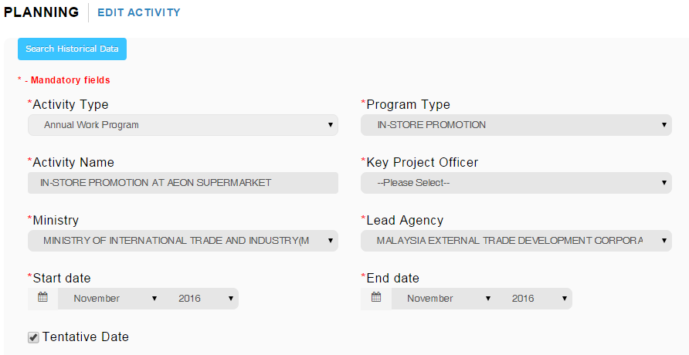

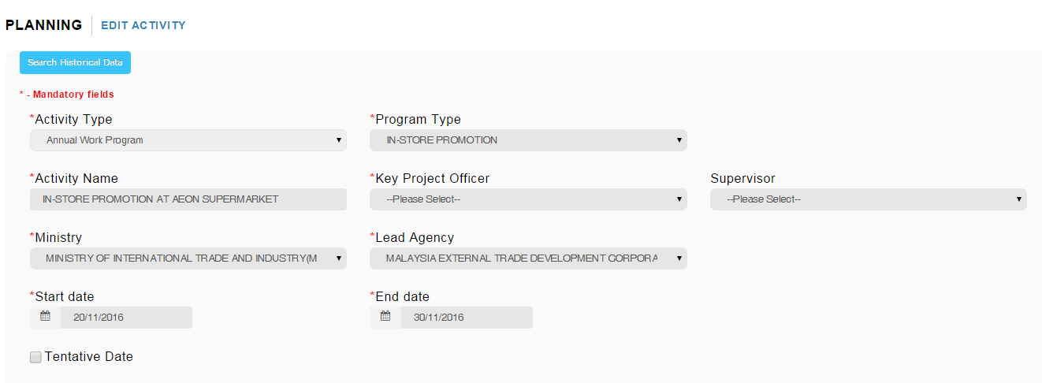

Click on Promotion > Event Info > Edit
Result:
System display edit page

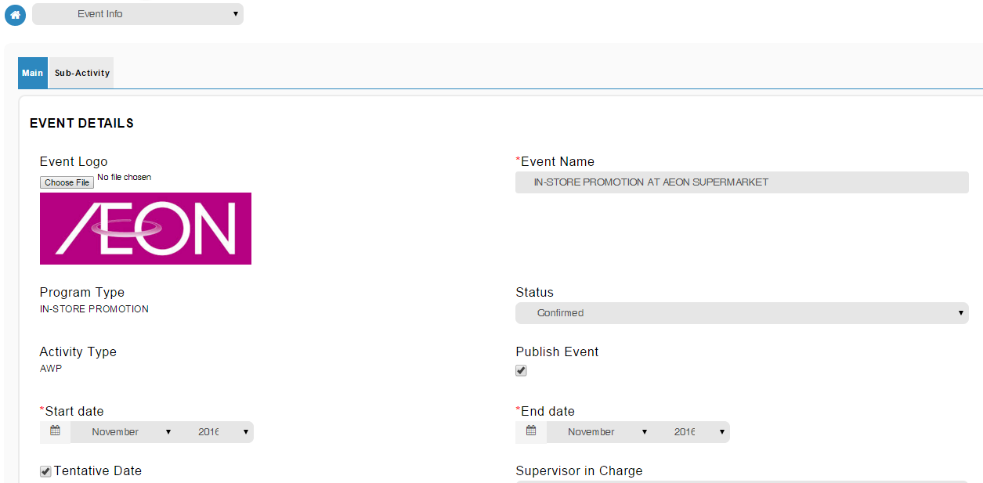

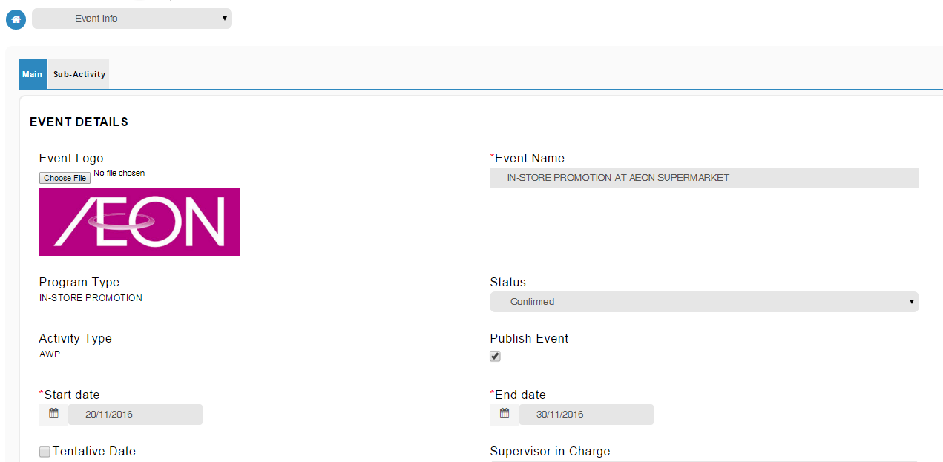

Reviewed By: (PMO)
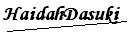 |  | Name/Position : NorhaidahBintiMdDasuki / Senior Manager, Quality Assurance and Support  Date : 13/1/2016

