Test Issue Log |  |  |  |  | Issue ID#: TPMS_Prod020
Project Name: | Trade Promotion Management System (TPMS)
Test Stage: | Unit Functionality Integration System Interface  Performance Regression Acceptance Pilot
Test Case Number: | Support #5893 |  |  | Test Started Date: |  | 13/1/2016
Test Title: | Media value doesn’t have value in original system but in TPMS it has copied value from no. of visitor.
Test Description: | To make sure media value takes from correct column and not copied from no. of visitor column.
Test Functionality: | Click on Post Event > JPPPA Programmes
Test Procedure: | - Click on Post Event > JPPPA Programmes > View  - Click on Post Event > JPPPA Programmes > Edit
Test Result: | Pass: Fail: Conditional Pass: |  | Tested by: |  | Siti Norahayu
Reason for Failed / Conditional Pass:
TEST DESCRIPTION
Click on Post Event > JPPPA Programmes > View
Result:
System display view page

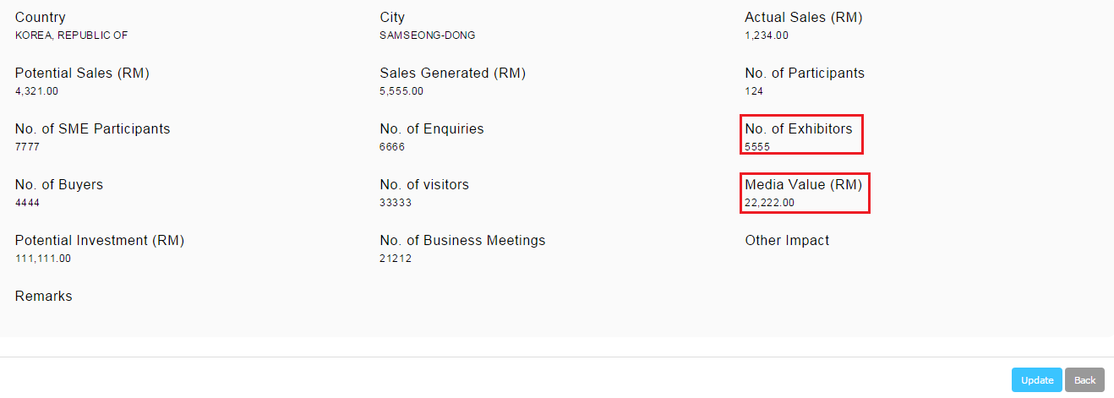

Click on Post Event > JPPPA Programmes > Edit
Result:
System display view page

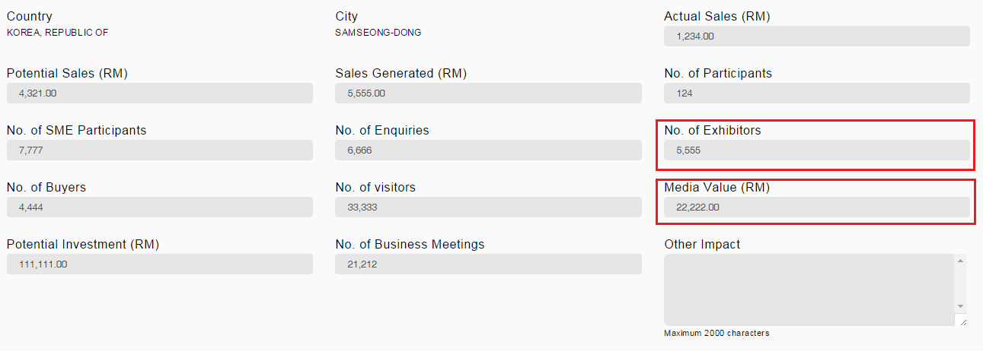

Reviewed By: (PMO)
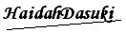 |  | Name/Position : NorhaidahBintiMdDasuki / Senior Manager, Quality Assurance and Support  Date : 13/1/2016

