Test Issue Log |  |  |  |  | Issue ID#: TPMS_Prod033
Project Name: | Trade Promotion Management System (TPMS)
Test Stage: | Unit Functionality Integration System Interface  Performance Regression Acceptance Pilot
Test Case Number: | Support #5921 |  |  | Test Started Date: |  | 14/1/2016
Test Title: | Sort the country list by alphabetical order.
Test Description: | To sort the country list by alphabetical order in Registration form for Public & Internal
Test Functionality: | Promotion> Registration - Registration Form
Test Procedure: | - Click on Promotion> Registration - Registration Form  - MATRADE Portal > Register Now button.
Test Result: | Pass: Fail: Conditional Pass: |  | Tested by: |  | Siti Norahayu
Reason for Failed / Conditional Pass:
TEST DESCRIPTION
MATRADE Portal > Register Now button.
Result:
System display Registration Form page

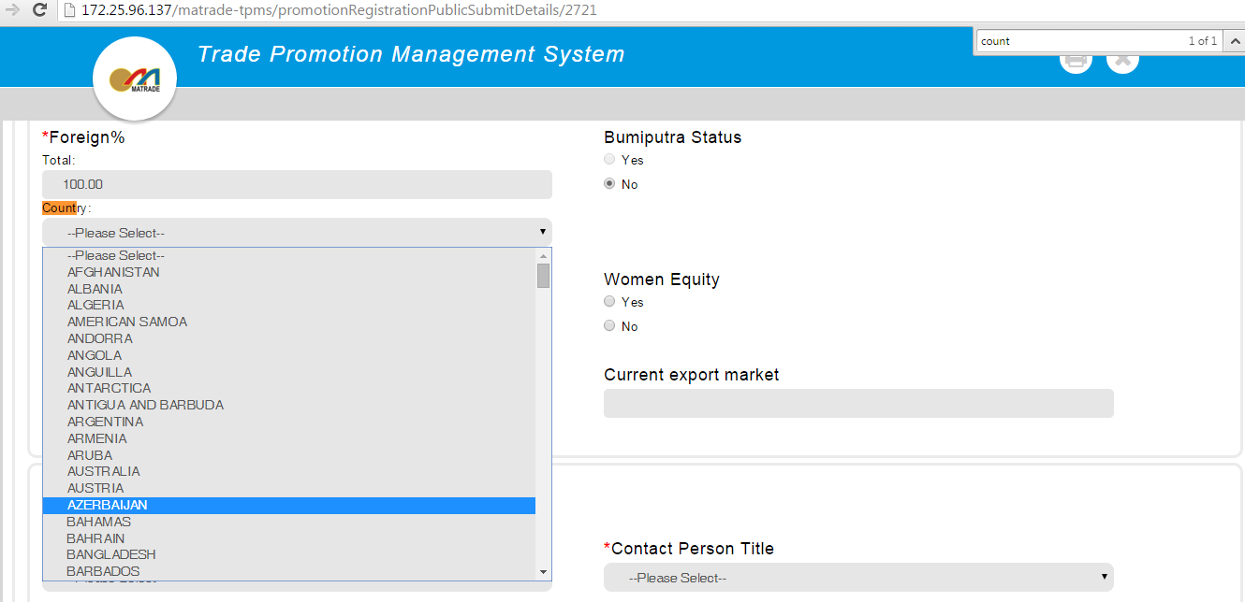

Click on Promotion> Registration
Result:
System display Registration Form page

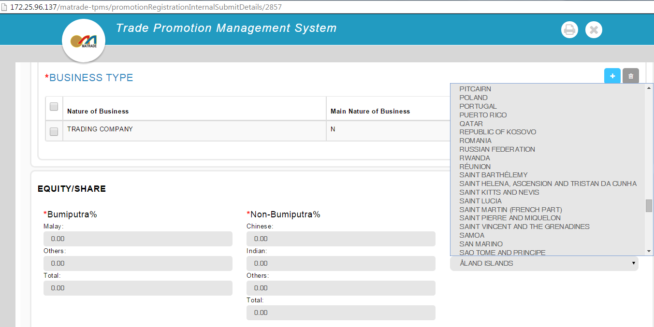

Reviewed By: (PMO)
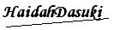 |  | Name/Position : NorhaidahBintiMdDasuki / Senior Manager, Quality Assurance and Support  Date : 14/1/2016

