Test Issue Log |  |  |  |  | Issue ID#: TPMS_Prod033
Project Name: | Trade Promotion Management System (TPMS)
Test Stage: | Unit Functionality Integration System Interface  Performance Regression Acceptance Pilot
Test Case Number: | Support #5901 |  |  | Test Started Date: |  | 14/1/2016
Test Title: | Registration public setup change without edit by user.
Test Description: | To make sure check box for Public Registration not default as false
Test Functionality: | Promotion > Event Setup > Other Module
Test Procedure: | - Click on Promotion > Event Setup > Other Module - Public
Test Result: | Pass: Fail: Conditional Pass: |  | Tested by: |  | Siti Norahayu
Reason for Failed / Conditional Pass:
TEST DESCRIPTION
Click on Promotion > Event Setup > Other Module - Public
Result:
System display Registration details page

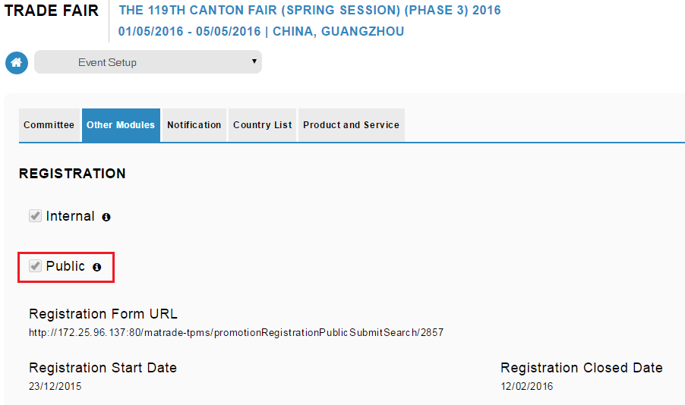

MATRADE Portal
Result:
System display Register Now button.
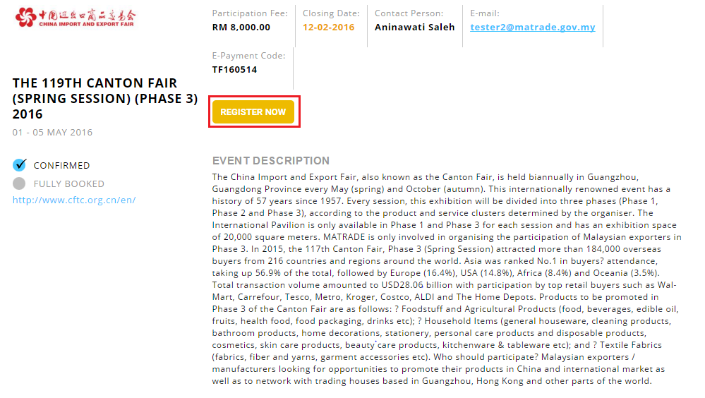
Reviewed By: (PMO)
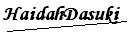 |  | Name/Position : NorhaidahBintiMdDasuki / Senior Manager, Quality Assurance and Support  Date : 14/1/2016

