Test Issue Log |  |  |  |  | Issue ID#: TPMS_Prod023
Project Name: | Trade Promotion Management System (TPMS)
Test Stage: | Unit Functionality Integration System Interface  Performance Regression Acceptance Pilot
Test Case Number: | Support #5899 |  |  | Test Started Date: |  | 15/1/2016
Test Title: | Website url in Event details setting
Test Description: | Checking website url link to update link properly before open web page.
Test Functionality: | Promotion > Event Info > Main
Test Procedure: | - Click on Promotion > Event Info > Main
Test Result: | Pass: Fail: Conditional Pass: |  | Tested by: |  | Siti Norahayu
Reason for Failed / Conditional Pass:
TEST DESCRIPTION
Click on Promotion > Event Info > Main
Result:
System display Event details page.

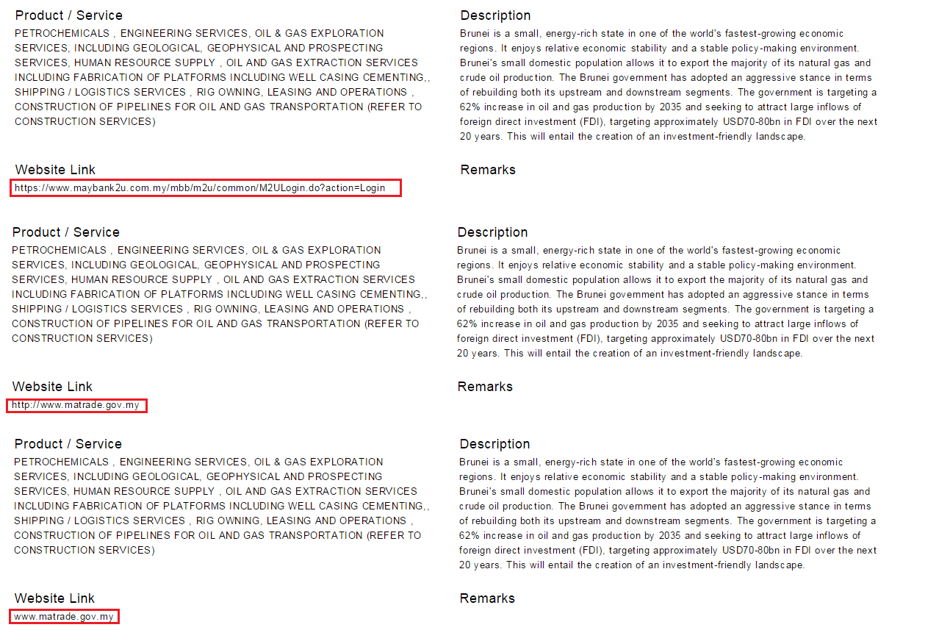

Reviewed By: (PMO)
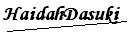 |  | Name/Position : NorhaidahBintiMdDasuki / Senior Manager, Quality Assurance and Support  Date : 15/1/2016

