***Issue Form (PROD)***

|  |  |
| --- | --- |
| **Originator's Name:** Norharizal Bin Ishak  **Project:** Trade Promotion Management System (TPMS)  **Project Manager:** NorharizalBinIshak  **Module :** Promotion  **Date Raised:** 15/1/2016  **Phase :** Phase 2_Module 3 - 8  **Functional Area :Promotion - Registration** | **Issue ID Number:** TPMS_Prod036  **Related Issue ID Number:** Redmine #5926  **Classification:**  **Priority:** Critical/High/Medium/Low  **Assigned to: Vendor / IT / PMO SA / UPA**  **Actual Closed Date:** |
| **Status:** Open/Assigned/Investigated/Resolved/Approved/Deferred/No Action  *(Circle one)* | |
| **Description :**  Reported by user:Form Empty  WhenProject Officer open the registration form, information that have been submitted such as address, phone number, company email, equity, contact information and representative were empty.  Event : INDONESIA INTERNATIONAL AUTO PARTS, ACCESSORIES & EQUIPMENT EXHIBITION 2016 (INAPA 2016)  Company : MULTI-CODE ELECTRONICS INDUSTRIES (M) BERHAD  *Please refer to file attached for further details.* | **Impact:** |
| **Findings/Root Caused (Description):** | **Resolution:** |
| **Estimated Impact :** |  |
| **Recommendation:** | |
| **Accepted : (Vendor / IT / PMO SA / UPA)**  **Date: 15/1/2016** | **Accepted (MATRADE Tester):**  **Date:** |

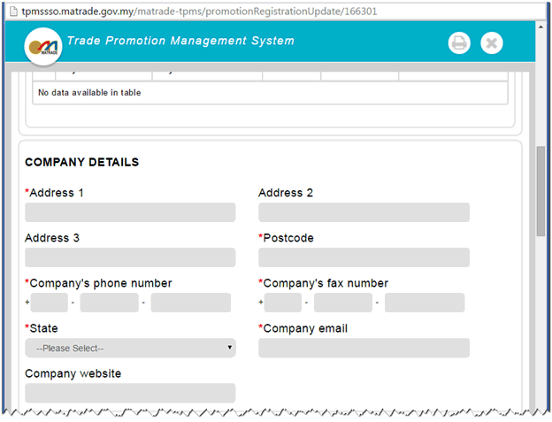

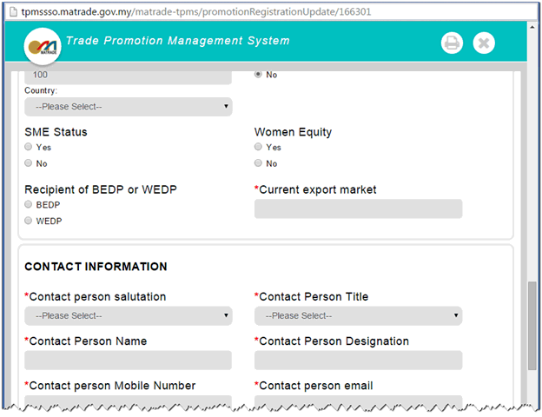

Also no valued to be selected in sector field.

