**Online Banking 🡪 Overview**

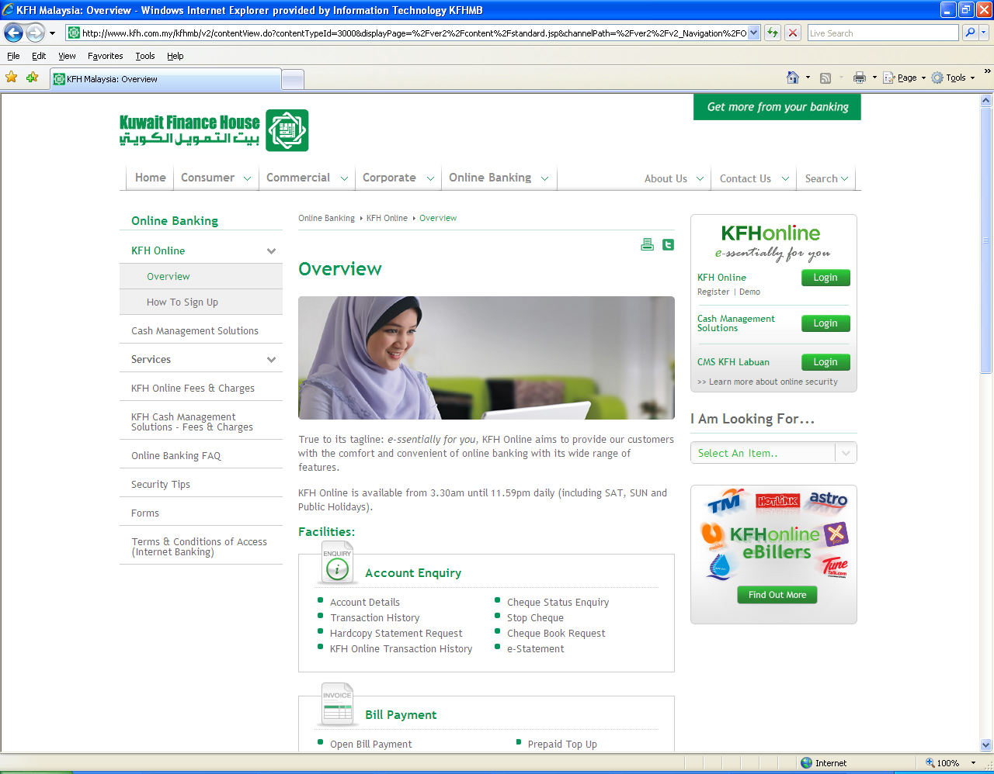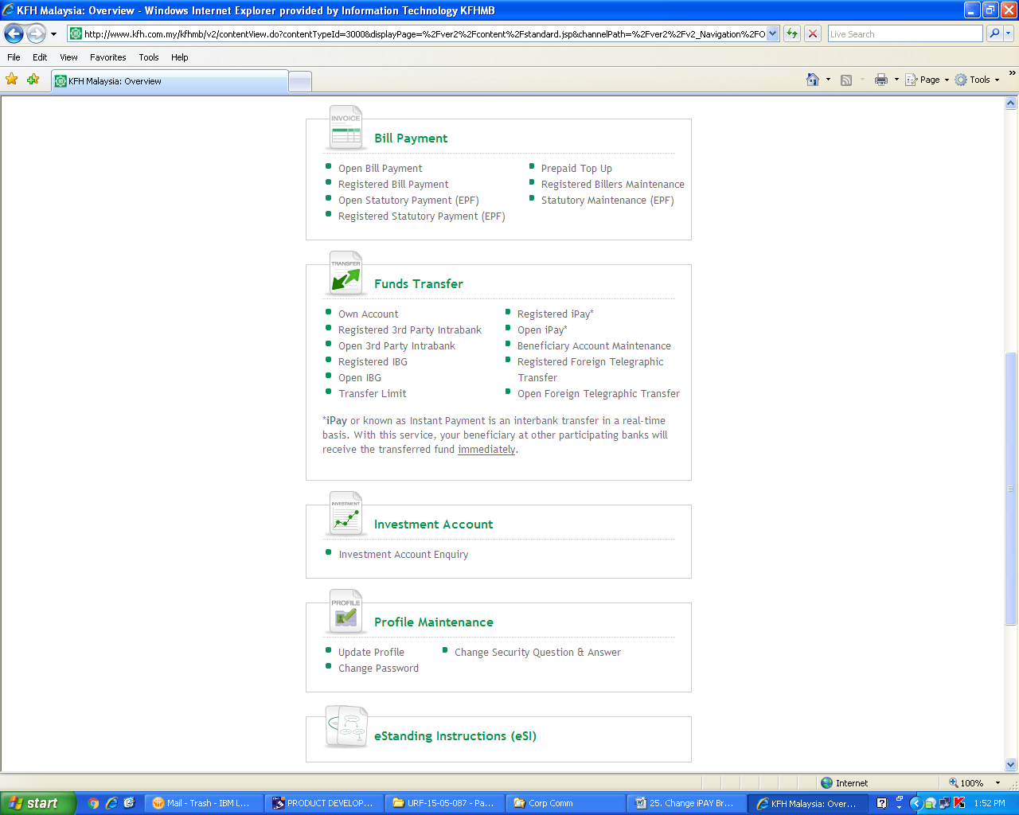

**To change “iPay” to**

**“Instant Transfer”**

**Services 🡪 iPay**

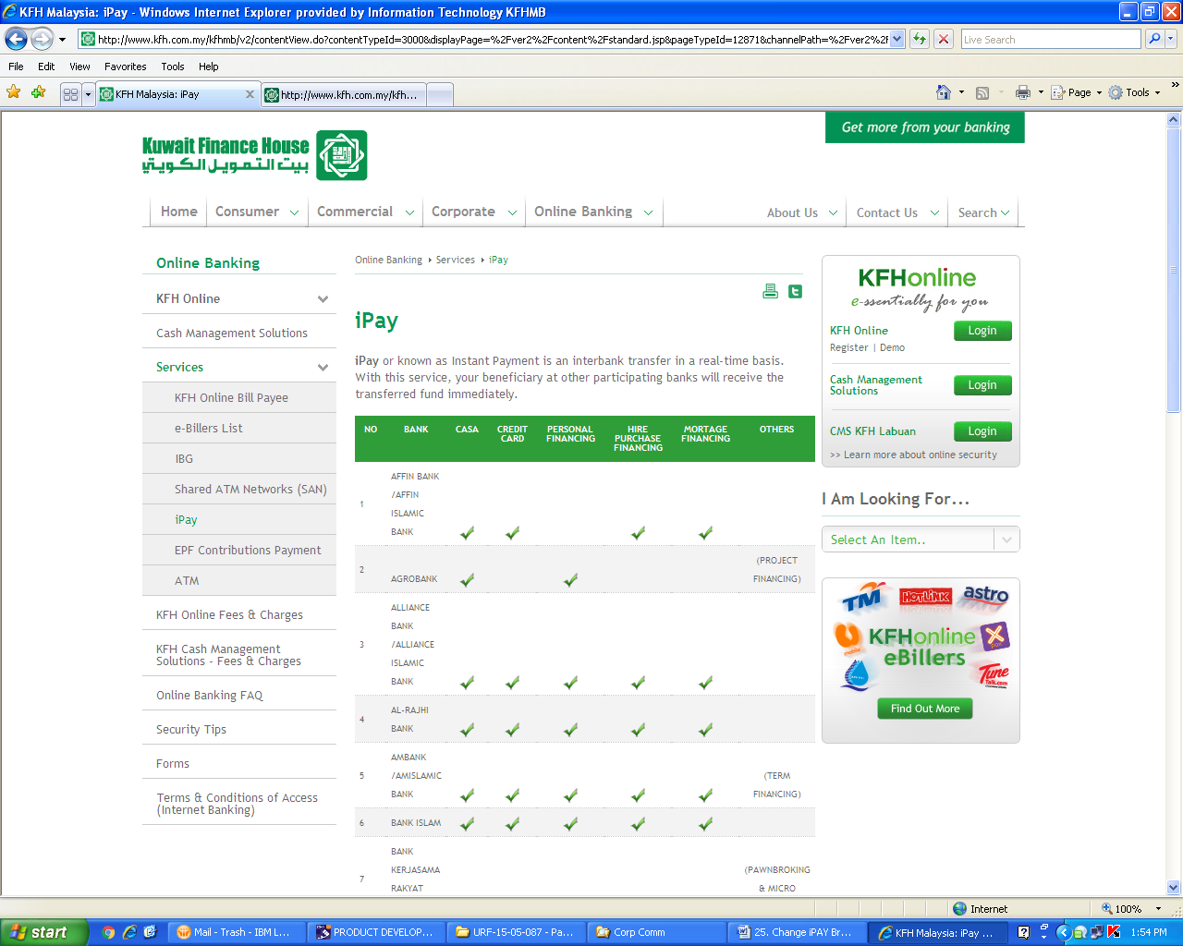

**Change to:**

**Instant Transfer is an interbank transfer in a real-time basis. With this service, your beneficiary at other participating banks will receive the transferred fund immediately.**

**To change “iPay” to**

**“Instant Transfer”**

**To change “iPay” to**

**“Instant Transfer”**

**To change “iPay” to**

**“Instant Transfer”**

**Services 🡪 IBG**

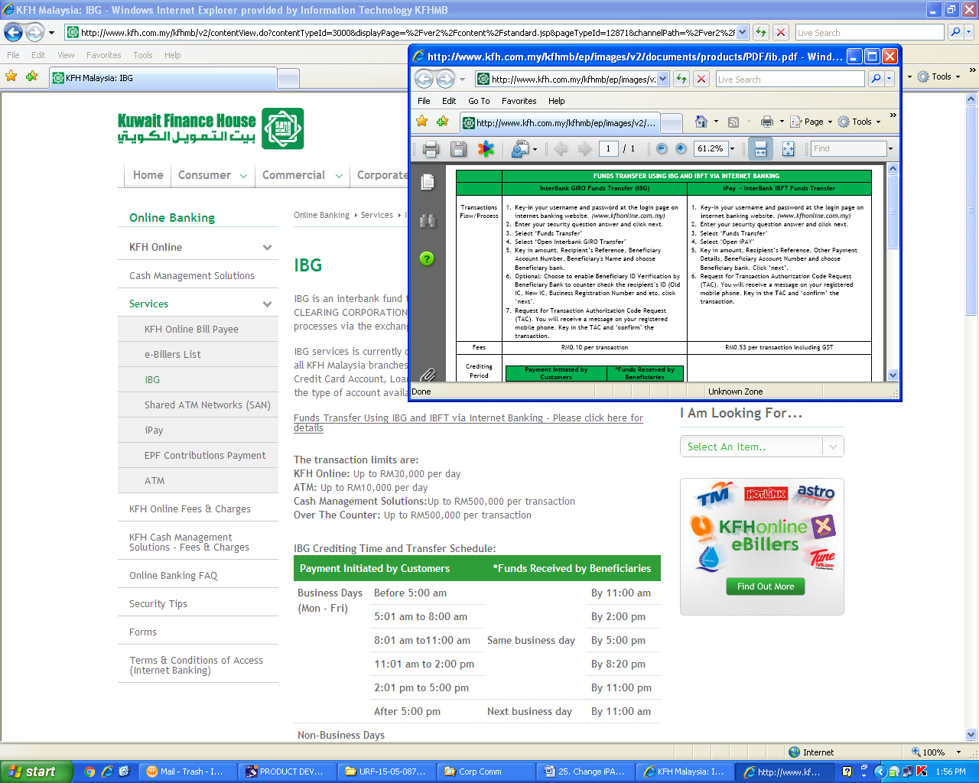

**Update with the amended version as attached below**

* **To upload the amended pdf file**



**Online Banking FAQ 🡪 Funds Transfer**

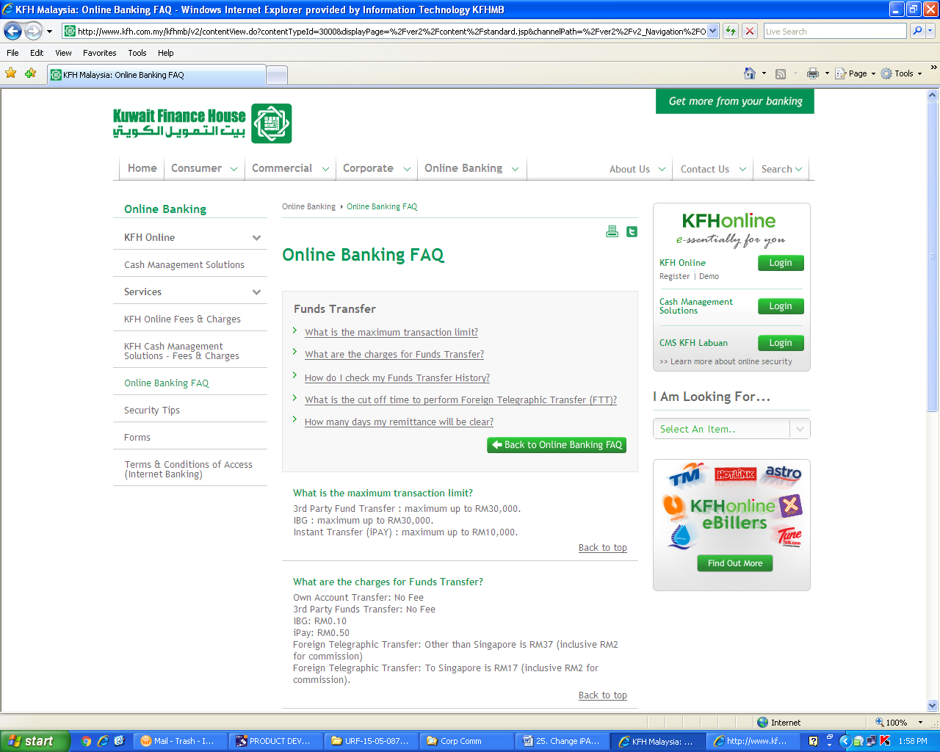

**To change “iPay” to**

**“Instant Transfer”**

**To remove “(iPAY)”**

**Deskmate 🡪 Products & Services 🡪 Fees & Charges**

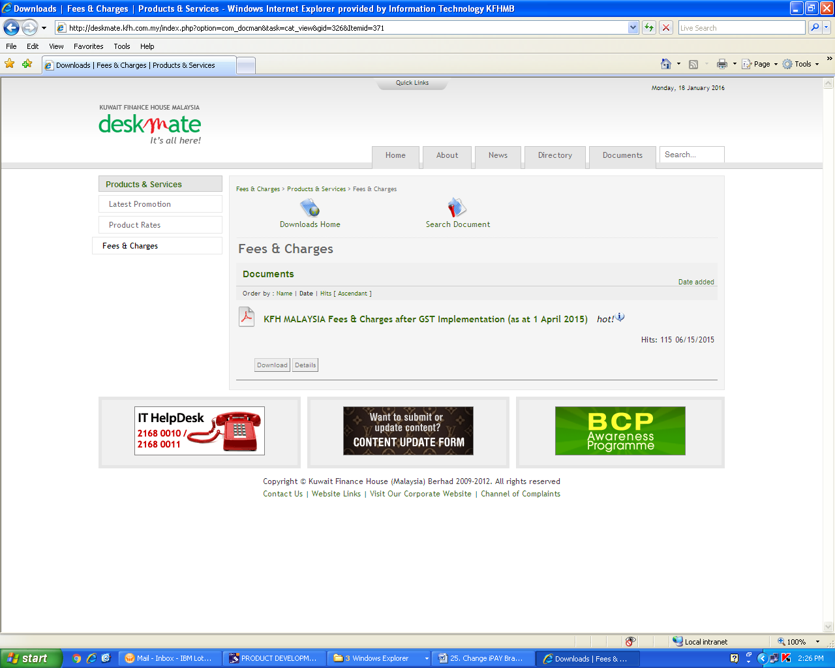

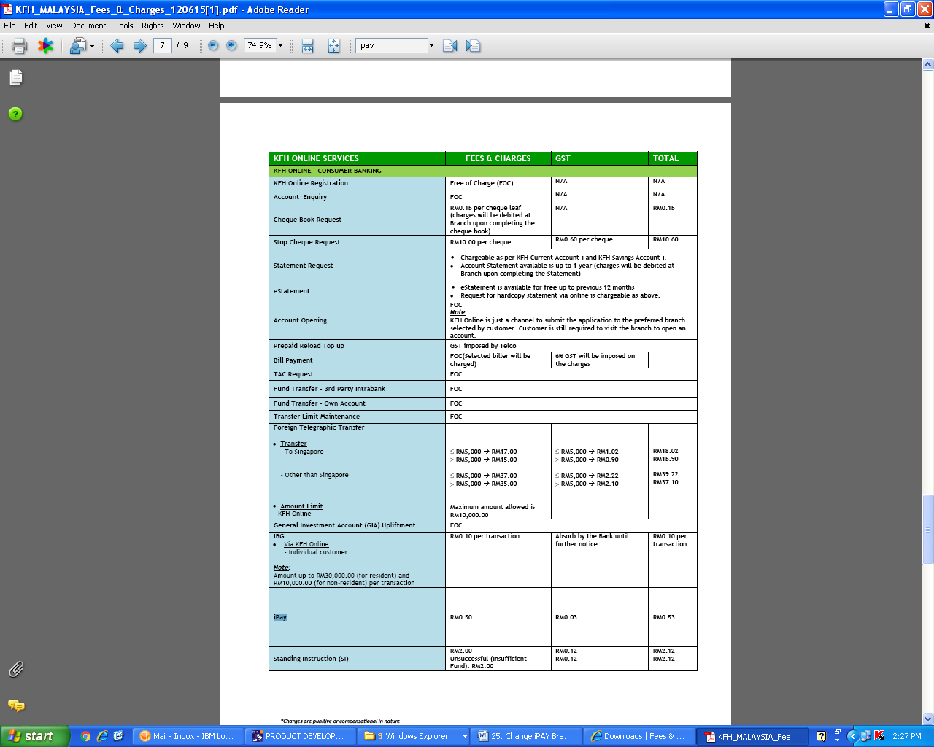

**To change “iPay” to**

**“Instant Transfer”**