Test Issue Log |  |  |  |  | Issue ID#: TPMS_UAT_097
Project Name: | Trade Promotion Management System (TPMS)
Test Stage: | Unit Functionality Integration System Interface  Performance Regression Acceptance Pilot
Test Case Number: | Support #5867 |  |  | Test Started Date: |  | 19/1/2016
Test Title: | To test on Summary of work programme report
Test Description: | - Data shall display by alphabetical order except month.  - Programme by Division change label Summary by Section. Apply to report and report parameter  - Remove column Proposed Budget at :  - Summary By TC  - Summary By Country  - Summary By Sector  - Summary By Region  - Summary By City  - Summary By Product/Services
Test Functionality: | Report > Report Planning > Overall Summary > Summary Of Work Programme
Test Procedure: | Click on Planning > Report Planning > Overall Summary > Summary Of Work Programme
Test Result: | Pass: Fail: Conditional Pass: |  | Tested by: |  | Siti Norahayu
Reason for Failed / Conditional Pass:
TEST DESCRIPTION
Click on Planning > Report Planning > Overall Summary > Summary Of Work Programme
Result:
System display selected report.
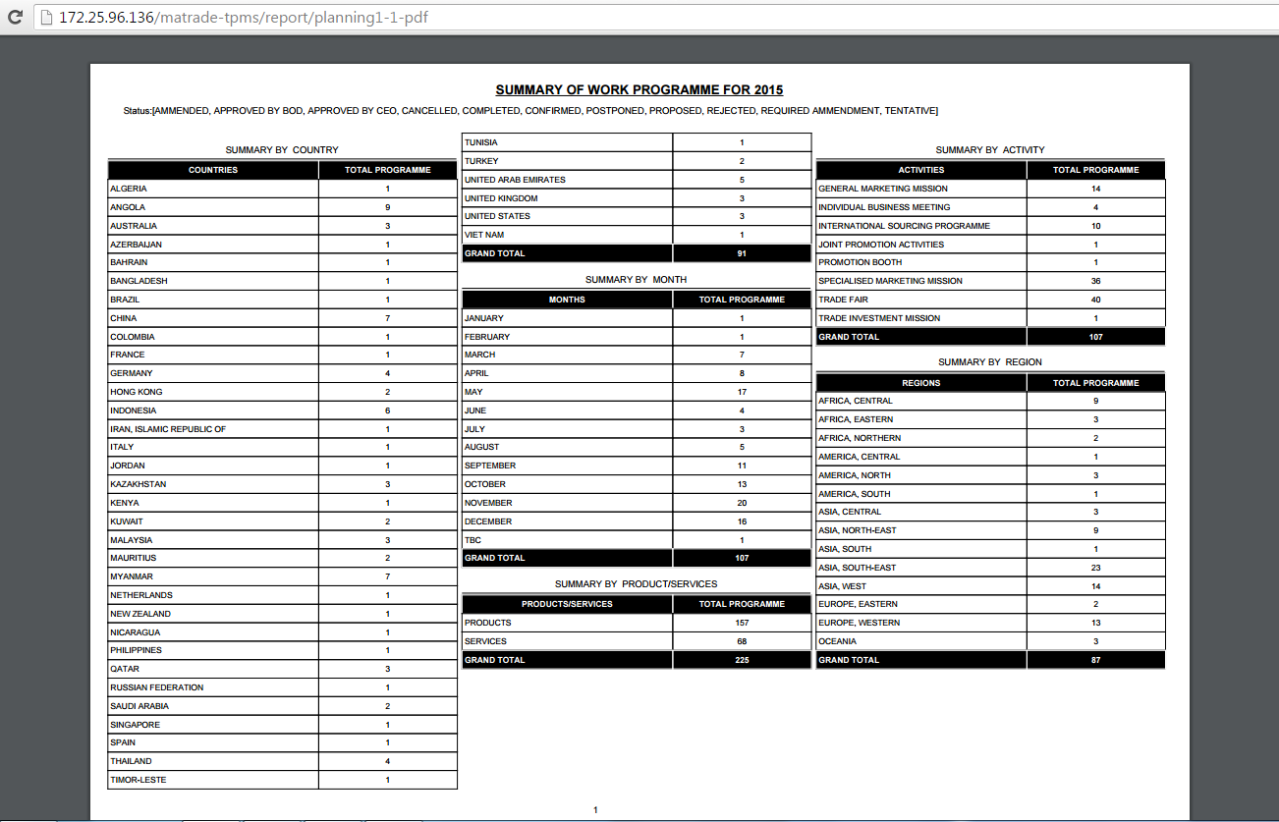
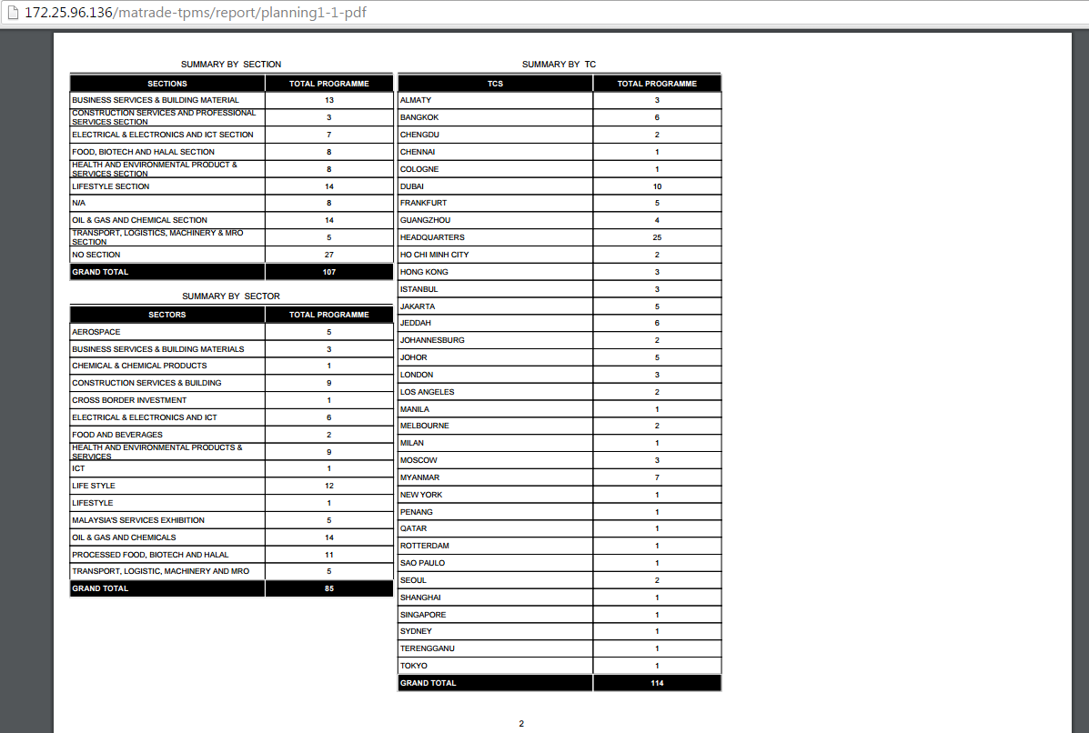

Reviewed By: (PMO)
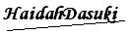 |  | Name/Position : NorhaidahBintiMdDasuki / Senior Manager, Quality Assurance and Support  Date : 19/1/2016

