Test Issue Log |  |  |  |  | Issue ID#: TPMS_UAT_027
Project Name: | Trade Promotion Management System (TPMS)
Test Stage: | Unit Functionality Integration System Interface  Performance Regression Acceptance Pilot
Test Case Number: | Support #5447 |  |  | Test Started Date: |  | 19/1/2016
Test Title: | Print button function at view page of KPI Setting
Test Description: | To test on print button at view page of KPI Setting
Test Functionality: | Planning > KPI Setting >View KPI > Print Button
Test Procedure: | - Click on Planning > KPI Setting > View KPI > Print Button
Test Result: | Pass: Fail: Conditional Pass: |  | Tested by: |  | Siti Norahayu
Reason for Failed / Conditional Pass:
TEST DESCRIPTION
Planning > KPI Setting >View KPI > Print Button
Result:
System display KPI details page in print format.

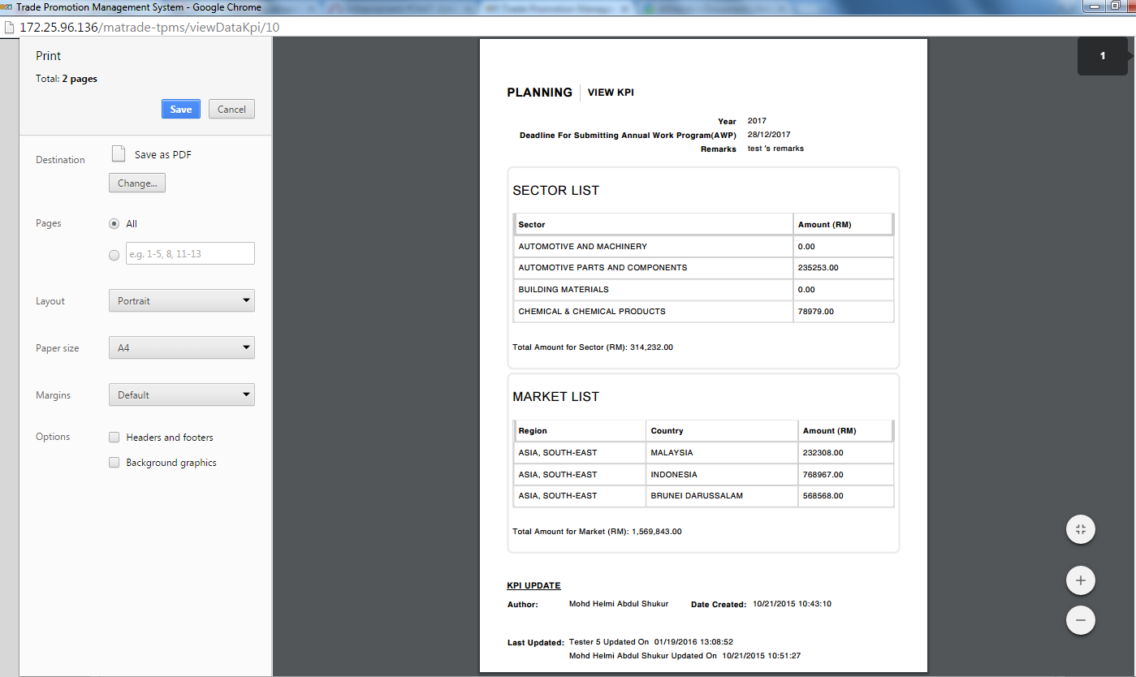

Reviewed By: (PMO)
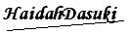 |  | Name/Position : NorhaidahBintiMdDasuki / Senior Manager, Quality Assurance and Support  Date : 15/1/2016

