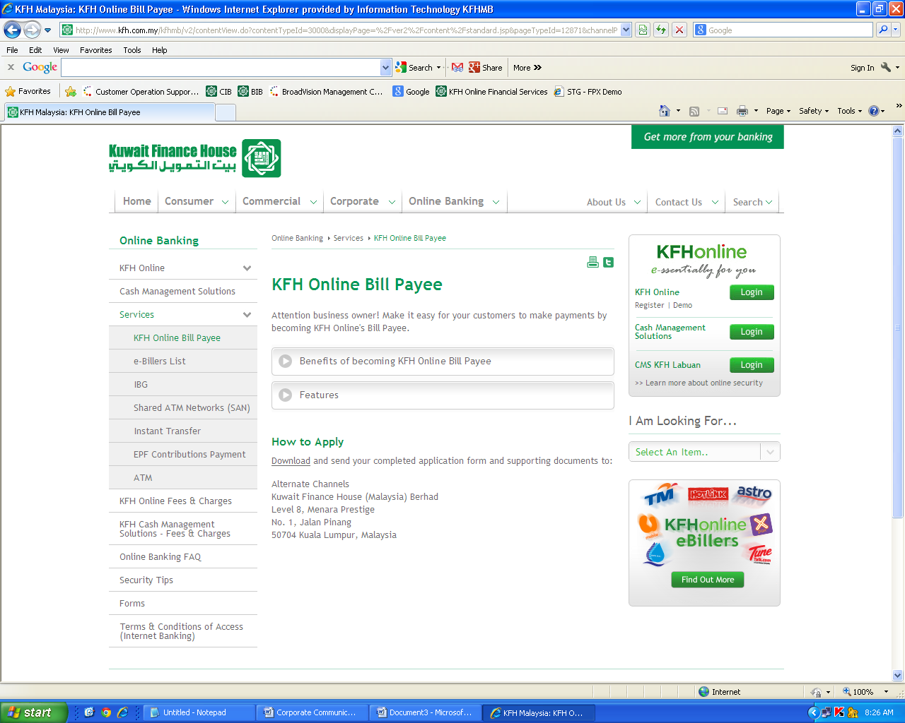

**Content for JomPAY service**

JomPAY Standard Payer Terms

**JomPAY**

JomPAY is a National Bill Payment Scheme that allows customers to pay bills conveniently and securely via Kfhonline.

Pay using your Current or Savings accounts anytime anywhere with no hidden cost. Just look for the JomPAY logo and Biller Code on your bill and logon to kfhonline.com.my to use JomPAY.

To learn more about JomPAY, visit www.jompay.com.my

To Add “JomPAY”

**To link to the attached JomPAY T&C**

**Attached the JomPAY T&C to be linked:**

