Test Issue Log |  |  |  |  | Issue ID#: TPMS_Prod038
Project Name: | Trade Promotion Management System (TPMS)
Test Stage: | Unit Functionality Integration System Interface  Performance Regression Acceptance Pilot
Test Case Number: | Support #5930 |  |  | Test Started Date: |  | 21/1/2016
Test Title: | To Generate Committee report
Test Description: | To generate Committee Report for all companies with status “Pending Approval”
Test Functionality: | Report – Promotion Report > Selection Committee Report
Test Procedure: | Click on Promotion > Report – Promotion Report > Selection Committee Report
Test Result: | Pass: Fail: Conditional Pass: |  | Tested by: |  | Siti Norahayu
Reason for Failed / Conditional Pass:
TEST DESCRIPTION
Click on Promotion > Report – Promotion Report > Selection Committee Report
Result:
System generate Committee report page.

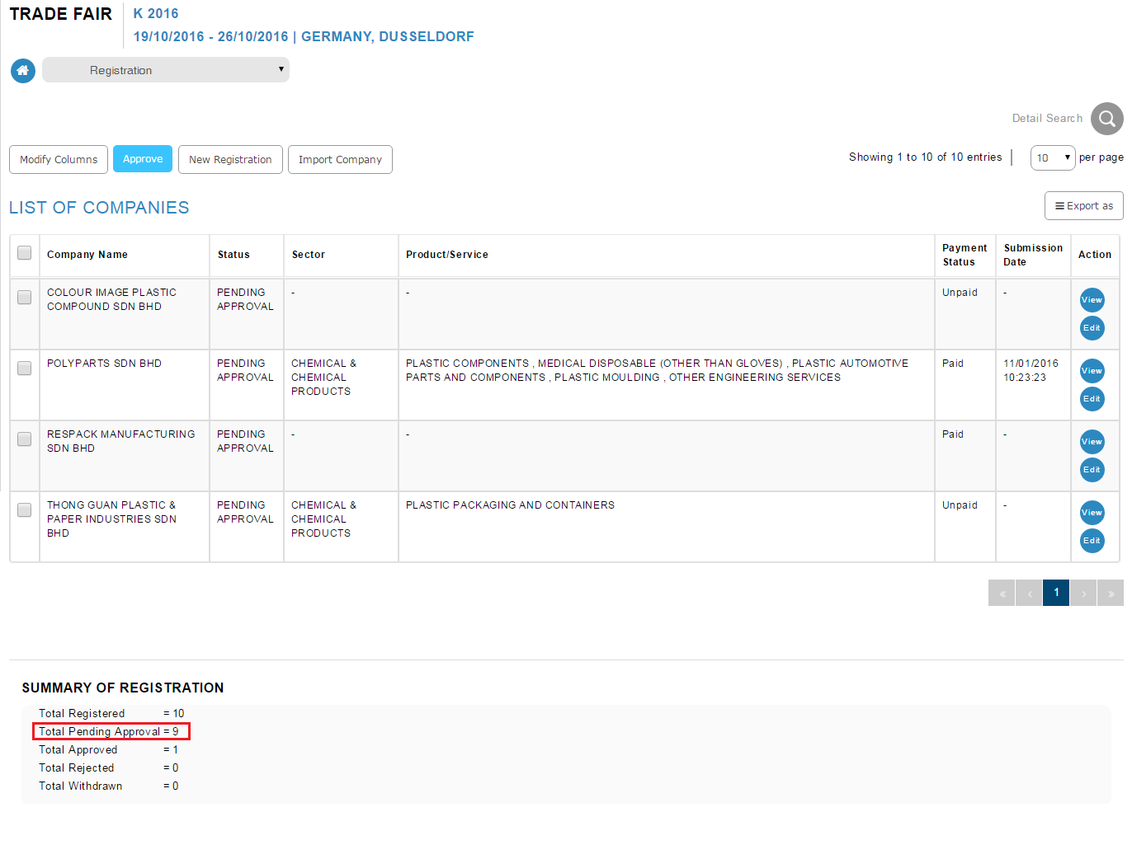
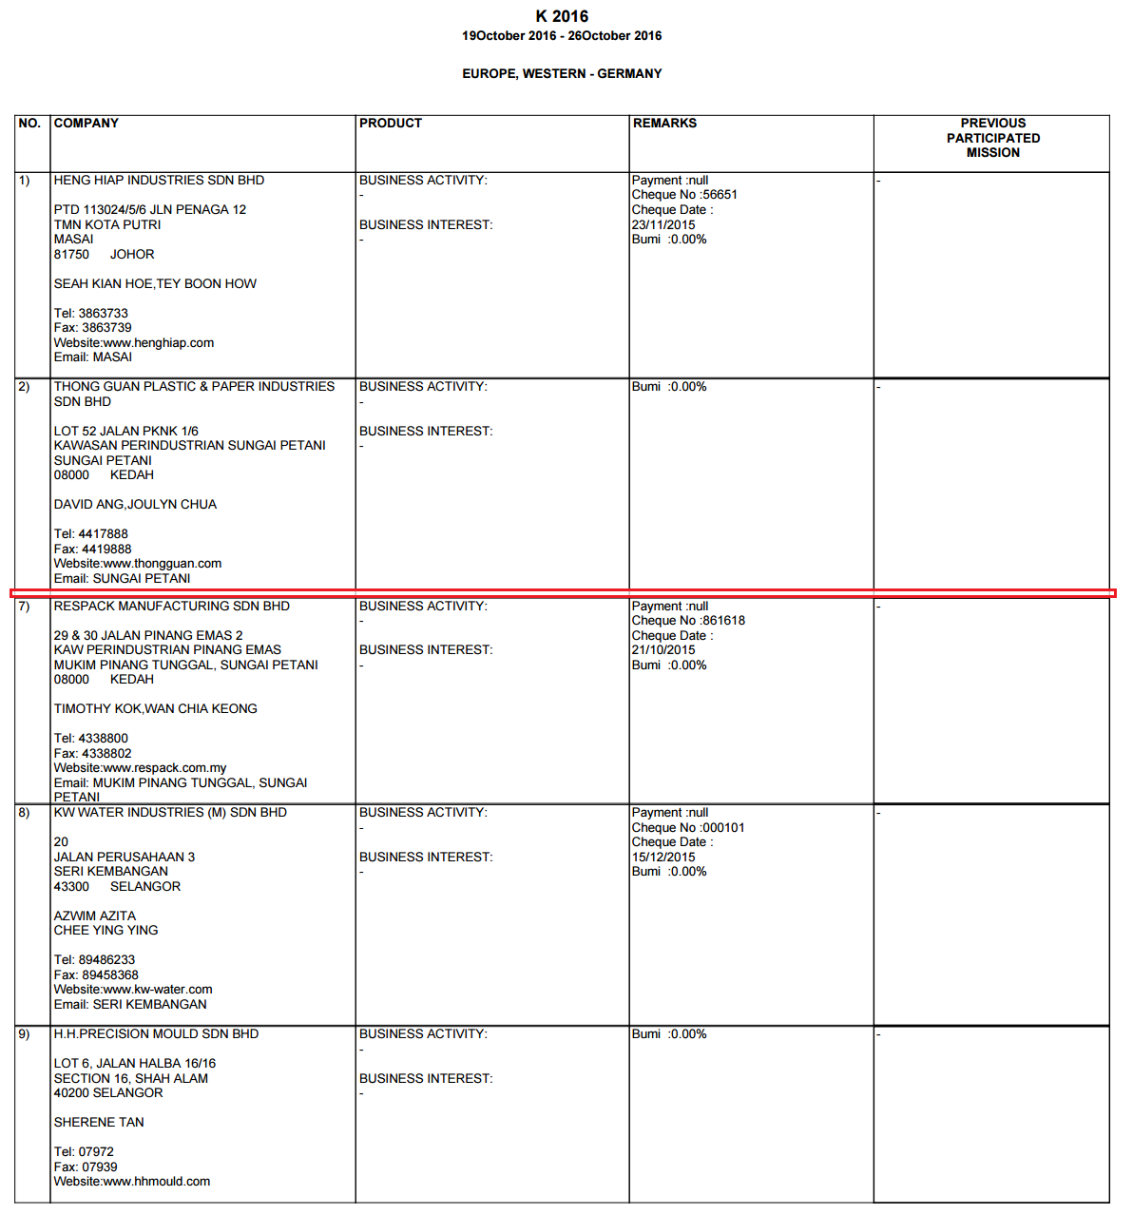

Reviewed By: (PMO)
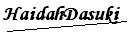 |  | Name/Position : NorhaidahBintiMdDasuki / Senior Manager, Quality Assurance and Support  Date : 21/1/2016

