Test Issue Log |  |  |  |  | Issue ID#: TPMS_Prod037
Project Name: | Trade Promotion Management System (TPMS)
Test Stage: | Unit Functionality Integration System Interface  Performance Regression Acceptance Pilot
Test Case Number: | Support #5925 |  |  | Test Started Date: |  | 22/1/2016
Test Title: | To test on creating JPPPA event and no email sent for PMT
Test Description: | To make sure system not sent registration acknowledgement email to PMT during JPPPA event creation.
Test Functionality: | Planning > Planning JPPPA
Test Procedure: | - Click on Planning > Planning JPPPA
Test Result: | Pass: Fail: Conditional Pass: |  | Tested by: |  | Siti Norahayu
Reason for Failed / Conditional Pass:
TEST DESCRIPTION
Click on Planning > Planning JPPPA
Result:
System display Planning JPPPA event list page

- Create new JPPPA event : TEST EVENT JPPPA 22012016
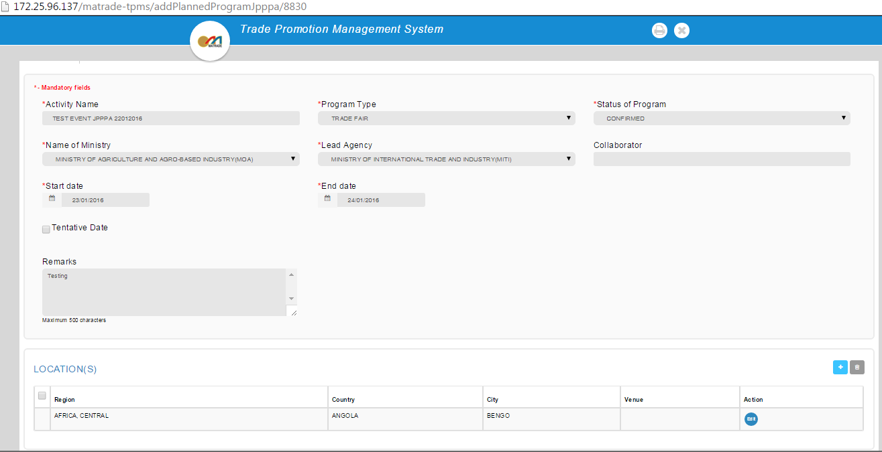
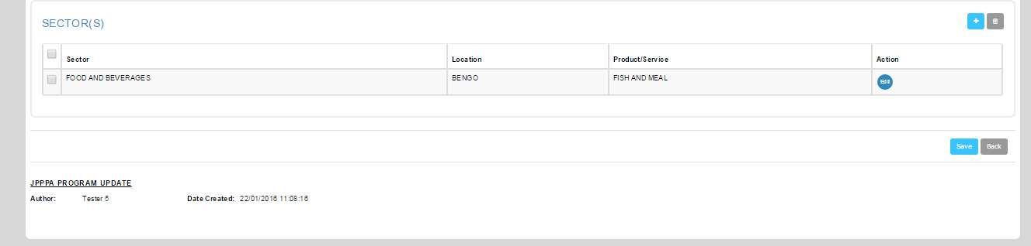

- New event successfully created
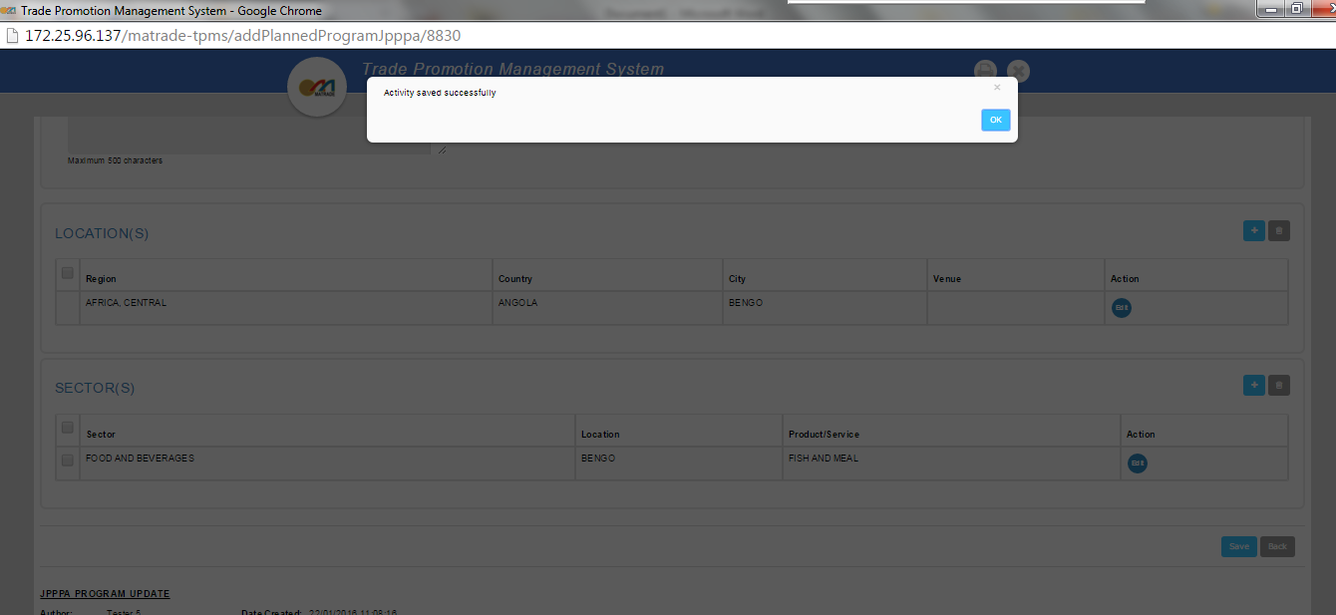

- New event able to display at listing
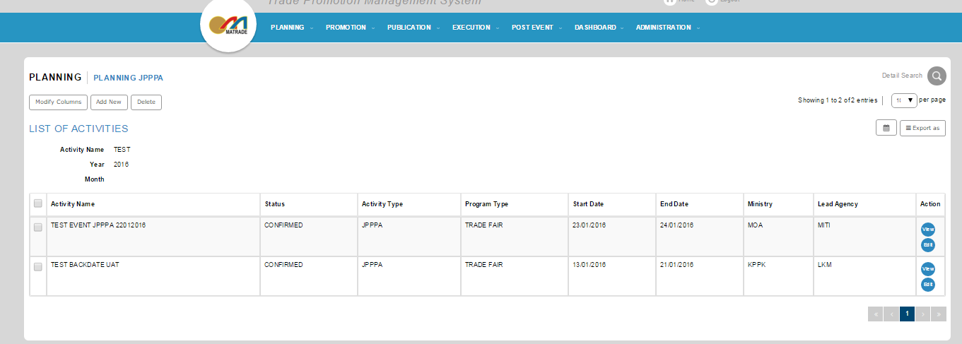

- Check on email notification

- Testing result : PMT did not received any notification email upon new created JPPPA event

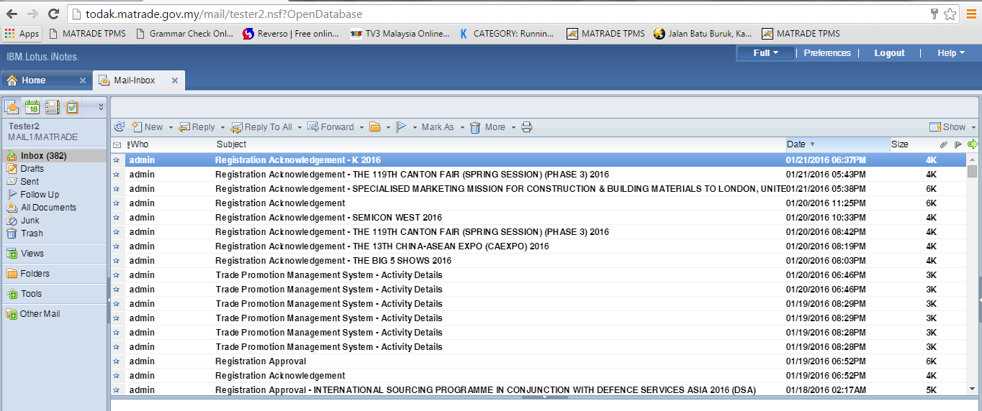

Reviewed By: (PMO)
 |  | Name/Position : NorhaidahBintiMdDasuki / Senior Manager, Quality Assurance and Support  Date : 22/1/2016

