Test Issue Log |  |  |  |  | Issue ID#: TPMS_Prod043
Project Name: | Trade Promotion Management System (TPMS)
Test Stage: | Unit Functionality Integration System Interface  Performance Regression Acceptance Pilot
Test Case Number: | Support #5939 |  |  | Test Started Date: |  | 22/1/2016
Test Title: | To check wording “Others” to be changed at Budget Module.
Test Description: | - Other change to Others  - Value 'Others' not appear in the column  - 'Others' not available in Budget Type list
Test Functionality: | Planning > Budget > Activity Budget Allocation
Test Procedure: | - Click on Planning > Budget > Activity Budget Allocation
Test Result: | Pass: Fail: Conditional Pass: |  | Tested by: |  | Siti Norahayu
Reason for Failed / Conditional Pass:
TEST DESCRIPTION
Click on Planning > Budget > Activity Budget Allocation
Result:
System display Budget > Activity Budget Allocation information list.

- Details Search
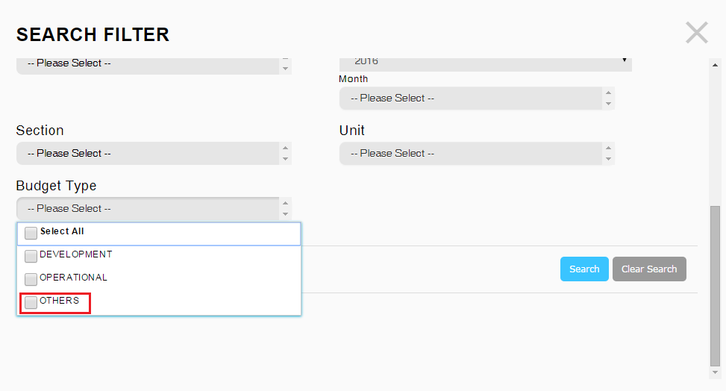

- Activity Budget information list.
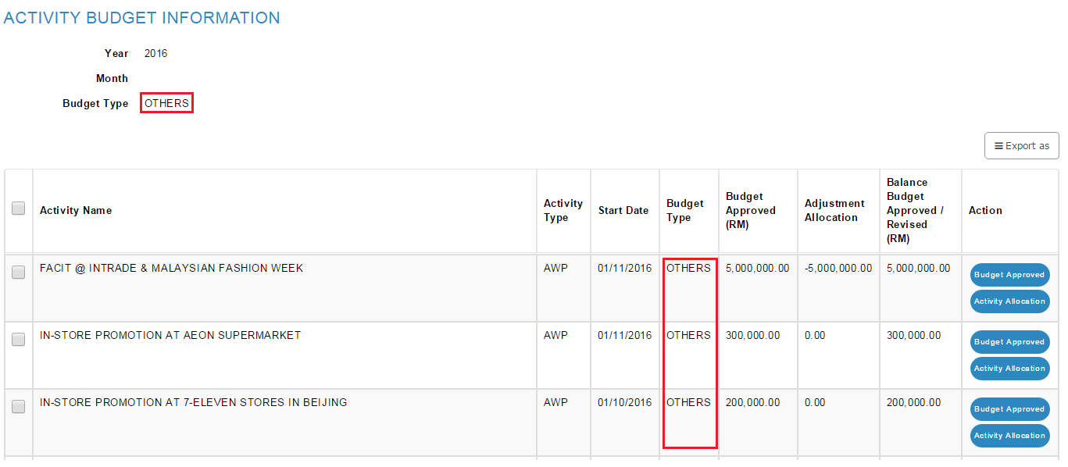

- Budget Approved

Reviewed By: (PMO)
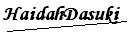 |  | Name/Position : NorhaidahBintiMdDasuki / Senior Manager, Quality Assurance and Support  Date : 22/1/2016

