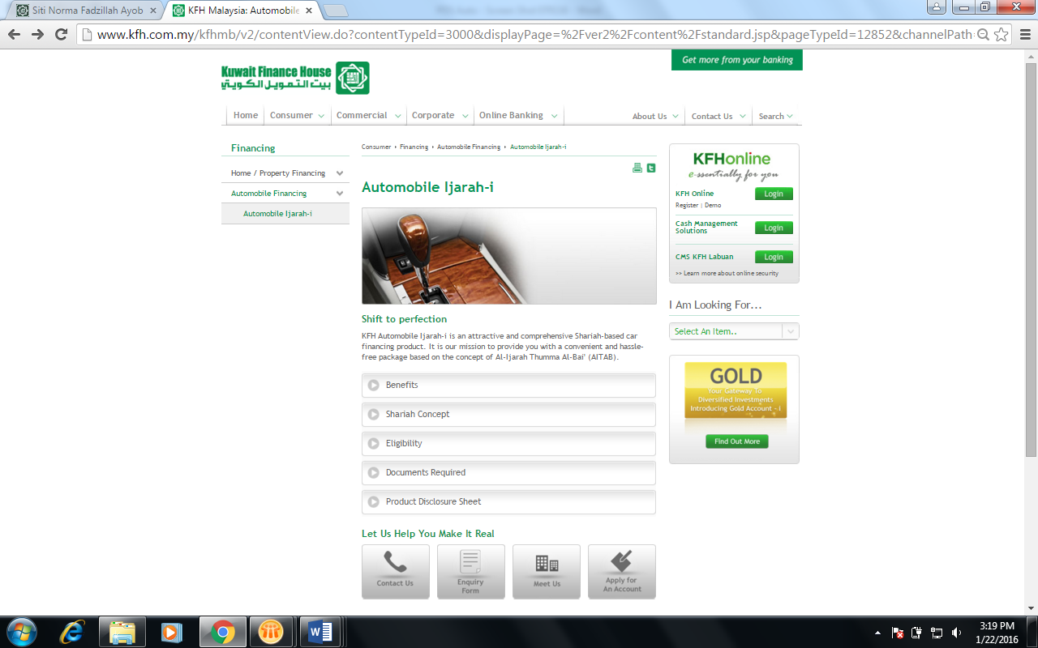

To insert file ‘070116 – PDS – Automobile & Superbike’

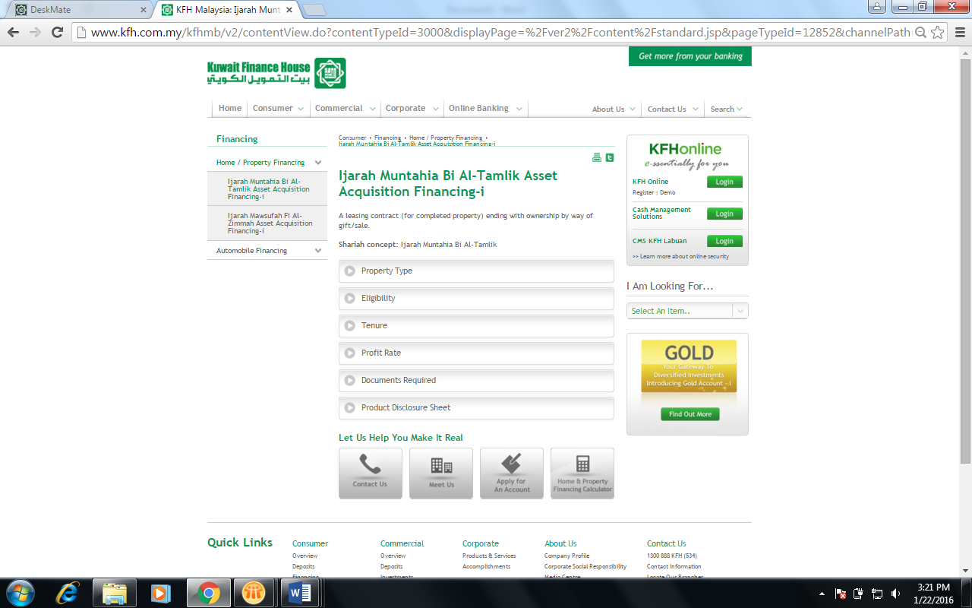

To reinstate the file ‘PDS Ijarah Muntahiah Bi Tamlik Asset Acquisition Financing-i - BR 301214’