Test Issue Log |  |  |  |  | Issue ID#: TPMS_Prod040 & 041
Project Name: | Trade Promotion Management System (TPMS)
Test Stage: | Unit Functionality Integration System Interface  Performance Regression Acceptance Pilot
Test Case Number: | Support #5935 |  |  | Test Started Date: |  | 22/1/2016
Test Title: | To check on the event setup setting
Test Description: | To make sure Edit and save event in module 1 will not overwrite promotion event setting such as public and registration setting.
Test Functionality: | Promotion > Event Setup > Other Modules > Edit  Planning > Activities List > Edit
Test Procedure: | - Promotion > Event Setup > Other Modules > Edit  - Click on Planning > Activities List > Edit
Test Result: | Pass: Fail: Conditional Pass: |  | Tested by: |  | Siti Norahayu
Reason for Failed / Conditional Pass:
TEST DESCRIPTION
Click on Promotion > Event Setup > Other Modules > Edit
Result:
System display Other Module info.

Test scenario:
1. In Promotion > Event Setup > Other Module, fill in all the fields like checkbox and date fields and save.
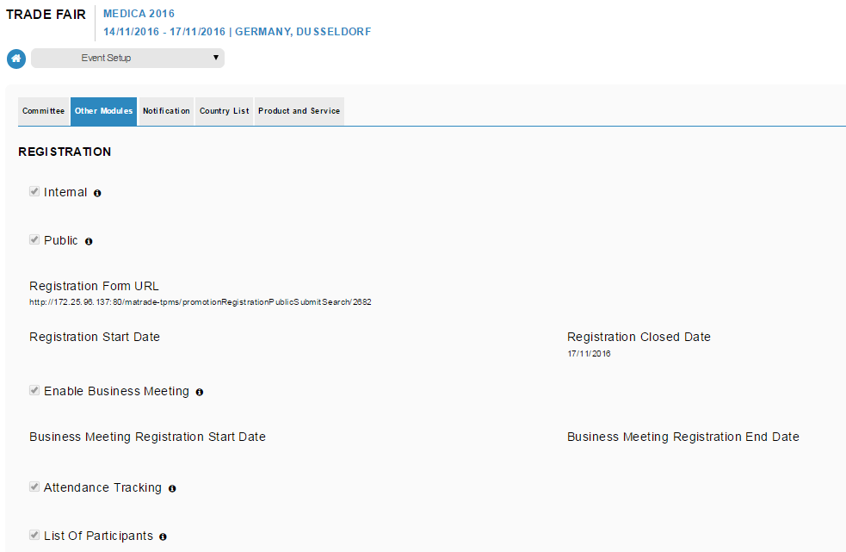

2. Go to Planning, choose the same event, edit and save (no need to change any data).
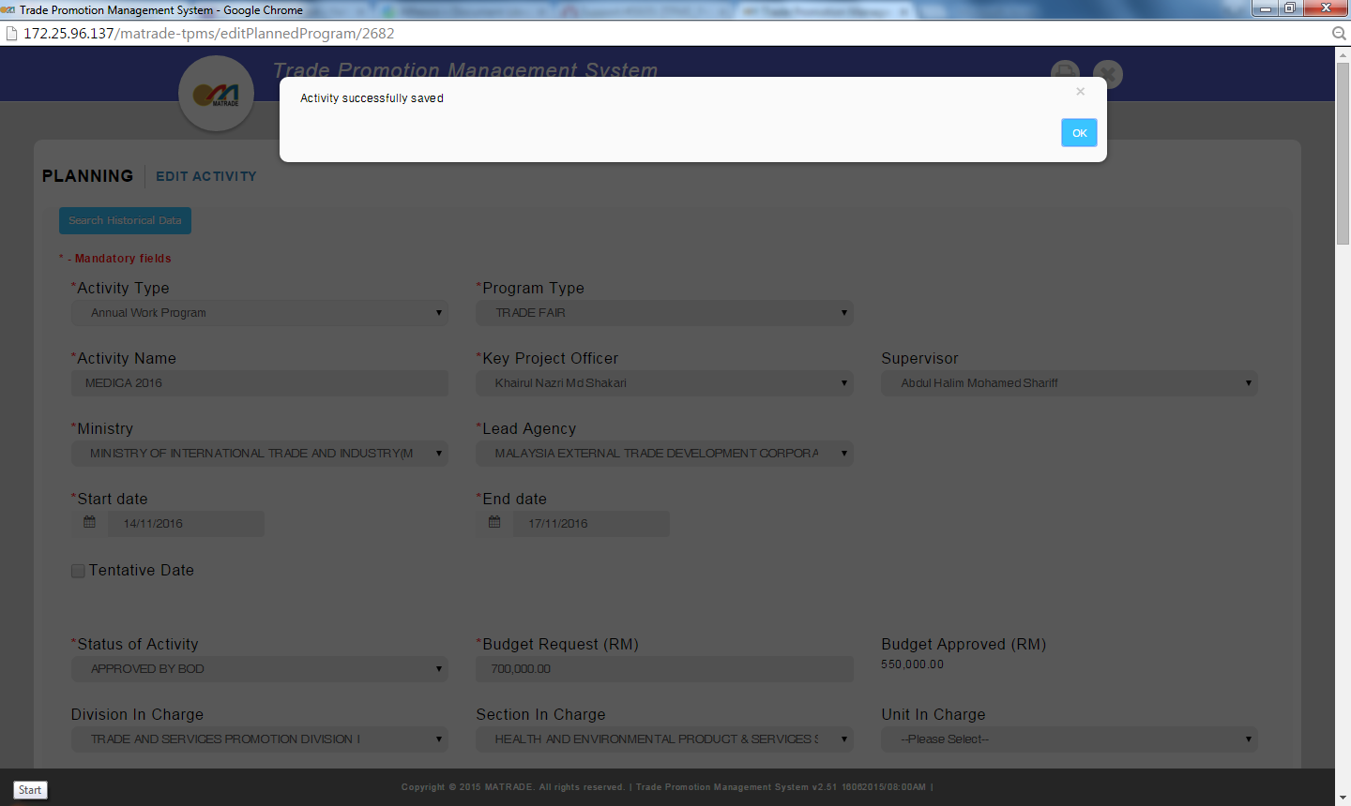

3. Go back to Promotion > Event Setup > Other Module and check the detail. Setting should be intact and not overwritten.

Reviewed By: (PMO)
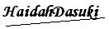 |  | Name/Position : NorhaidahBintiMdDasuki / Senior Manager, Quality Assurance and Support  Date : 22/1/2016

