Test Issue Log |  |  |  |  | Issue ID#: TPMS_Prod042
Project Name: | Trade Promotion Management System (TPMS)
Test Stage: | Unit Functionality Integration System Interface  Performance Regression Acceptance Pilot
Test Case Number: | Support #5936 |  |  | Test Started Date: |  | 22/1/2016
Test Title: | Required field in Registration form details disappear.
Test Description: | To make sure all data to be view and edit accordingly.
Test Functionality: | Promotion > Registration - Registration Form
Test Procedure: | - Click on Promotion > Registration > Registration Form - Edit
Test Result: | Pass: Fail: Conditional Pass: |  | Tested by: |  | Siti Norahayu
Reason for Failed / Conditional Pass:
TEST DESCRIPTION
Click on Promotion > Registration > Registration Form - Edit
Result:
System display Registration Form details.

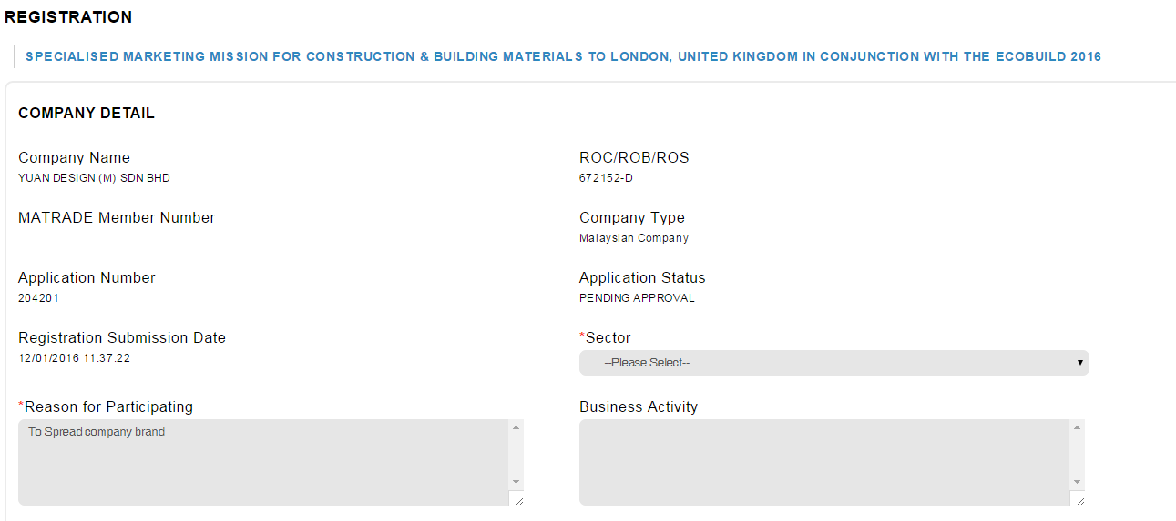

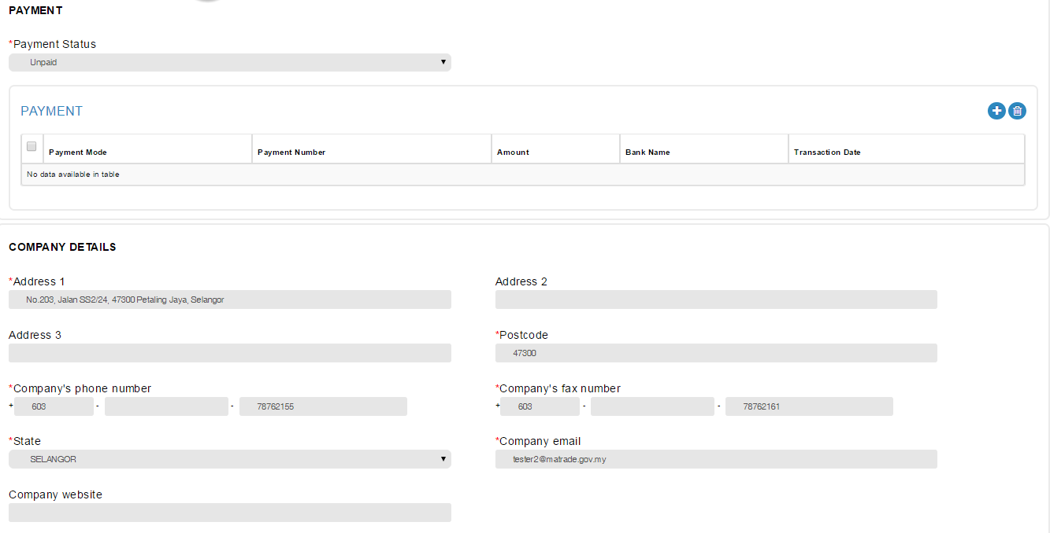

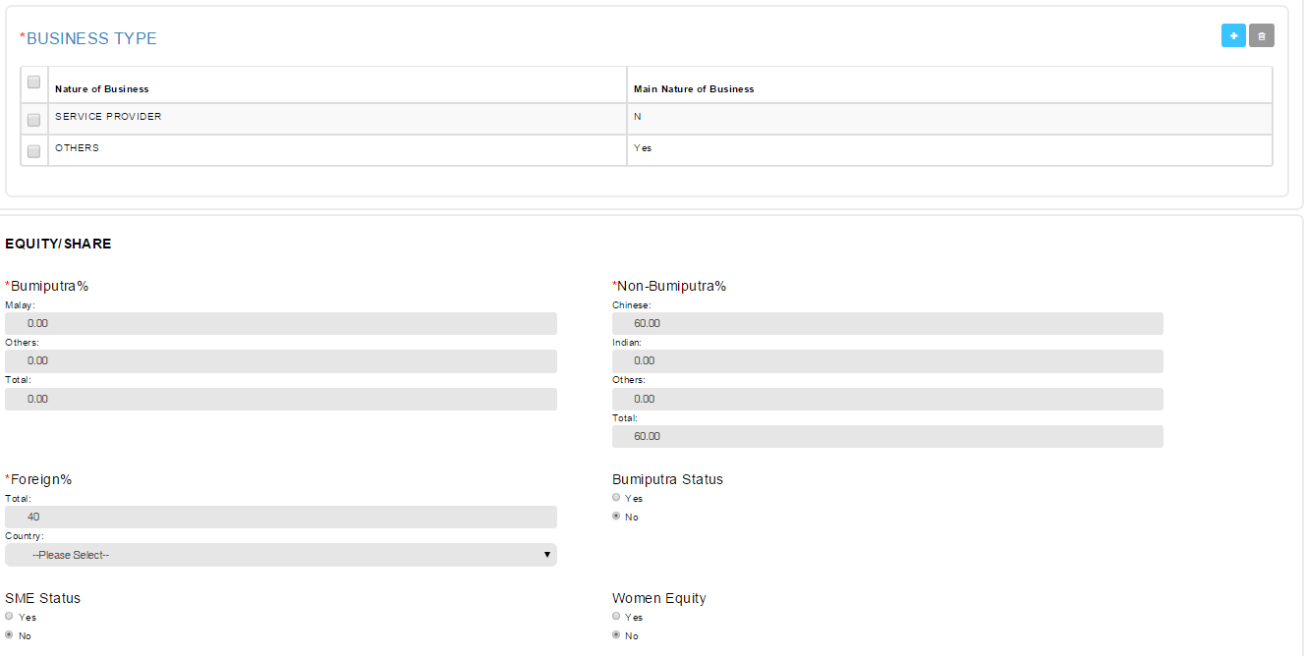

Reviewed By: (PMO)
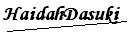 |  | Name/Position : NorhaidahBintiMdDasuki / Senior Manager, Quality Assurance and Support  Date : 22/1/2016

