***Issue Form (PROD)***

|  |  |
| --- | --- |
| **Originator's Name:** Azliza Husain  **Project:** Trade Promotion Management System (TPMS)  **Project Manager:** Norharizal Ishak  **Module :** Promotion  **Date Raised:** 03/02/2016  **Phase :** Phase 2_Module 3 - 9  **Functional Area:** Registration | **Issue ID Number: TPMS_Prod046**  **Related Issue ID Number:**  **Classification: GUI**  **Priority:** Critical/High/Medium/Low  **Assigned to: Vendor / IT / PMO SA / UPA**  **Actual Closed Date:** |
| **Status:** Open/Assigned/Investigated/Resolved/Approved/Deferred/No Action  *(Circle one)* | |
| **Description :**  To hide E-payment code and the word “YES, I am interested to participate in this………….” For programme type International Sourcing Programme.  Add-in: To remove the check box of "Participating in IBM" for INTERNATIONAL SOURCING PROGRAMME (IBM) events.  *Please refer to file attached for further details.* | **Impact:** |
| **Findings/Root Caused (Description):** | **Resolution:** |
| **Estimated Impact :** |  |
| **Recommendation:** | |
| **Accepted :**  **(Vendor / IT / PMO SA / UPA)**  **Date:** | **Accepted (KFHMB Tester):**  **Date:** |

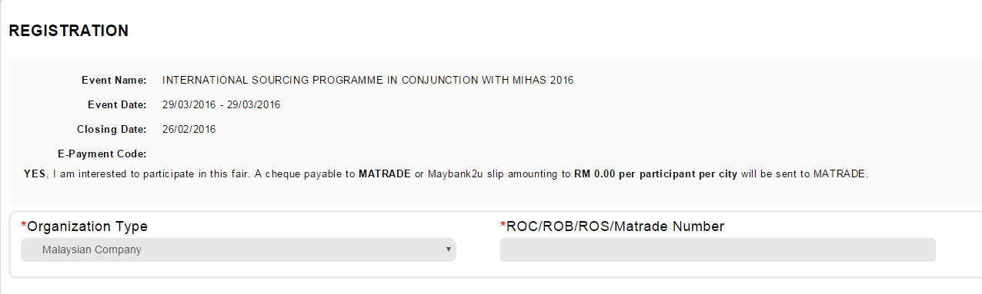

To hide:

-E-Payment Code

-YES, I am interested to participate in this fair. A cheque payable to **MATRADE** or Maybank2u slip amounting to **RM 0.00 per city** will be sent to MATRADE