***Issue Form (PROD)***

|  |  |
| --- | --- |
| **Originator's Name:** Chooi So Fun  **Project:** Internet Banking  **Project Manager:** Malarvili  **Module :**  **Date Raised: 03.02.2016**  **Phase :**  **Functional Area : BVMC** | **Issue ID Number:**  **Related Issue ID Number:** HD00016469  **Classification:**  **Priority:** Critical/High/Medium/Low  **Assigned to: Vendor / IT / PMO SA / UPA**  **Actual Closed Date:** |
| **Status:** Open/Assigned/Investigated/Resolved/Approved/Deferred/No Action  *(Circle one)* | |
| **Description :**  Since the implementation on change ipay brand name noticed that the internet transaction report did reflect the beneficiary maintenance transaction. Please remove it as Internet Transaction Report only reflects all the monetary transactions.  *Please refer to file attached for further details.* | **Impact:** |
| **Findings/Root Caused (Description):** | **Resolution:** |
| **Estimated Impact :** |  |
| **Recommendation:** | |
| **Accepted :**  **(Vendor / IT / PMO SA / UPA)**  **Date:** | **Accepted (KFHMB Tester):**  **Date:** |

# BVMC Internet Transaction Report dated 22.01.2016

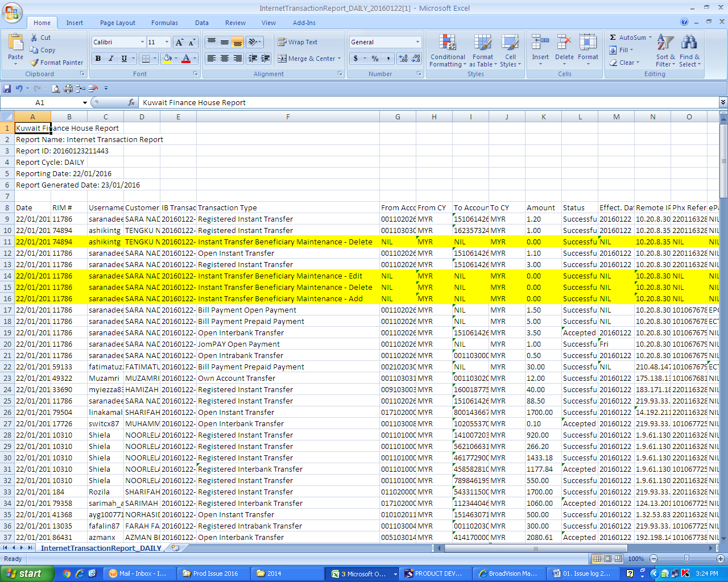

# BVMC Internet Transaction Report dated 02.02.2016

