***Issue Form (PROD)***

|  |  |
| --- | --- |
| **Originator's Name:** Mohd Helmi Bin Abdul Shukur  **Project:** Trade Promotion Management System (TPMS)  **Project Manager:** Norharizal b. Ishak  **Module :** Post Event  **Date Raised:** 5/2/2016  **Phase :** Phase 2_Module 3 - 9  **Functional Area : Post Event > JPPPA Programme** | **Issue ID Number:** TPMS_Prod052  **Related Issue ID Number:** Redmine #5895  **Classification:**  **Priority:** Critical/High/Medium/Low  **Assigned to: Vendor / IT / PMO SA / UPA**  **Actual Closed Date:** |
| **Status:** Open/Assigned/Investigated/Resolved/Approved/Deferred/No Action  *(Circle one)* | |
| **Description :**  “Remarks” field with values is not included in “Impact / Feedback” field in report.  This fixes have to be applied to all “Impact / feedback” report.  *Please refer to file attached for further details.* | **Impact:** |
| **Findings/Root Caused (Description):** | **Resolution:** |
| **Estimated Impact :** |  |
| **Recommendation:** | |
| **Accepted : (Vendor / IT / PMO SA / UPA)**  **Date: 5/2/2016** | **Accepted (MATRADE Tester):**  **Date:** |

Event details

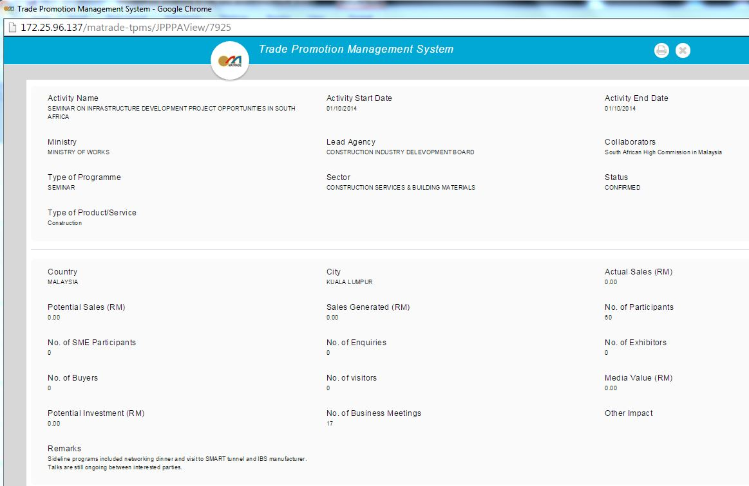

Report from TPMS system

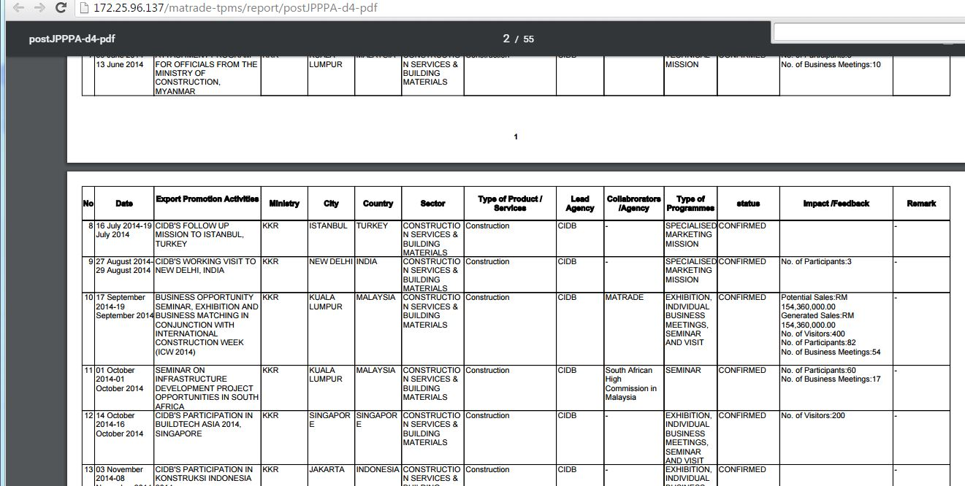

Original report from previous system

