Test Issue Log |  |  |  |  |  | Issue ID# : TPMS_Prod045
Project Name: | Trade Promotion Management System (TPMS)
Test Stage: | Unit Functionality Integration System Interface  Performance Regression Acceptance Pilot
Test Case Number: | Support # 5955 |  |  | Test Started Date: |  |  | 05/02/2016
Test Title: | Prompt message Server Error with status code [405] when user want to delete nature of business.
Test Description: | User should be able to delete business nature without error
Test Functionality: | TPMS>Promotion>Registration
Test Procedure: | - Access to New or Edit Registration Detail  - Delete business nature
Test Result: | Pass: Fail:  Conditional Pass: : |  | Tested by: |  | Siti Aishah Ibrahim
Reason for Failure:
TEST DESCRIPTION
Issue : Test to delete Business Nature from form

Login as Administrator (Tester5)
Select Promotion Tab
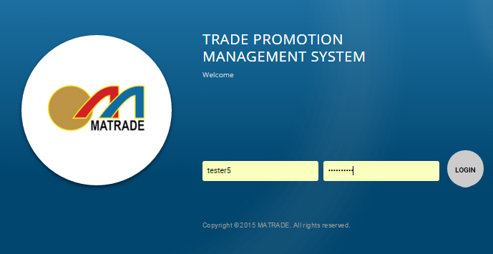

- Select “Registration” from the sub menu drop down list

- Add new Business Type

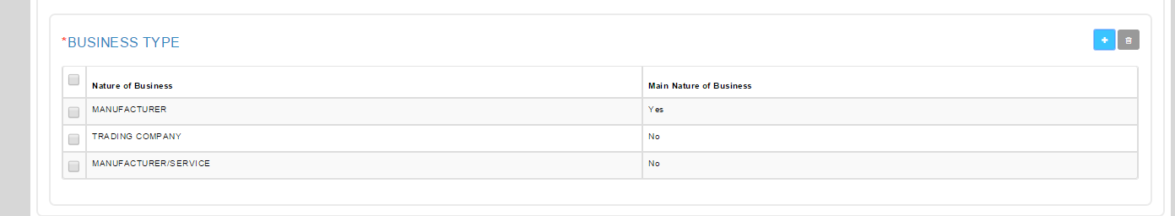

- Remove nature of Business from Business Type list

Result: TPMS able to delete the nature of business from Business Type list

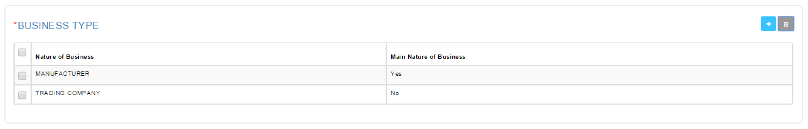

Reviewed By: (PMO)
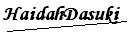 |  | Name/Position : Norhaidah Binti Md Dasuki / Senior Manager, Quality Assurance and Support  Date : 05/02/2016

