Test Issue Log |  |  |  |  |  | Issue ID# : TPMS_Prod044
Project Name: | Trade Promotion Management System (TPMS)
Test Stage: | Unit Functionality Integration System Interface  Performance Regression Acceptance Pilot
Test Case Number: | Support # 5945 |  |  | Test Started Date: |  |  | 11/02/2016
Test Title: | In execution list, only event from MATRADE shall be listed.
Test Description: | In execution list, TPMS shall display only event from MATRADE.
Test Functionality: | TPMS>Execution>List of Event
Test Procedure: | Click on Execution  System display event from MATRADE only at List of Event screen.
Test Result: | Pass: Fail:  Conditional Pass: : |  | Tested by: |  | Siti Aishah Ibrahim
Reason for Failure:
TEST DESCRIPTION
Issue : Test to display event from MATRADE only

Login as Administrator (Tester5)
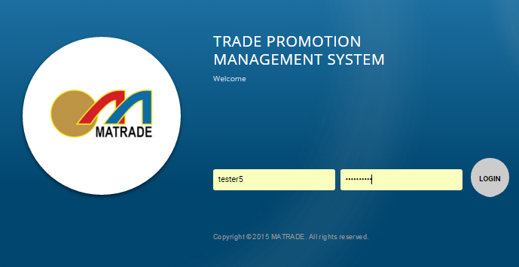

- Select “Execution” from the sub menu drop down list
Result: TPMS to display MATRADE event only

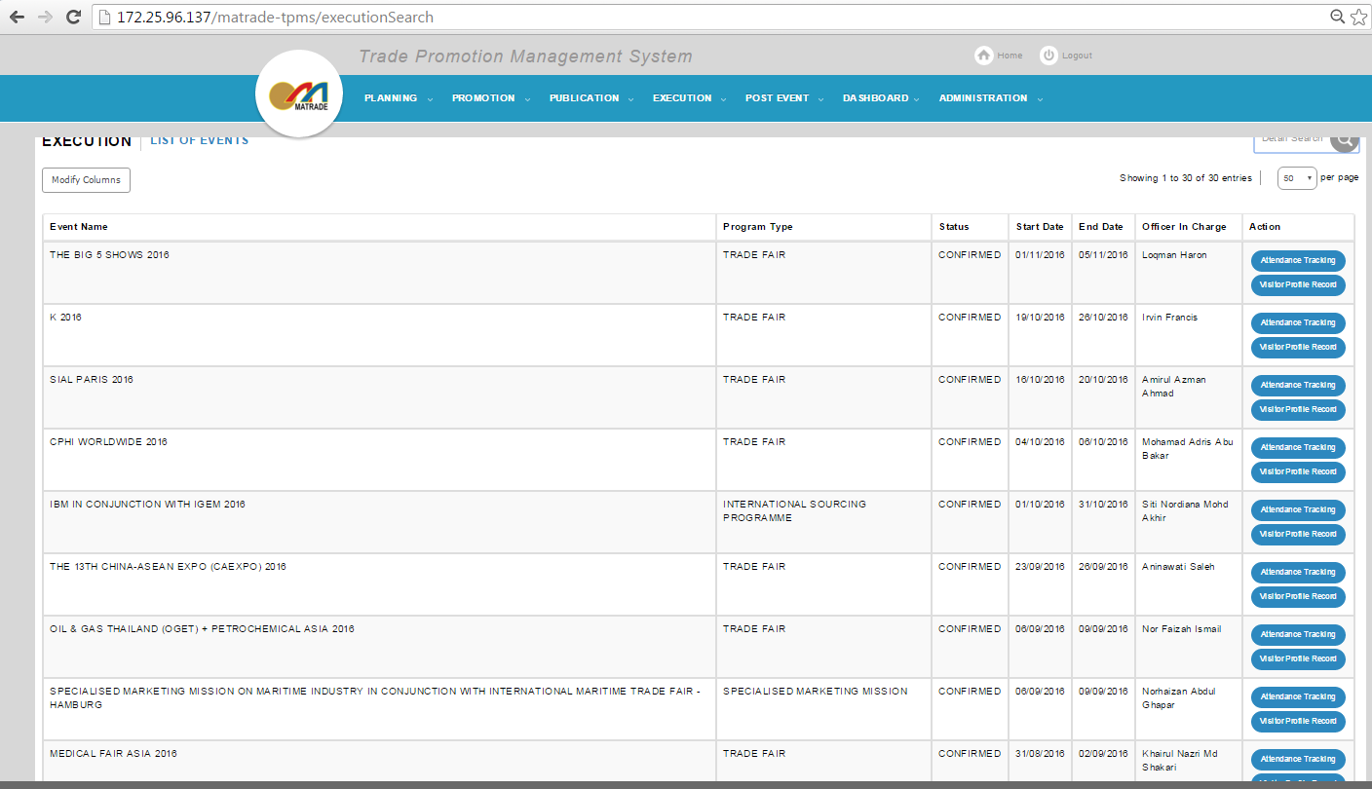

- Select event based on search filter
Program Type – Dropdown list just display MATRADE event program type only

Reviewed By: (PMO)
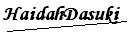 |  | Name/Position : Norhaidah Binti Md Dasuki / Senior Manager, Quality Assurance and Support  Date : 11/2/2016

