***Issue Form (PROD)***

|  |  |
| --- | --- |
| **Originator's Name:** Mohd Helmi Bin Abdul Shukur  **Project:** Trade Promotion Management System (TPMS)  **Project Manager:** Norharizal b. Ishak  **Module :** Planning  **Date Raised:** 12/2/2016  **Phase :** Phase 1_Module 1 - 2  **Functional Area : Planning JPPPPA** | **Issue ID Number:** TPMS_Prod056  **Related Issue ID Number:** Redmine #5919  **Classification:**  **Priority:** Critical/High/Medium/Low  **Assigned to: Vendor / IT / PMO SA / UPA**  **Actual Closed Date:** |
| **Status:** Open/Assigned/Investigated/Resolved/Approved/Deferred/No Action  *(Circle one)* | |
| **Description :**   1. Start year selection for (Image A.) is limited to 2016. Suggest start year selection from 2013 till current year + 5 year. 2. Month selection for (Image B) doesn’t display “September” in full. This section also have same problem as above. 3. Month Selection and Year Selection from calendar is not clickable (Image C & D).     *Please refer to file attached for further details.* | **Impact:** |
| **Findings/Root Caused (Description):** | **Resolution:** |
| **Estimated Impact :** |  |
| **Recommendation:** | |
| **Accepted : (Vendor / IT / PMO SA / UPA)**  **Date: 15/2/2016** | **Accepted (MATRADE Tester):**  **Date:** |

Image A

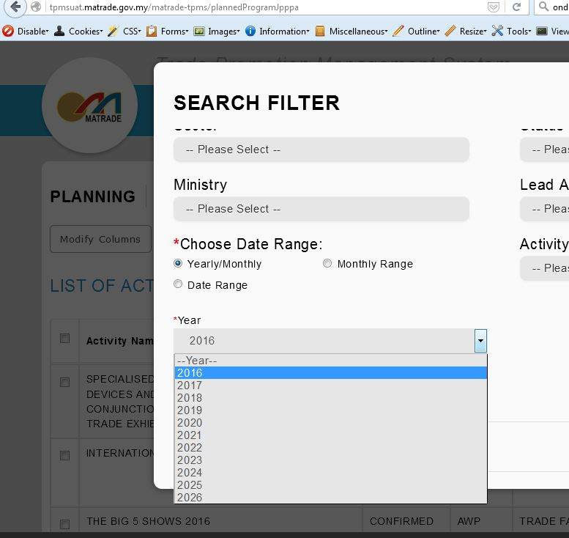

Image B

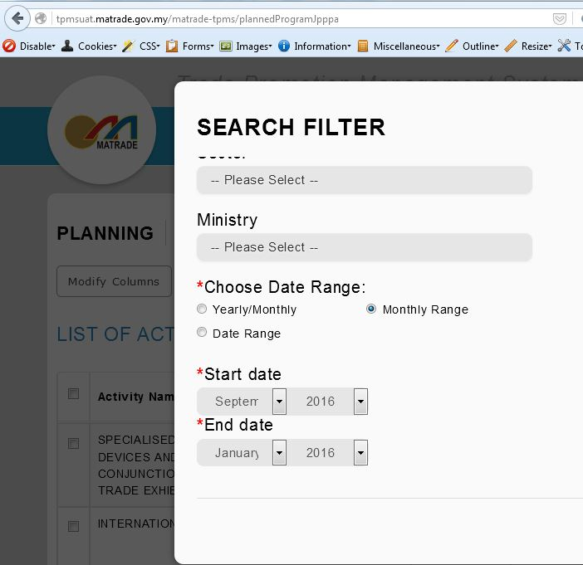

Image C & D

