Test Issue Log |  |  |  |  |  | Issue ID# : TPMS_Prod046
Project Name: | Trade Promotion Management System (TPMS)
Test Stage: | Unit Functionality Integration System Interface  Performance Regression Acceptance Pilot
Test Case Number: | Support # 5956 |  |  | Test Started Date: |  |  | 12/02/2016
Test Title: | To hide E-payment code and the word “YES, I am interested to participate in this………….” For programme type International Sourcing Programme.  Add-in: To remove the check box of "Participating in IBM" for INTERNATIONAL SOURCING PROGRAMME (IBM) events.
Test Description: | To test on new GUI requirement for IBM event’s registration form for Malaysian Company and foreign buyer.
Test Functionality: | TPMS>Promotion>Registration  TPMS>Promotion>Business Meeting
Test Procedure: | To test reported issue as below:  TPMS>> Promotion>>Registration - New, View & Edit  - To remove the check box of "Participating in IBM" for INTERNATIONAL SOURCING PROGRAMME (IBM) events.  - To hide E-payment code and the word “YES, I am interested to participate in this………….” For programme type International Sourcing Programme  TPMS>>Promotion>>Business Meeting - Register Buyer - New, View & Edit  To regroup below information field in column to look more structure:  1. Representative Informations  - Representative 1  - Representative 2  2. Flight Details  - Representative 1  - Representative 2  3. Hotel Details  4. Meeting Information
Test Result: | Pass: Fail:  Conditional Pass: : |  | Tested by: |  | Siti Aishah Ibrahim
Reason for Failure:
TEST DESCRIPTION
- TPMS>> Promotion>>Registration - New, View & Edit

- To remove the check box of "Participating in IBM" for INTERNATIONAL SOURCING PROGRAMME (IBM) events.
- To hide E-payment code and the word “YES, I am interested to participating this………….” For programme type International Sourcing Programme

Login as Administrator (Tester5)
Select Promotion
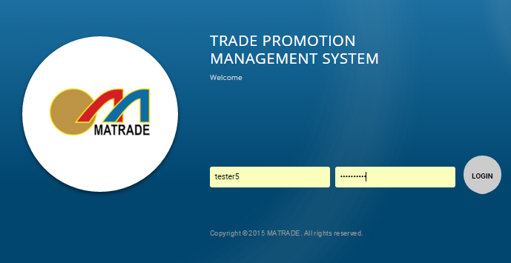

- Select “Promotion” from the sub menu drop down list
- Search Program Type : INTERNATIONAL SOURCING PROGRAMME at details search filtering
- Choose the selected event and click on View button
- Select “Registration” from the sub navigation drop down list

Result :
- Check box of "Participating in IBM" for INTERNATIONAL SOURCING PROGRAMME (IBM) events has been removed at New registration screen, View screen and Edit screen.
- E-payment code and the word “YES, I am interested to participating this………….” For programme type International Sourcing Programme has been hide from New registration screen, View screen and Edit screen.

- New Registration
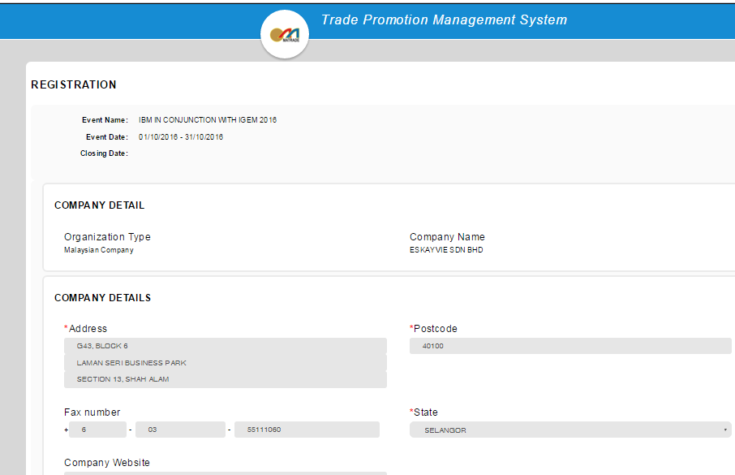

- View
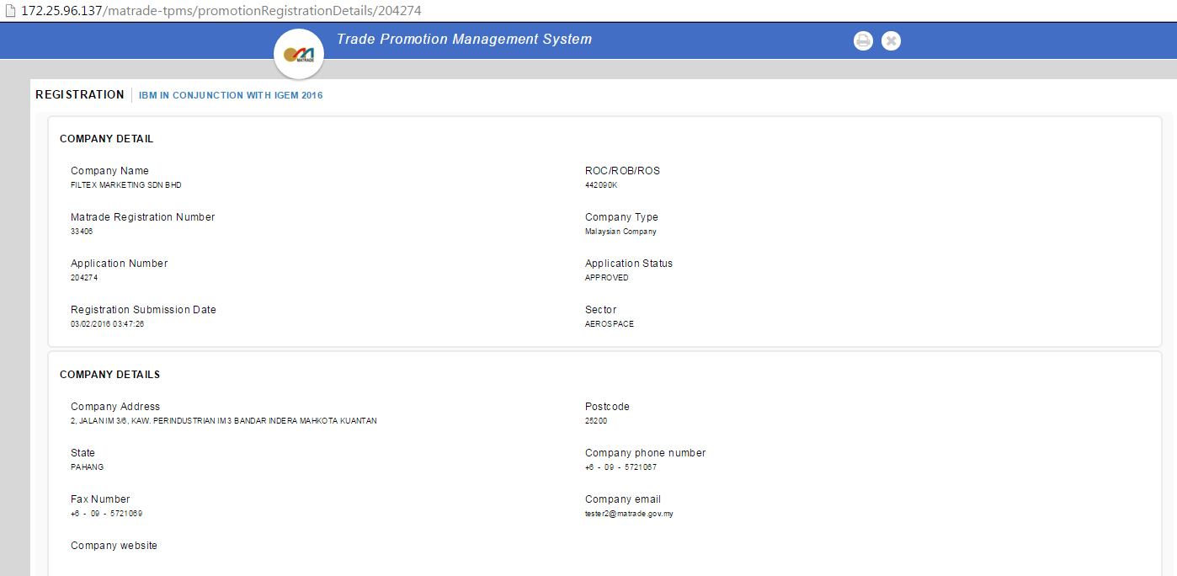

- Edit
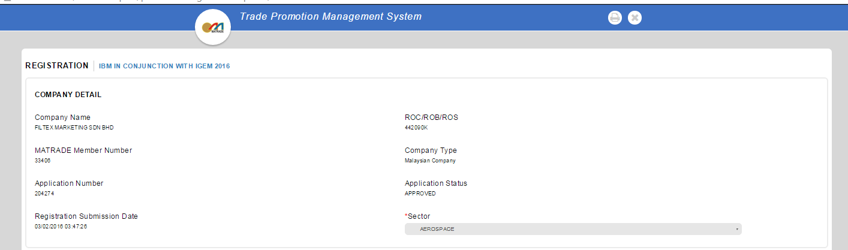

- TPMS>>Promotion>>Business Meeting - Register Buyer - New, View & Edit
To regroup below information field in column to look more structure:

Login as Administrator (Tester5)
Select Promotion

- Select “Promotion” from the sub menu drop down list
- Choose the selected event and click on View button
- Select “Business Meeting” from the sub navigation drop down list

Result : Representative Information has been regroup into proper column

- Register New Buyer

- View
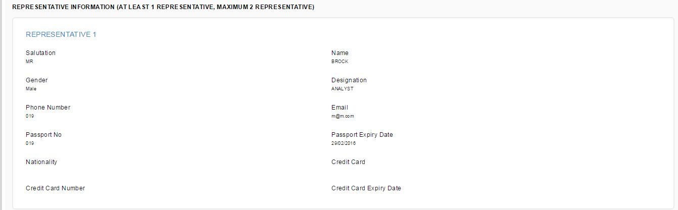

- Edit

2. Flight Details

- Register New Buyer
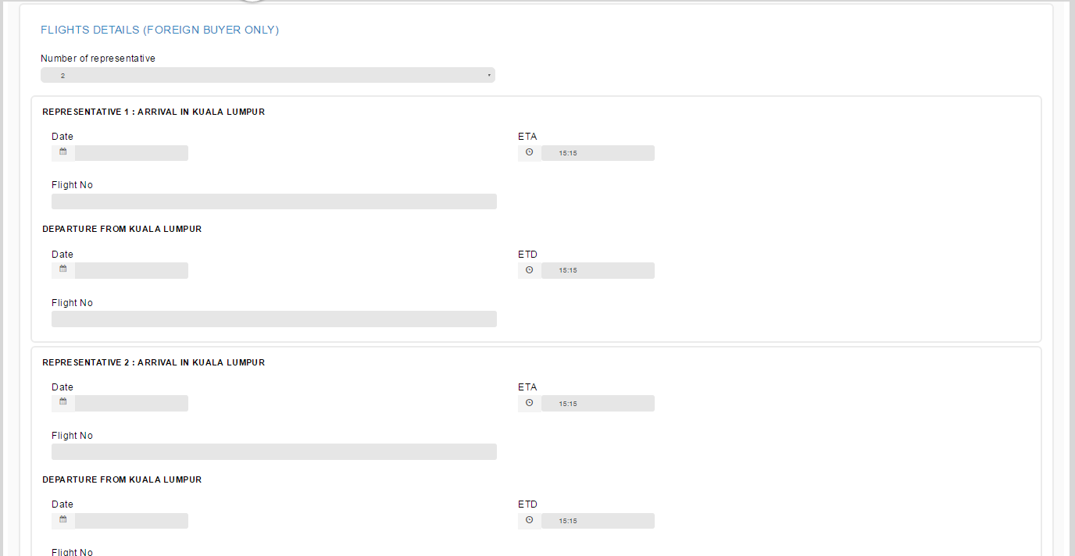

- View

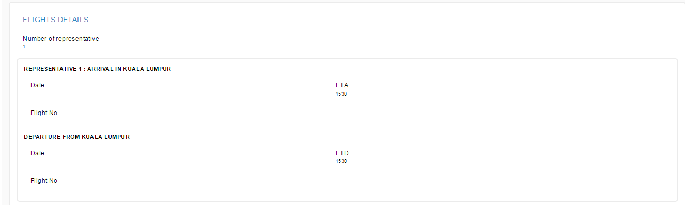

- Edit

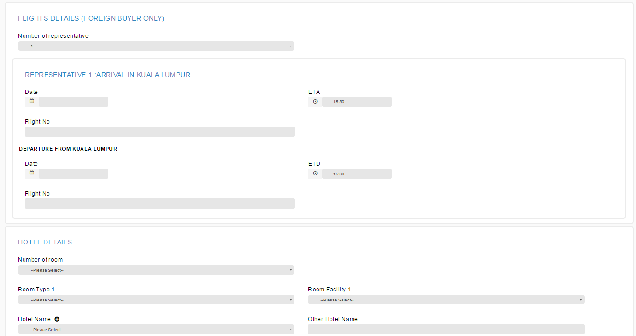

- Hotel Details

- Register New Buyer
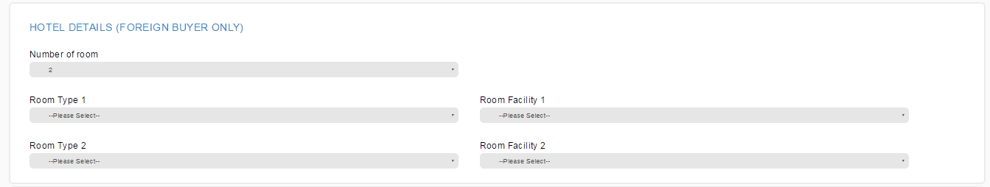
- View
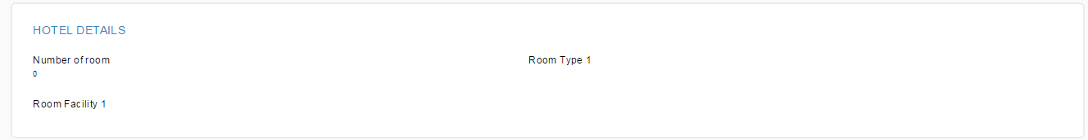

- Edit

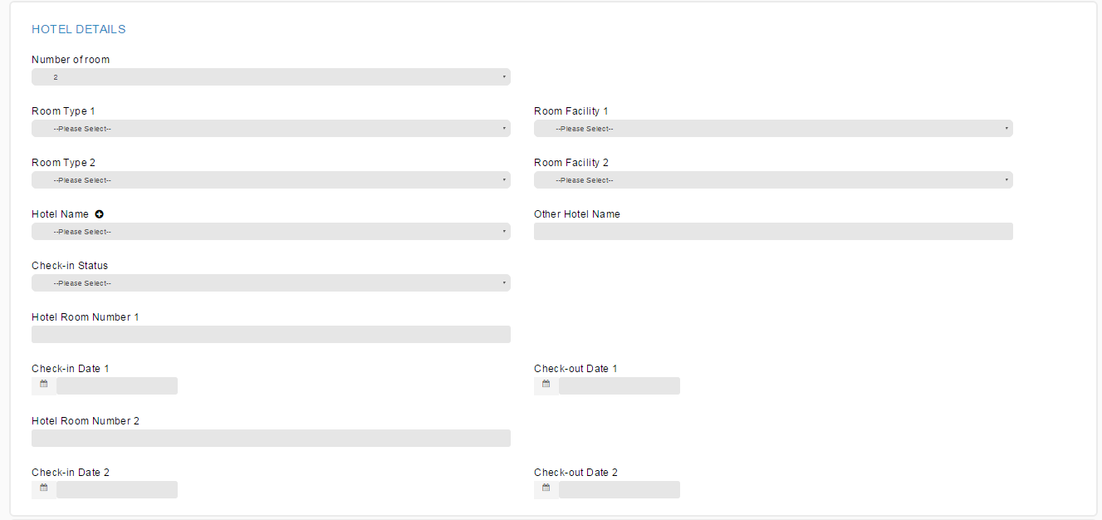

- Meeting Information

- Register New Buyer
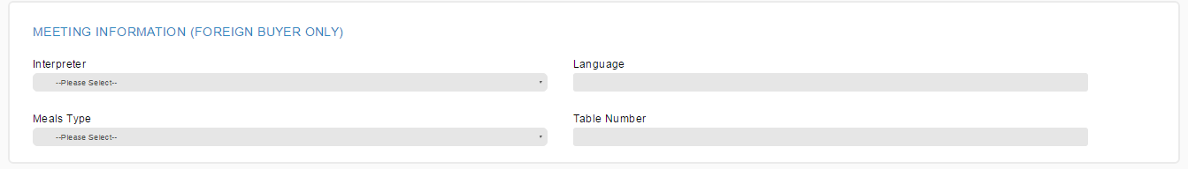

- View

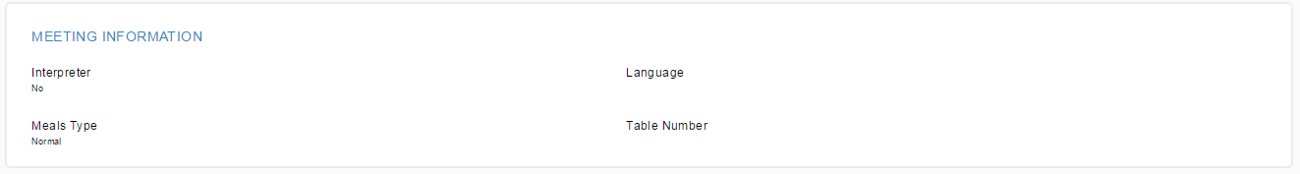

- Edit

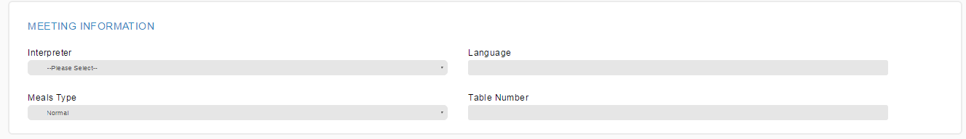

Reviewed By: (PMO)
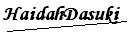 |  | Name/Position : Norhaidah Binti Md Dasuki / Senior Manager, Quality Assurance and Support  Date : 30/12/2015

