Test Issue Log |  |  |  |  |  | Issue ID# : TPMS_Prod055
Project Name: | Trade Promotion Management System (TPMS)
Test Stage: | Unit Functionality Integration System Interface  Performance Regression Acceptance Pilot
Test Case Number: | Support # 5967 |  |  | Test Started Date: |  |  | 15/02/2016
Test Title: | To add Summary of Registration in the Business Meeting Foreign Buyer same as in the Registration Malaysia Company.
Test Description: | User should be able to display Summary of Registration in the Business Meeting Foreign Buyer
Test Functionality: | TPMS>Promotion>Business Meeting
Test Procedure: | - Click on Promotion navigation  - Access to Business Meeting screen by click on related event “View” button  - Select “Business Meeting” from the sub navigation drop down list  - Select “Foreign Buyer List” tab  System display Foreign Registration List with the summary at the bottom of the list.
Test Result: | Pass: Fail:  Conditional Pass: : |  | Tested by: |  | Siti Aishah Ibrahim
Reason for Failure:
TEST DESCRIPTION
Login as Administrator (Tester5)
Select Promotion
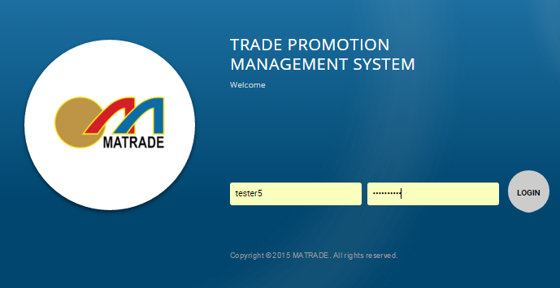

Result :
TPMS able to view Summary of Registration in the Business
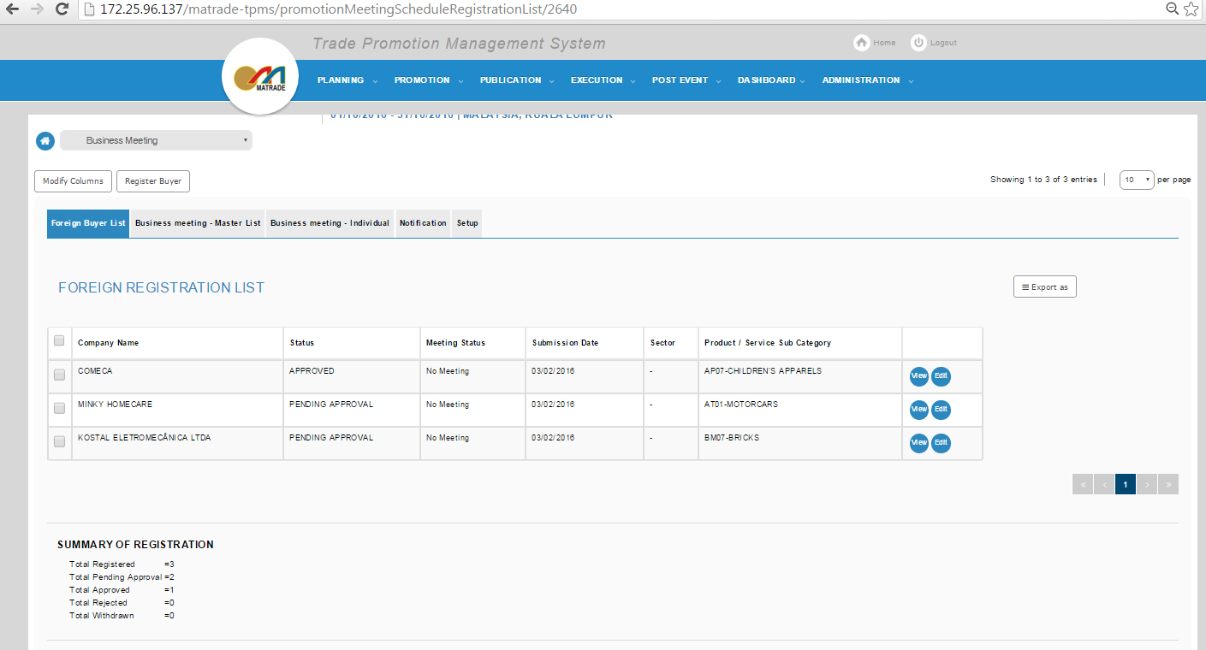

Reviewed By: (PMO)
 |  | Name/Position : Norhaidah Binti Md Dasuki / Senior Manager, Quality Assurance and Support  Date : 16/2/2016

