Test Issue Log |  |  |  |  |  | Issue ID# : TPMS_Prod053
Project Name: | Trade Promotion Management System (TPMS)
Test Stage: | Unit Functionality Integration System Interface  Performance Regression Acceptance Pilot
Test Case Number: | Support # 5966 |  |  | Test Started Date: |  |  | 15/02/2016
Test Title: | When export participating company list, Payment Status column empty.
Test Description: | User should be able to display Payment Status column at Registration – List of Company
Test Functionality: | TPMS>Promotion>Registration>Export As
Test Procedure: | - Select “Promotion” from the sub menu drop down list  - Choose the selected event and click on View button  - Select “Registration” from the sub navigation drop down list  - Click on Export As button. Choose export as file type (PDF/Excel)
Test Result: | Pass: Fail:  Conditional Pass: : |  | Tested by: |  | Siti Aishah Ibrahim
Reason for Failure:
TEST DESCRIPTION
Issue:
To display Payment Status at Registration – List of Company

Login as Administrator (Tester5)
Select Promotion
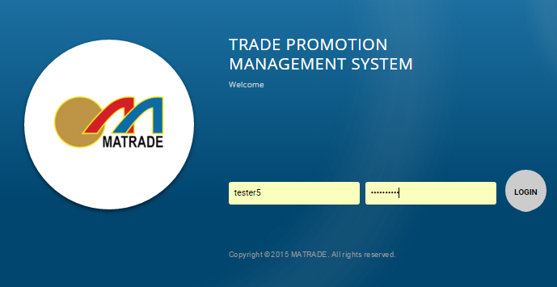

Application
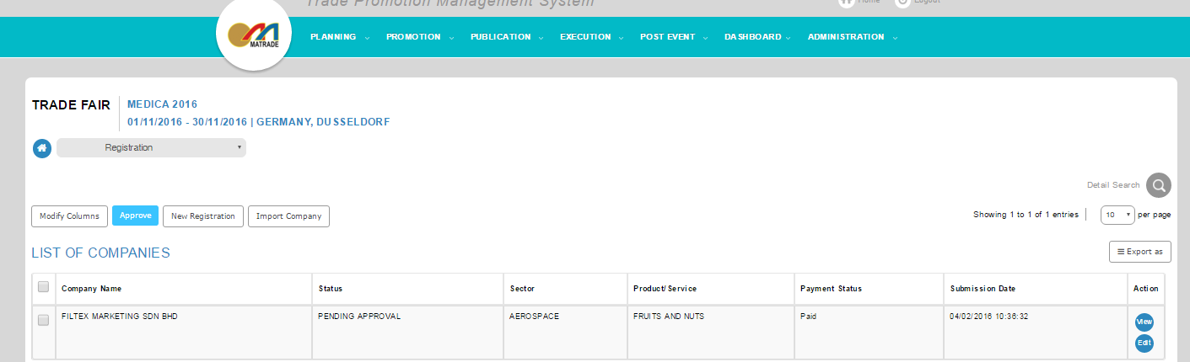

Export As
Result :
TPMS able to display Payment Status.
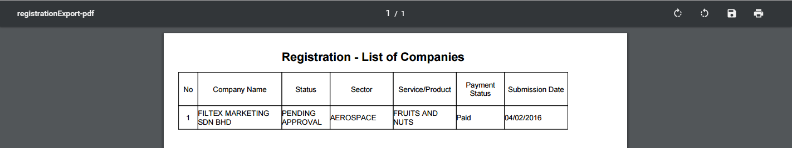

Reviewed By: (PMO)
 |  | Name/Position : Norhaidah Binti Md Dasuki / Senior Manager, Quality Assurance and Support  Date : 15/02/2016

