Test Issue Log |  |  |  |  |  | Issue ID# : TPMS_Prod059
Project Name: | Trade Promotion Management System (TPMS)
Test Stage: | Unit Functionality Integration System Interface  Performance Regression Acceptance Pilot
Test Case Number: | Support # 5976 |  |  | Test Started Date: |  |  | 19/02/2016
Test Title: | Unable to register Buyer due to problem in key-in Postcode and Representative Phone Number
Test Description: | To test on fixing the input specification for Foreign Registration Form “Postcode” and Representative’s “Phone Number” field as below  - Postcode - change from Numeric to Alphanumeric  - Phone Number - enhance field length from 10 to 20
Test Functionality: | TPMS>Promotion-View>Business Meeting – Register Buyer  TPMS>Promotion-View>Business Meeting – Foreign Buyer List - Edit
Test Procedure: | Register Buyer – New  - Select “Promotion” from the sub menu drop down list  - Choose the selected event and click on View button  - Select “Business Meeting” from the sub navigation drop down list and click on “Register Buyer”  Result: Able to key-in Postcode in Alphanumeric format and Phone Number with max length of 20  Foreign Buyer List – Edit  - Select “Promotion” from the sub menu drop down list  - Choose the selected event and click on View button  - Select “Business Meeting” from the sub navigation drop down list and click on “Edit” button for selected event.  Result: Able to key-in Postcode in Alphanumeric format and Phone Number with max length of 20
Test Result: | Pass: Fail:  Conditional Pass: : |  | Tested by: |  | Norhaidah Md Dasuki
Reason for Failure:
TEST DESCRIPTION
Issue:
To test on fixing the input specification for Foreign Registration Form “Postcode” and Representative’s “Phone Number” field.

Login as Administrator (Tester5)
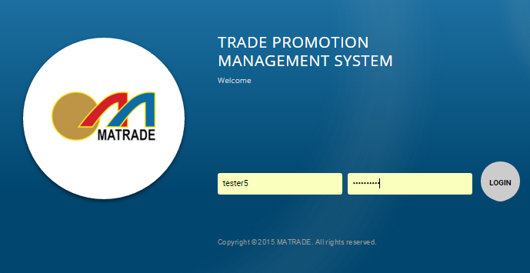

Select Promotion>Selected Event “View” - Business Meeting

- Change Input specification for Company Details - Postcode field to Alphanumeric and add checking if the field if empty only.

Register Buyer - New

Foreign Buyer List - Edit

- Enhance Input specification for Representative – Phone Number field length from 10 to 20.

Reviewed By: (PMO)
 |  | Name/Position : Norhaidah Binti Md Dasuki / Senior Manager, Quality Assurance and Support  Date :19/02/2016

