***Issue Form (PROD)***

|  |  |
| --- | --- |
| **Originator's Name:** Muhammad Arshad Nordin  **Project:** Trade Promotion Management System (TPMS)  **Project Manager:** Norharizal Ishak  **Module :** Planning  **Date Raised:** 23/02/2016  **Phase :** Module 3 - 8  **Functional Area:** Promotion ->List of event -> List of companies | **Issue ID Number:** TPMS_Prod072  **Related Issue ID Number:** Redmine #6002  **Classification:**  **Priority:** Critical/High/Medium/Low  **Assigned to: Vendor / IT / PMO SA / UPA**  **Actual Closed Date:** |
| **Status:** Open/Assigned/Investigated/Resolved/Approved/Deferred/No Action  *(Circle one)* | |
| **Description :**  Companies details display at list of companies not same as view companies details (popup windows view).  For telephone number column, after symbol “/” display phone number but phone number cannot be found in popup window view. Which data systems take to display at table list of companies?  *Please refer to file attached for further details.* | **Impact:** |
| **Findings/Root Caused (Description):** | **Resolution:** |
| **Estimated Impact :** |  |
| **Recommendation:** | |
| **Accepted :**  **(Vendor / IT / PMO SA / UPA)**  **Date: 23/2/2016** | **Accepted (KFHMB Tester):**  **Date:** |

**LIST OF COMPANIES – COLUMN TELEPHONE NUMBER [COMPANY KOON BROTHER SDN BHD]**

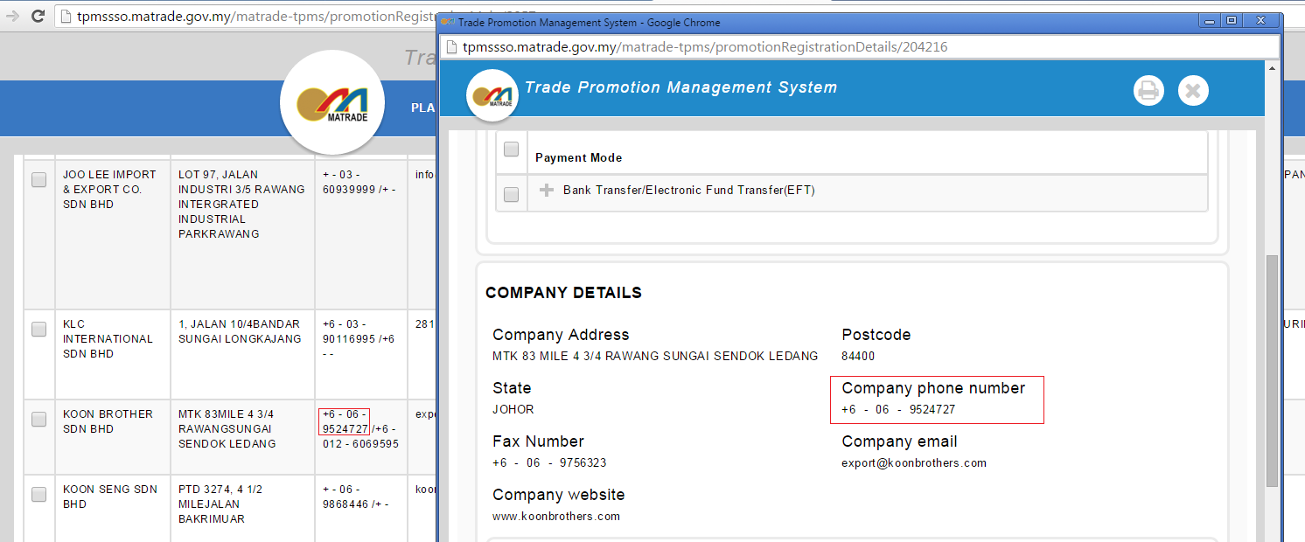

**LIST OF COMPANIES – COLUMN EQUITY/SHARE[COMPANY KOON SENG SDN BHD]**