Test Issue Log |  |  |  |  | Issue ID#: TPMS_Prod061
Project Name: | Trade Promotion Management System (TPMS)
Test Stage: | Unit Functionality Integration System Interface  Performance Regression Acceptance Pilot
Test Case Number: | Support #5977 |  |  | Test Started Date: |  | 23/2/2016
Test Title: | Sort product category alphabetically
Test Description: | To check product category sorting display in alphabetically.
Test Functionality: | Business Meeting > Register Buyer - Product Category
Test Procedure: | - Click on Promotion > Business Meeting > Setup  - Add new product/service  - Click on Business Meeting > Foreign Buyer List > Register Buyer  - In the registration form buyer clicks on Add product & see the product category dropdown.
Test Result: | Pass: Fail: Conditional Pass: |  | Tested by: |  | Siti Norahayu
Reason for Failed / Conditional Pass:
TEST DESCRIPTION
Click on Promotion > Business Meeting > Setup
Result:
System display Product & Service list

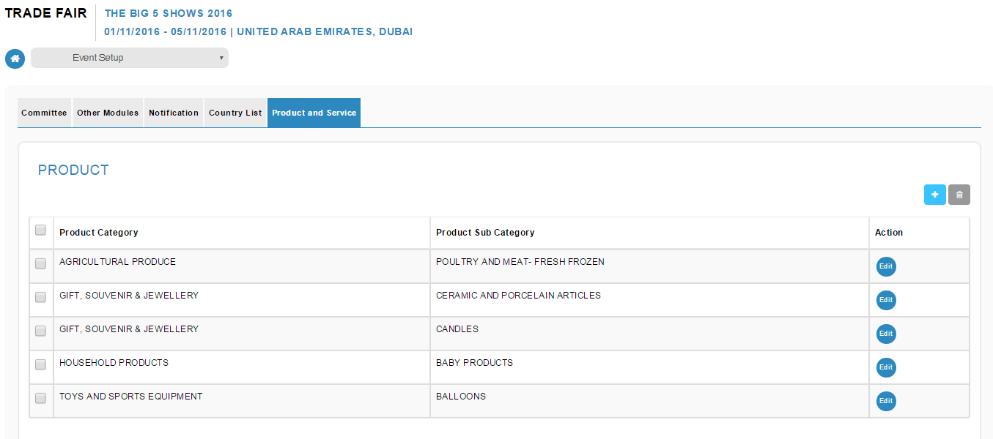

- Click on Business Meeting > Foreign Buyer List > Register Buyer
- In the registration form buyer clicks on Add product & see the product category dropdown
Result:
System display Product Category in Alphabetical

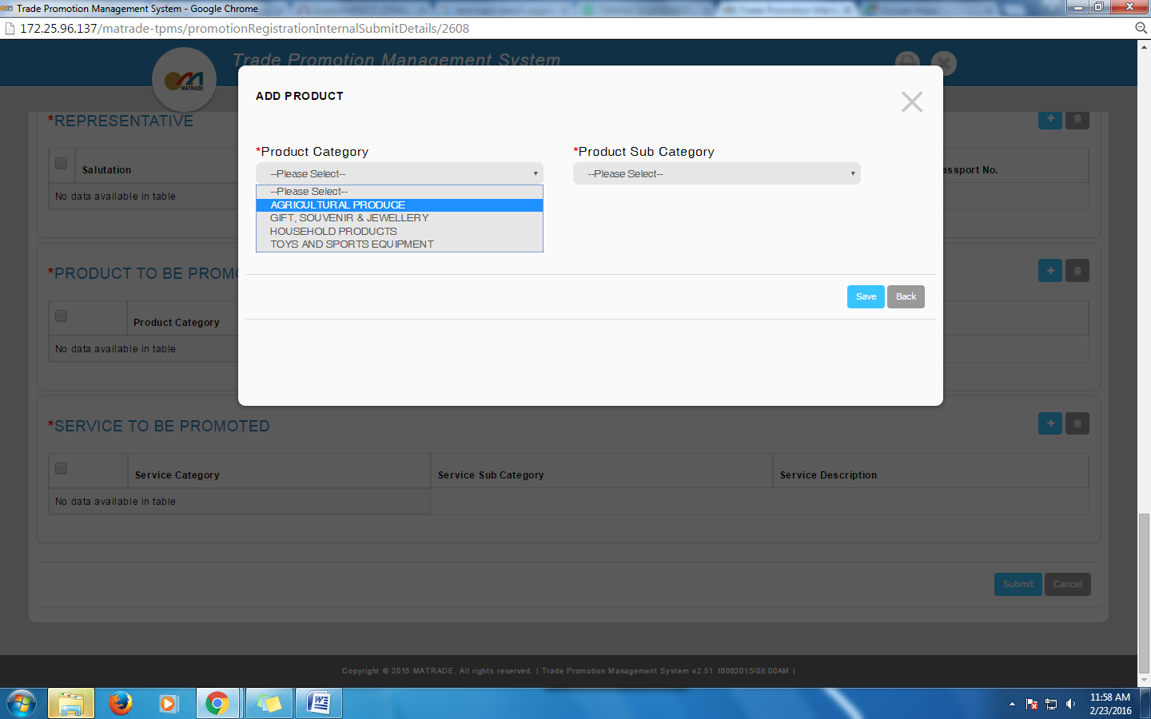

Reviewed By: (PMO)
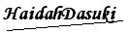 |  | Name/Position : NorhaidahBintiMdDasuki / Senior Manager, Quality Assurance and Support  Date : 23/2/2016

