Test Issue Log |  |  |  |  | Issue ID#: TPMS_Prod062
Project Name: | Trade Promotion Management System (TPMS)
Test Stage: | Unit Functionality Integration System Interface  Performance Regression Acceptance Pilot
Test Case Number: | Support #5978 |  |  | Test Started Date: |  | 24/2/2016
Test Title: | JPPPA Details in Activities List
Test Description: | To test on JPPPA Details in Activities List to display accurately.
Test Functionality: | Planning > Activities List
Test Procedure: | - Click on Planning > Activities List
Test Result: | Pass: Fail: Conditional Pass: |  | Tested by: |  | Siti Norahayu
Reason for Failed / Conditional Pass:
TEST DESCRIPTION
Click on Planning > Activities List
Result:
System display List of Activities

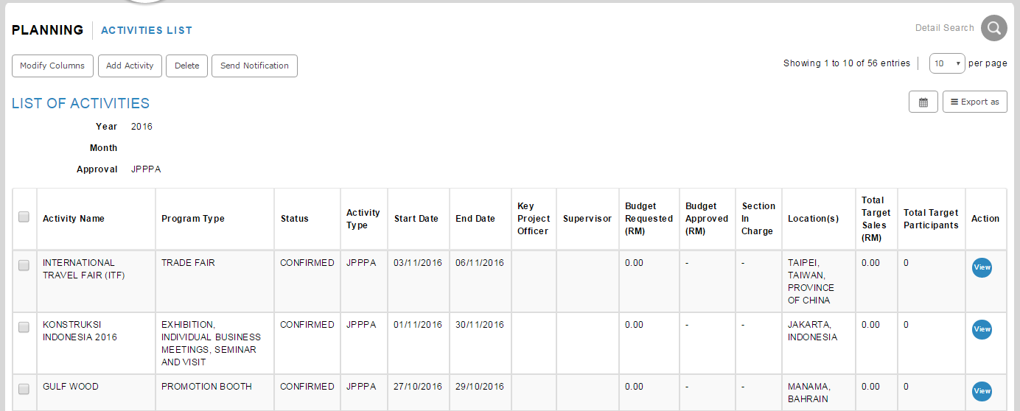

Search for JPPPA program. Click on View button.
Result:
System display JPPPA details.

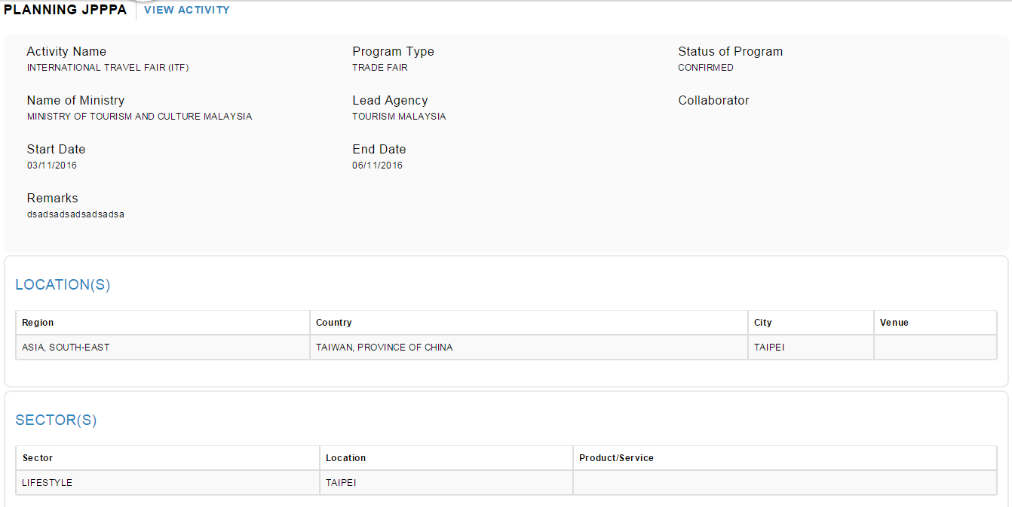

Reviewed By: (PMO)
 |  | Name/Position : NorhaidahBintiMdDasuki / Senior Manager, Quality Assurance and Support  Date : 24/2/2016

