Test Issue Log |  |  |  |  | Issue ID#: TPMS_Prod069
Project Name: | Trade Promotion Management System (TPMS)
Test Stage: | Unit Functionality Integration System Interface  Performance Regression Acceptance Pilot
Test Case Number: | Support #5998 |  |  | Test Started Date: |  | 24/2/2016
Test Title: | Number of booth requested column is blank.
Test Description: | To test on “Number of booth requested” column in List of company registration.
Test Functionality: | Promotion > Registration - List of company
Test Procedure: | - Click on Promotion > Registration - List of company  - Click on view button
Test Result: | Pass: Fail: Conditional Pass: |  | Tested by: |  | Siti Norahayu
Reason for Failed / Conditional Pass:
TEST DESCRIPTION
Click on Promotion > Registration - List of company
Result:
System display List of Companies

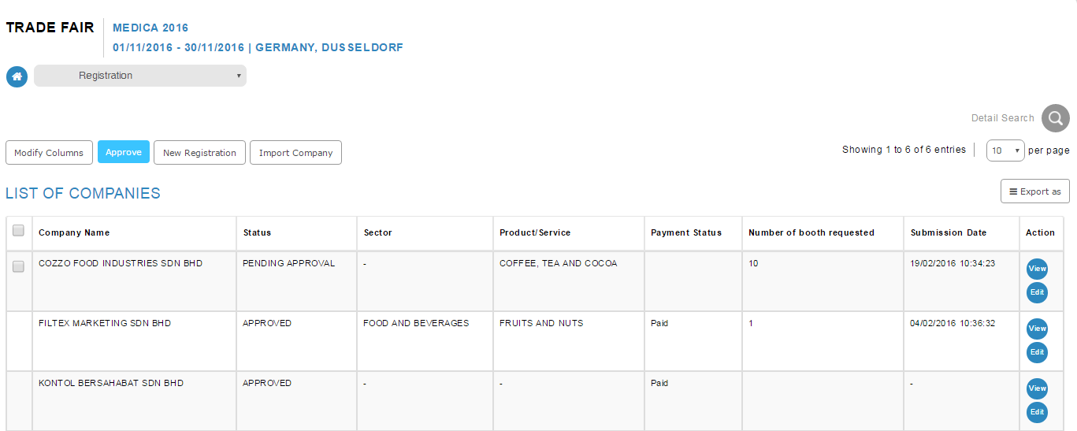

Click on View button.
Result:
System display company registrations details.
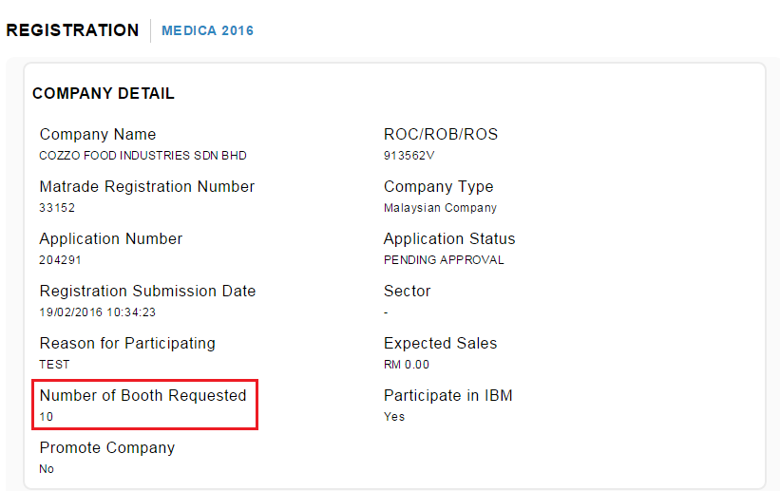

Reviewed By: (PMO)
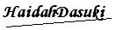 |  | Name/Position : NorhaidahBintiMdDasuki / Senior Manager, Quality Assurance and Support  Date : 24/2/2016

