**Services 🡪 e-Billers List**

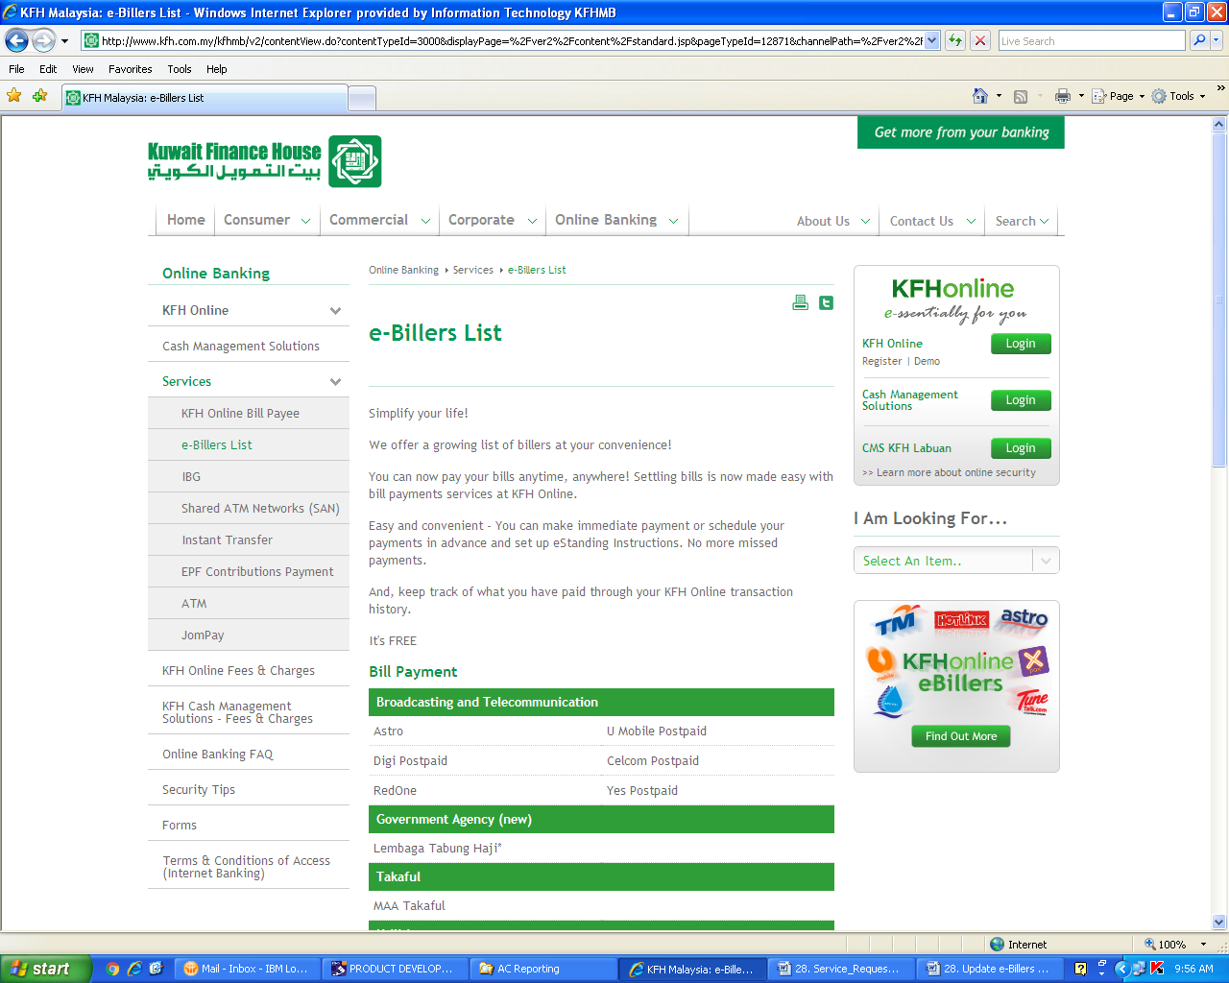



**To Rename:**

**🡪Celcom Prepaid (Pin and Pinless) to Celcom Prepaid (Pinless)**

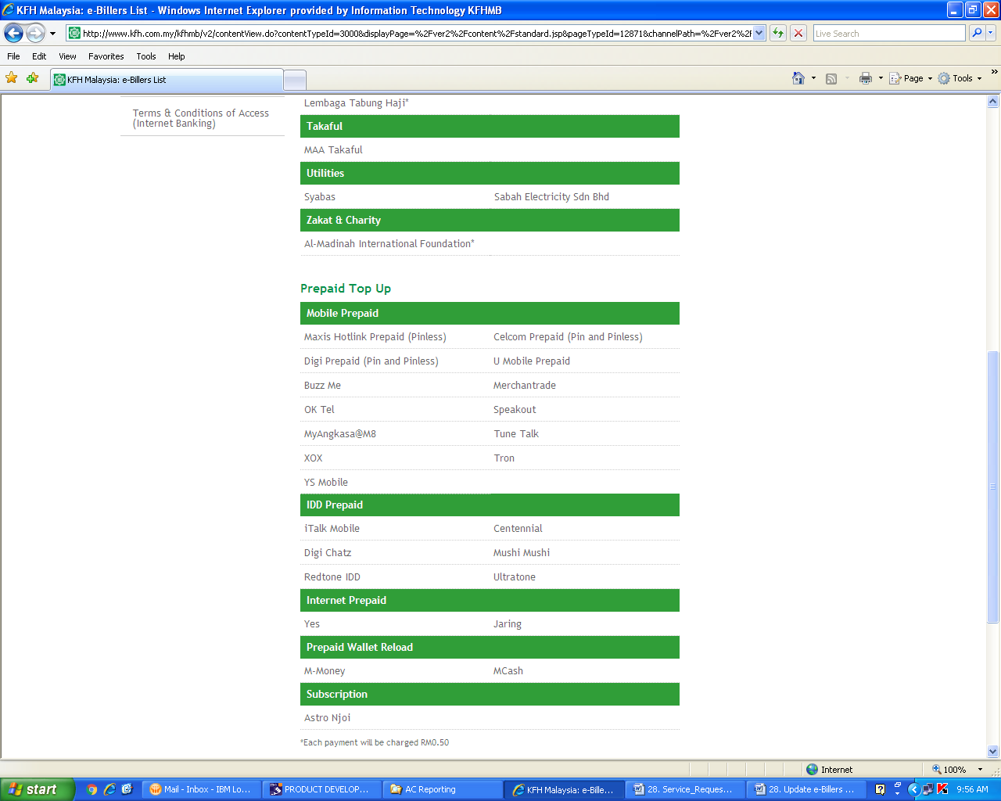

**To Add:**

**🡪Friendi**

**🡪Altel**

**🡪Xiddig**

**🡪2in1**

**To Add:**

**🡪 TNB**

**To remove:**

**🡪 M-Money**

**To Add:**

**🡪 HyppMe**

**To Remove:**

**🡪 Jaring**

**To Add:**

**🡪 TM Go**

**🡪 Lebara**

GloReload Everest Nepal

Mobile Prepaid (Oversea)

**To add a new section for “Mobile Prepaid (Oversea) after the “Mobile Prepaid” section as per below:**

**To Rename:**

**🡪Buzz Me to M8**

**🡪OK Tel to iTel**

**🡪MyAngkasa@M8 to MyAngkasa**