Test Issue Log |  |  |  |  | Issue ID#: TPMS_Prod067
Project Name: | Trade Promotion Management System (TPMS)
Test Stage: | Unit Functionality Integration System Interface  Performance Regression Acceptance Pilot
Test Case Number: | Support #5983 |  |  | Test Started Date: |  | 25/2/2016
Test Title: | To complete the label “Total No of.” >> “Total No. of Activities :”
Test Description: | To test on downloading report and make sure “Total No of.” To be display as a >> “Total No. of Activities :”
Test Functionality: | Post Event > JPPPA Report > Reports > List of program with multiple locations
Test Procedure: | - Post Event > JPPPA Report > Reports > List of program with multiple locations
Test Result: | Pass: Fail: Conditional Pass: |  | Tested by: |  | Siti Norahayu
Reason for Failed / Conditional Pass:
TEST DESCRIPTION
Click on Post Event > JPPPA Report > Reports > List of program with multiple locations
Result:
System generate the report.
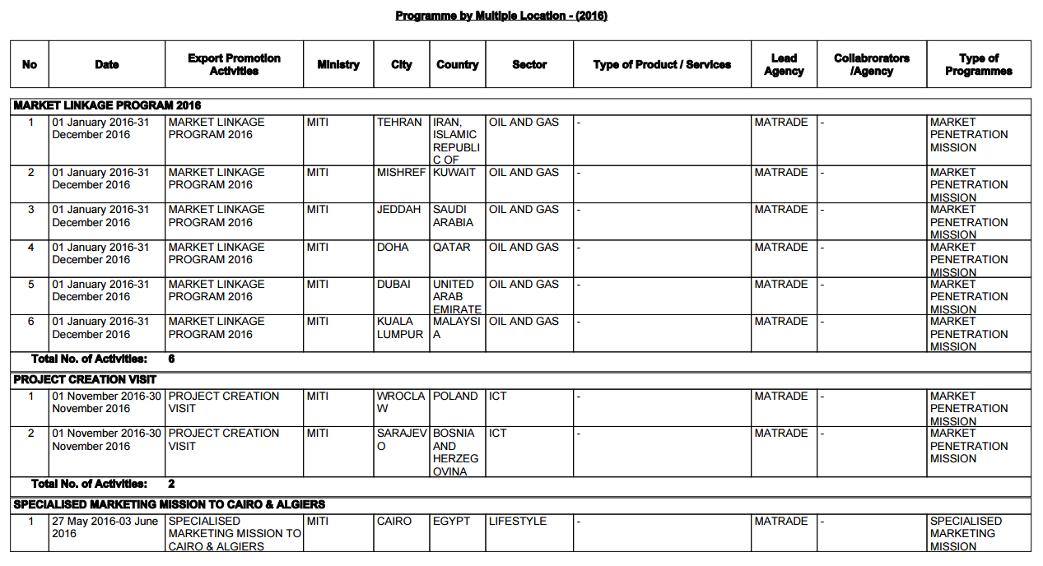

Reviewed By: (PMO)
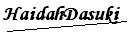 |  | Name/Position : Norhaidah Binti MdDasuki / Senior Manager, Quality Assurance and Support  Date : 25/2/2016

