Test Issue Log |  |  |  |  | Issue ID#: TPMS_Prod072
Project Name: | Trade Promotion Management System (TPMS)
Test Stage: | Unit Functionality Integration System Interface  Performance Regression Acceptance Pilot
Test Case Number: | Support #6001 |  |  | Test Started Date: |  | 26/2/2016
Test Title: | Companies details display at list of companies not same as view companies details
Test Description: | To test on companies details to display data accurately.
Test Functionality: | Promotion >List of event > List of companies
Test Procedure: | - Promotion >List of event > List of companies
Test Result: | Pass: Fail: Conditional Pass: |  | Tested by: |  | Siti Norahayu
Reason for Failed / Conditional Pass:
TEST DESCRIPTION
Click on Promotion > List of event > List of companies
Result:
System display List of companies

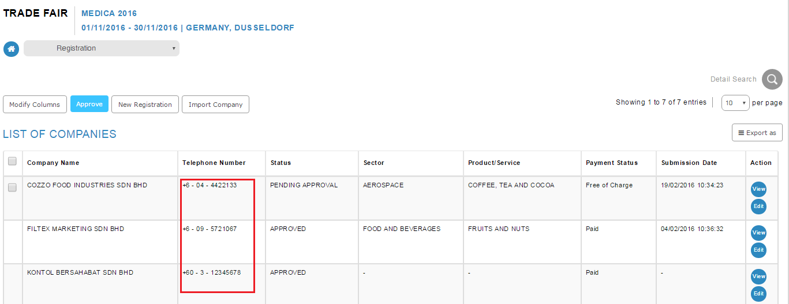

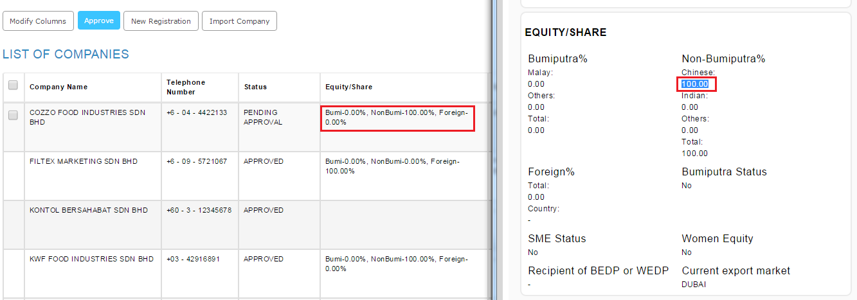

Reviewed By: (PMO)
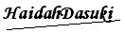 |  | Name/Position : NorhaidahBintiMdDasuki / Senior Manager, Quality Assurance and Support  Date : 26/2/2016

